# The CPT SharePoint 2016 VM Setup Guide

**Setup Time**: 8 to 12 hours

**Overview**: Before you can begin to work on the lab exercises for a Critical Path Training course on SharePoint 2016, you must first build or acquire a virtual machine (VM) with all the prerequisite software installed by following the instructions provided in this document.

This guide will step you through using the Microsoft's Hyper-V to create a new VM and install the Windows Server 2012 R2 operating system onto a new server named **WingtipServer**. You will then create a new Active Directory domain named **wingtip.com** by promoting **WingtipServer** to be a domain controller. After that, you will install SQL Server 2016. Next you will download the installation files for **SharePoint Server 2016**. You will then install and configure SharePoint 2016 and create all of the starting points needed by the lab files.

In later tasks in this setup guide, you will download the installation files and install **Office 2016, Visual Studio 2015,** and **SharePoint Designer 2013**. Once you have completed all the tasks in this setup guide, you will have created a VM that can be used as the starting point for any of the Great SharePoint Adventure 2016 training course offered by Critical Path Training.

Please note that the instructions and screenshots in this setup guide are based on Microsoft's Hyper-V Environment. If you plan to build the VM using a different virtualization product other than Hyper-V such as VMWare, you will have to make adjustments as you move through this setup guide for the ways in which your virtualization product differs from Hyper-V.

### Task 1: Make Sure You Meet the Hardware Requirements

Before getting started, make sure you have a student workstation that meets the following requirements

1. Make sure you have a host computer running Windows 10, Windows Server 2016 or Windows Server 2012 R2.
2. Make sure your host computer is configured to run Hyper-V.
3. Make sure your host computer has at least 120GB of free hard drive space
4. Make sure your host computer has enough RAM to run a VM with SharePoint Server 2016
   1. 16GB is the recommended amount of RAM.
   2. 12GB should be considered the minimum amount of RAM to achieve acceptable performance.
   3. Running with less than 12GB of RAM of your host computer will likely lead to poor performance and is not recommended.
5. Make sure your host computer has a connection to the Internet.
   1. The connection can be based on either a network card with a cable plugged in or a wireless connection.

Note that the instructions and the screenshots of the host computer and the Hyper-V environment in this document were created using Windows 10. Things will look a bit different with Hyper-V if you are running Windows Server 2016 or Windows Server 2012 R2.

### Task 2: Configure the Hyper-V Network Adapters on the Host Computer

In this task you will configure two Hyper-V network adapters. This task involves creating two virtual switches in Hyper-V that will be used to configure both an internal network adapter and an external network adapter. The internal network adapter will be used to configure a static IP address in the VM. The external network adapter will be used to connect the VM to the Internet.

1. Launch the Hyper-V Manager: **Start** 🡪 **Administrative Tools** 🡪 **Hyper-V Manager**.

The host computer that was used to create the following screenshots is named **HULLABALOO**. Your screen will look a little different because your host computer will have a different name.

1. Create a new virtual switch named **Internal** for an internal network adapter:
   1. In the **Actions** pane on the right-hand side of the screen, click **Virtual Switch Manager**.

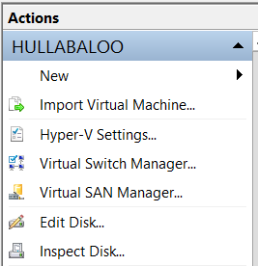

* 1. In the **Virtual Switch Manager** dialog, create a new virtual switch by selecting **Internal** and then clicking the **Create Virtual Switch** button.

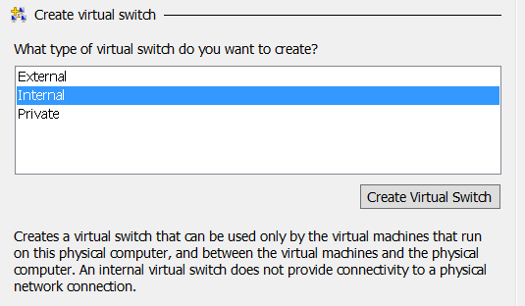

* 1. Configure the new virtual switch with the following properties:
     1. **Name**: Internal
     2. **Connection Type**: Internal network.

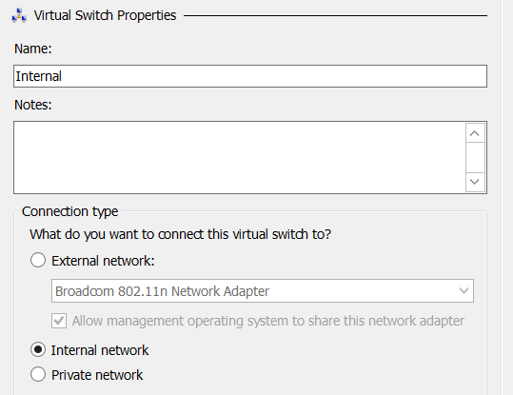

* 1. Click **OK** to save your changes.

In the next step you will create an external virtual switch that will be used to connect the VM to the Internet. You can create this external network switch by using either a network adapter with a network cabled plugged in or a wireless connection on your host computer. All that is required is that you create the virtual switch using a network adapter on your host computer that can connect to the Internet. The Internet connection is an essential part of the setup for this VM because it's required when running the Prerequisite Installer utility of SharePoint Server 2016.

1. Create a new virtual switch named **External** for an external network adapter:
   1. In the **Actions** pane on the right-hand side of the screen, click **Virtual Switch Manager**.



* 1. In the **Virtual Switch Manager** dialog, create a new virtual switch by selecting **External** and then clicking the **Create Virtual Switch** button.

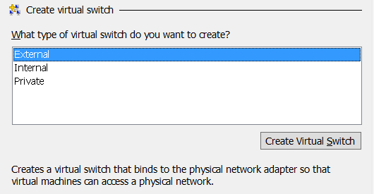

* 1. Configure the new virtual switch with the following properties:
     1. **Name**: External
     2. **Connection Type**: External network.
        1. Make sure to select a network adapter or wireless connection from the host computer in the dropdown menu under the **External network** radio button.

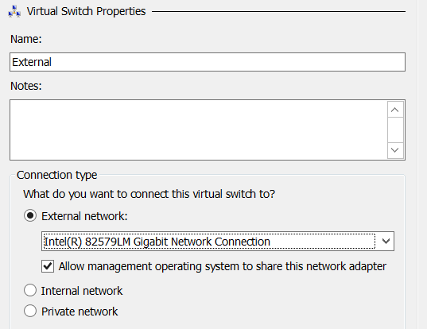

* 1. Click **OK** to save your changes.

### Task 3: Create a new Virtual Machine (VM) using Hyper-V

To complete this task, you will create a new VM using the Hyper-V environment.

1. If it is not open, launch **Hyper-V Manager**.
2. On the left-hand side of **Hyper-V Manager**, locate the node with the name of the local host computer and select it.
3. In the **Actions** pane select **New 🡪 Virtual Machine**.
   1. When you execute this menu command, the Hyper-V Manager will launch the **New Virtual Machine Wizard**.

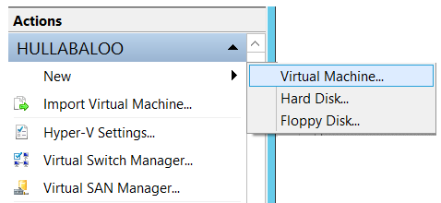

1. The **New Virtual Machine Wizard** begins with the **Specify Name and location dialog.**
   1. Enter a **Name** of **WingtipServer**.
   2. Select a folder path for the **Location** property where the virtual machine files will be stored. Ensure the **Location** path is hosted by a hard drive that has at least 100GB of free space. If possible, configure the **Location** path on a secondary hard drive that is different from the hard drive running the host operating system to improve the performance of your VM.
   3. Click **Next** to move to the next page of the New Virtual Machine Wizard.

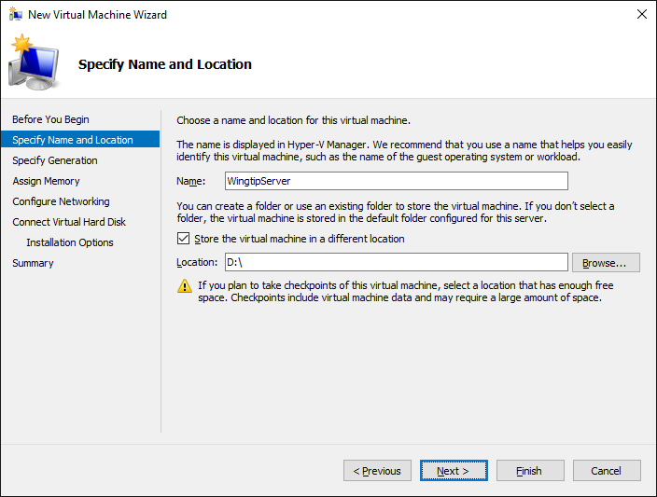

1. On the **Specify Generation** page, select **Generation 1** and then click **Next**.

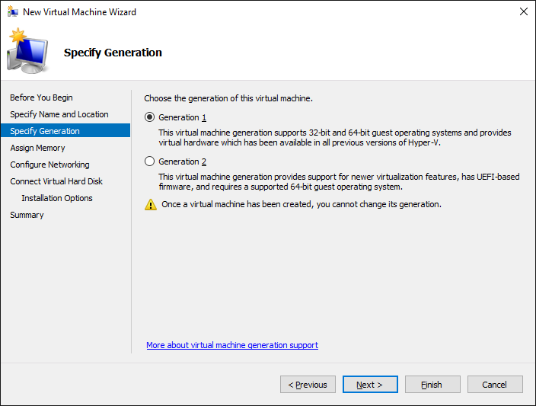

1. In the **Assign Memory** dialog, enter the amount of **Memory** to allocate to the virtual machine.
   1. Determine the amount of memory to use for the VM from the following table.

|  |  |
| --- | --- |
| **If host machine has this much RAM** | **Then configure the VM with this much RAM** |
| 16 GB or more | 14 GB - configure the VM with **14336 MB** of RAM. |
| 14 GB | 12 GB - configure the VM with **12288 MB** of RAM. |
| 12 GB | 10 GB - configure the VM with **10240 MB** of RAM. |
| 10 GB (not supported) | 8 GB - configure the VM with **8192 MB** of RAM. |
| 8 GB (not supported) | 6.5 GB - configure the VM with **6656 MB** of RAM. |

* 1. Enter the amount of RAM you calculated in the previous step as the **Startup** memory property. Make sure you enter the number in megabytes (e.g. **14336 MB**). Finally, make sure to leave the **Use Dynamic Memory for this virtual machine** checkbox unchecked. Click **Next** to continue.

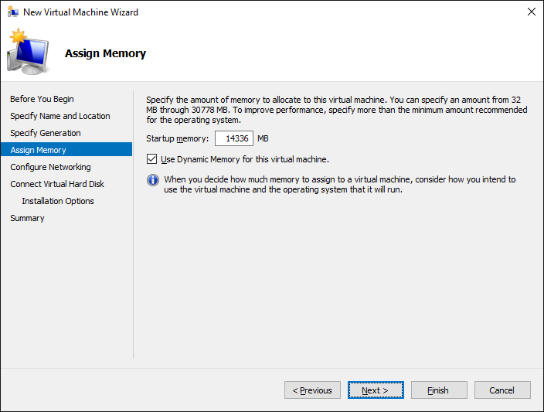

1. In the **Configure Networking** dialog, assign a **Connection** property of theInternal and click **Next**.

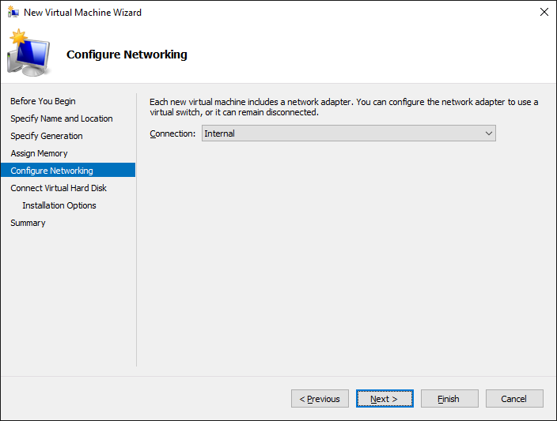

In the next step you will configure the file location for the files Hyper-V uses to store the VM. If possible, configure the VM file location on a separate physical drive that is different than the drive which holds the host computer’s operating system. This is one of the best way to increase the performance of a VM.

1. In the **Connect Virtual Hard Disk** dialog, accept the default option of **Create a virtual hard disk**. Make sure the **Location** is set to a directory in a local hard drive on our host computer that has at least 120 GB of free space. Click **Next**.

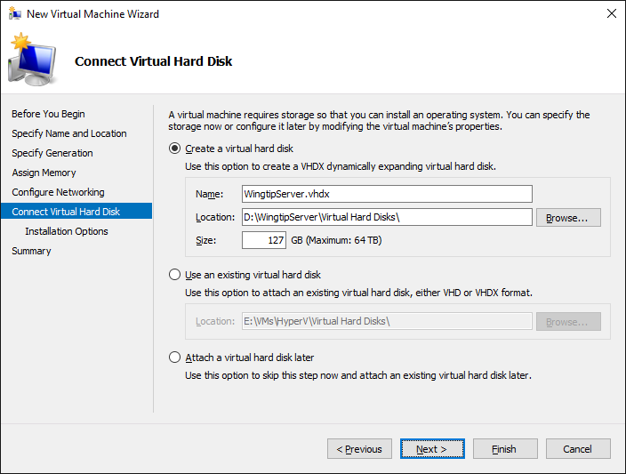

1. In the **Installation Options** dialog, accept the default option which is **Install an operating system later** and click **Next**.

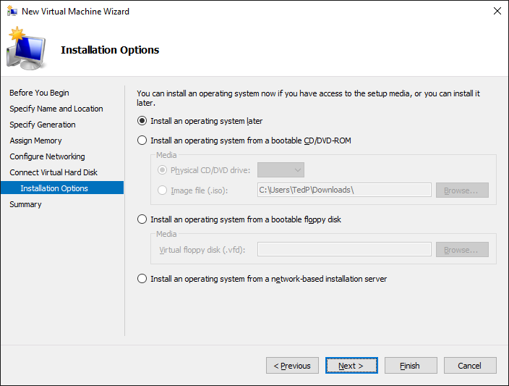

1. On the **Completing the New Virtual Machine Wizard** dialog, review the setting and verify that these settings are what you expected. Click **Finish** to create the new VM.

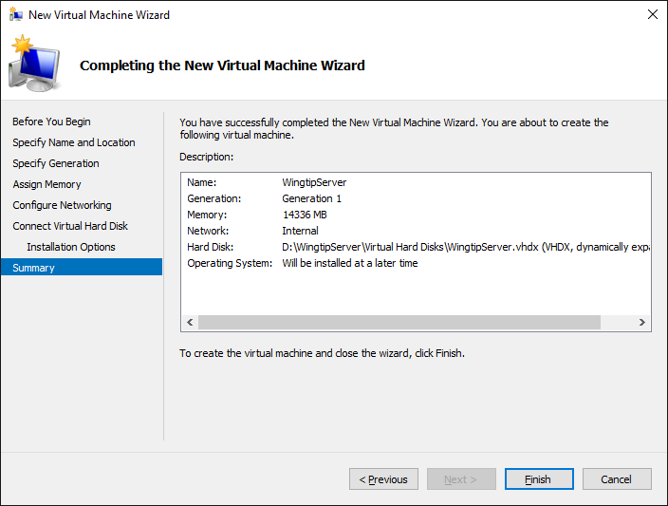

Even though you have finished going through the New Virtual Machine Wizard, there are still two more configuration changes you need to make on the VM before you are ready to install the Windows Server 2016 operating system.

1. In the **Hyper-V Manager** window, right-click the VM you just created and select **Settings**:

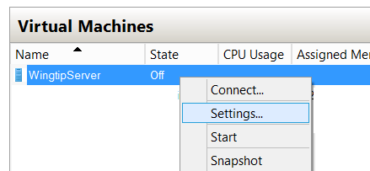

1. In the **Settings for WingtipServer** dialog, complete the following steps
   1. Select the **Processor** setting and increment the **Number of processors** property value from its default value of **1** to the maximum allowable number for your host machine. You can increment the **Number of processors** property value using the up arrow in the spinner control to its right. Depending on the processor capabilities of your host computer, you should be able to increase this property to a value of either **2**, **4** or **8**.

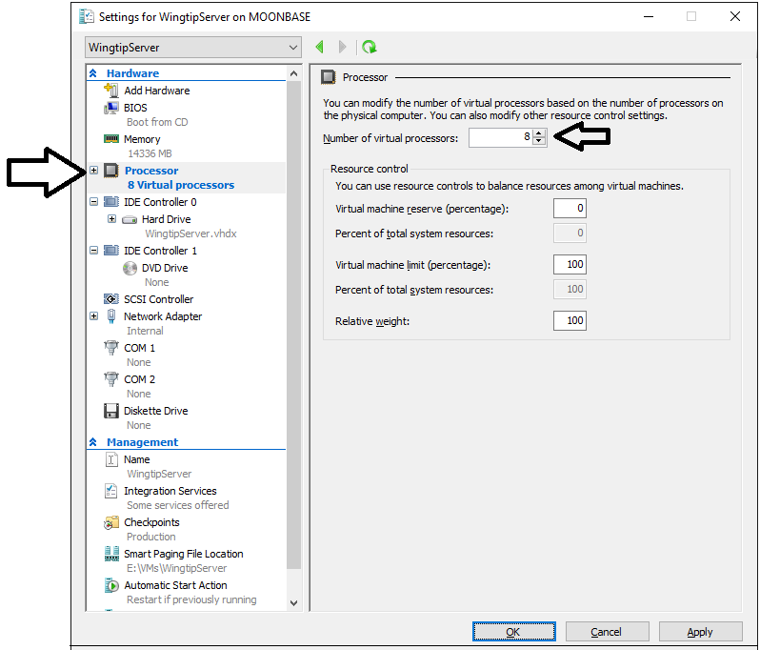

* 1. Click the **Apply** button to save your changes to the **Number of virtual processors** property while leaving the dialog open.

1. Create a second network adapter in the VM.
   1. In the **Settings for WingtipServer** dialog, select **Add Hardware**. Next, select **Network Adapter** and click **Add**:

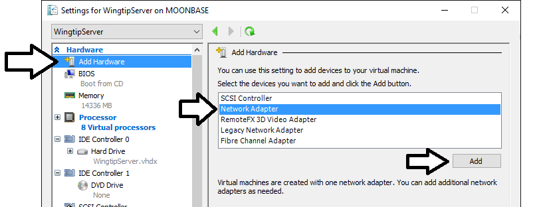

* 1. Once the new Network Adapter has been created, do **not** assign a **Virtual switch** yet. In an upcoming task later in this setup guide you will bind this network adapter to the **External** virtual switch. For now, however, you should leave the **Virtual switch** setting with its default value of **Not connected**.

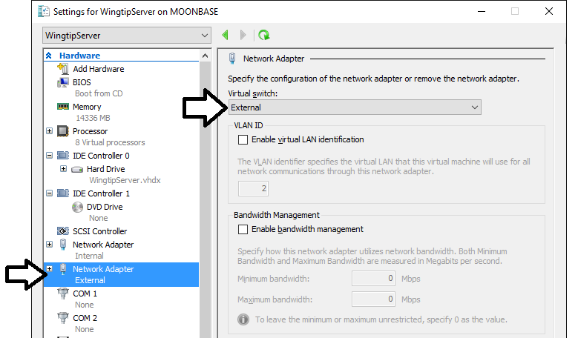

* 1. Click **OK** to save the changes you have made to the VM.

At this point you have created and configured a new VM. You are now ready to install Windows Server 2016.

### Task 4: Install the Windows Server 2012 R2 Operating System and Apply All Updates

You will begin this task by acquiring the installation files and optionally a product key for Windows Server 2012 R2. After that you will move through the steps of installing the operating system and configuring the VM as a server computer named **WingtipServer**.

1. Obtain a copy of the Windows Server 2012 R2 install binaries.
   1. Choose between using your own licensed copy of Windows Server 2012 R2 or using a free trial version.
      1. Note that downloading the free trial version will require that you have a TechNet or an MSDN subscription.
   2. If you plan to use a licensed copy, acquire the install image (*.iso) for of Windows Server 2012 R2 and the product key.
   3. If you plan to use a free trial copy of Windows Server 2012 R2, follow these steps:
      1. Navigate to the evaluation down page at **http://technet.microsoft.com/en-us/evalcenter/hh670538.aspx**.
      2. Find the **Download the Evaluation ISO** section and click the **Get Started Now** button underneath to begin the download.
      3. When prompted, log in using the credentials for your TechNet or MSDN subscription.
      4. Work through the instructions for downloading the Windows Server 2012 installation files in the .ISO file format.
      5. When you are done, you should have successfully downloaded the .ISO file with the Windows Server 2012 installation files to the hard drive of your host computer.
2. Mount the .ISO file so the **WingtipServer** VM recognizes it as a DVD.
   1. Navigate to **Hyper-V Manager**.
   2. Right-click the **WingtipServer** VM and select the **Connect…** command to display the Hyper-V console window for this VM.

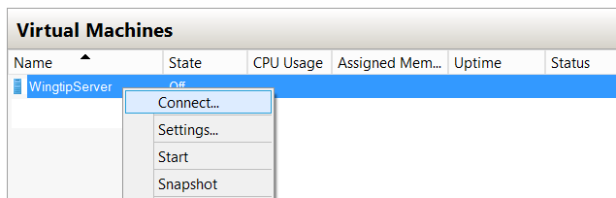

* 1. In the Hyper-V console windows for the **WingtipServer** VM, select the **Insert Disk…** command.

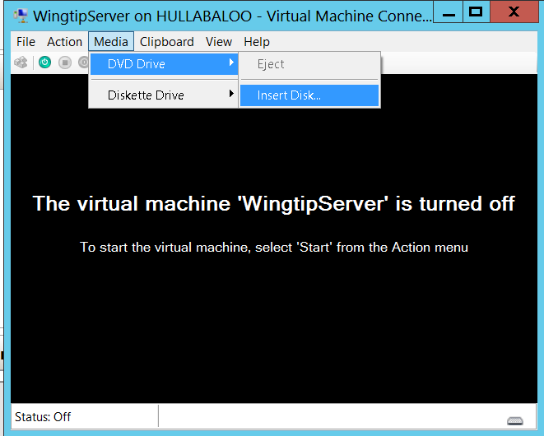

* 1. When the **Open File** dialog appears, enter the path to the .ISO file with the Windows Server 2012 installation files.
  2. Click **OK**.

1. Start the **WingtipServer** VM.
   1. In the Hyper-V console windows for **WingtipServer**, select the **Start** command from the **Action** menu to start up the VM.

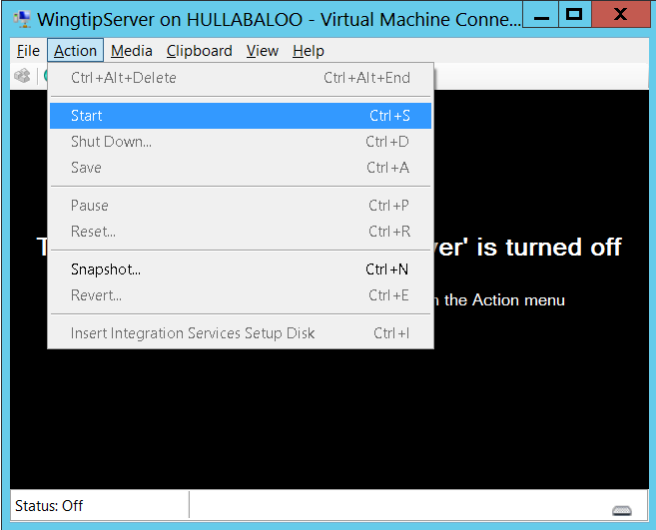

When the **WingtipServer** VM starts, it should automatically start the Windows Server 2012 installation program.

1. After the setup program for Windows Server 2012 loads, it will prompt you with a dialog asking you to select a language. Accept the default of **English** and click **Install** to continue.

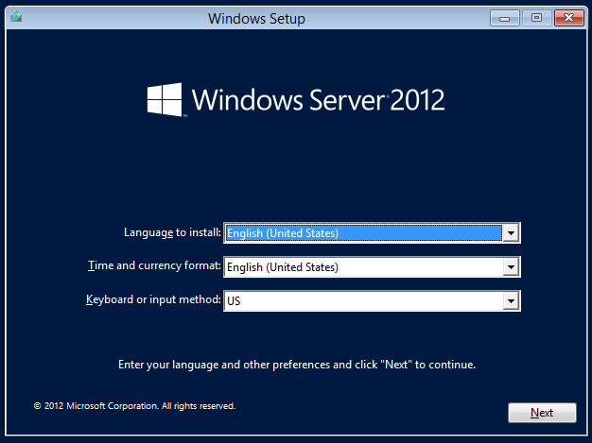

1. At the next dialog, click the **Install Now** button to begin the installation.

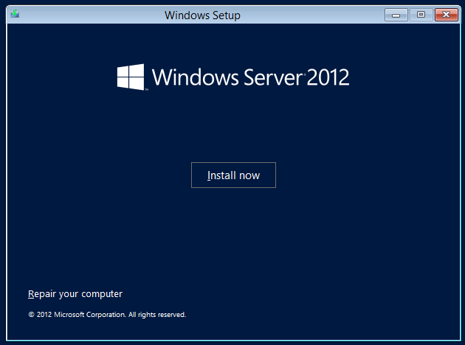

1. Depending on the type of installation files you have for Windows Server 2012, you might be prompted with a dialog which asks you to provide your Windows Server 2012 product key. If so, enter your product key and click **Next**.

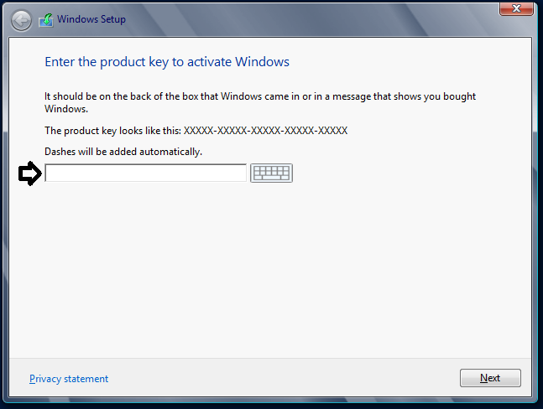

1. Depending on the type of installation files you have for Windows Server 2012, you might be prompted with a dialog which asks you to select the operating system you want to install. If so, select the **64-bit** edition of **Windows Server 2012 Standard Evaluation (Server with a GUI)** and click **Next**.

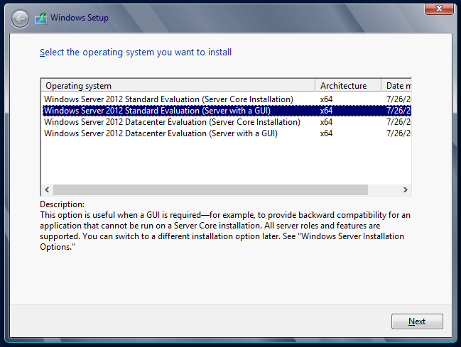

1. On the following dialog, agree to the licensing terms and click **Next**.
2. The next dialog prompts you with the question **Which type of installation do you want?**
   1. Select the installation type of **Custom: Install Windows only (advanced)**
   2. Click **Next**.

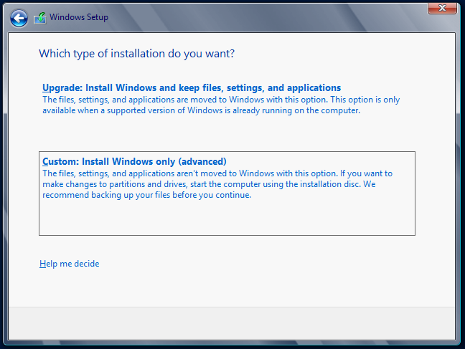

1. The next dialog asks you where you want to install Windows.
   1. Accept the default configuration which uses a location of **Disk 0 Unallocated Space** as shown below.
   2. Click **Next** to continue.

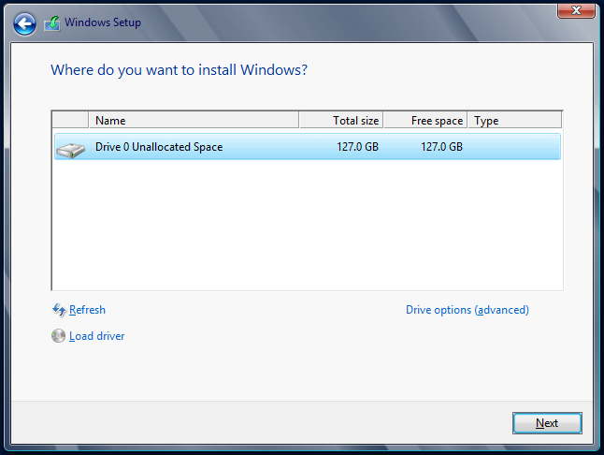

At this point you have given the Windows setup program enough information to install the basic operating system. The Windows Server 2012 setup program will now run for several minutes as it copies and expands files and installs Windows features. You now have a few minutes to get a cup of coffee or catch up on email.

1. Wait until the Windows Server 2012 setup program completes
2. When the setup program has completed, it will prompt you to assign a new password for the **Administrator** account.
   1. Click **OK** to continue and reset the administrator password.
   2. Set the password for the **Administrator** account to **Password1**.

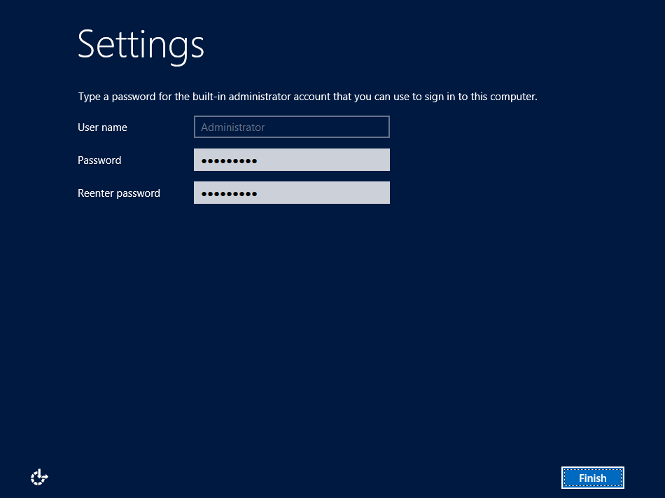

* 1. After you have updated the **Administrator** password, you will get a confirmation that the update was successful.
  2. Click **OK** to complete the basic installation of the operating system.
  3. When you click **OK** in the previous step, you will be logged off of the VM and the Hyper-V console window will then display the current date and time as well as the message **Press Ctrl + Alt + Delete to sign in**.



At this point, you have installed the basic operating system for Windows Server 2012 but there are several more configuration changes that you must make. Over the next few steps you will complete the required configuration by changing the computer name of the VM and making a few additional changes to the configuration of the operating system.

1. Log onto the VM using the local **Administrator** account.
   1. Do **not** attempt to log on by pressing the **Ctrl + Alt + Delete**.This keyboard combination will be sent to the host computer instead of the VM running inside Hyper-V.
   2. Log on to the VM by pressing the **Ctrl + Alt + End** keyboard combination or by selecting the **Ctrl + Alt + Delete** menu command inside the **Action** menu of the Hyper-V console window. When prompted to log on to the **Administrator** account, provide a password of **Password1**.

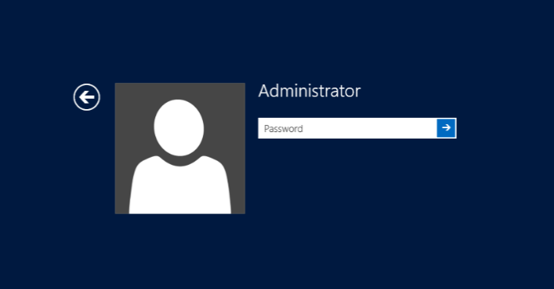

1. When you log in, Windows Server 2012 automatically displays the **Dashboard** page of the **Server Manager**. If you look at the left-hand portion of the screen, you will notice several navigation links including **Dashboard**, **Local Server**, **All Servers** and **File and Storage Services**.

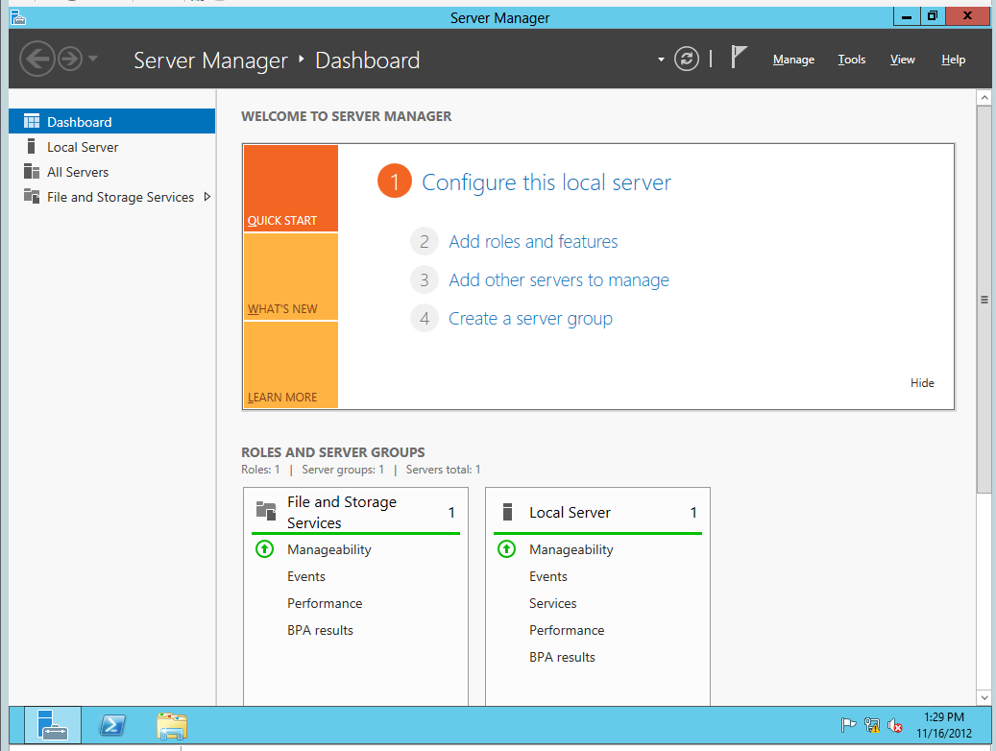

1. Click on **Local Server** link to navigate the main page used to update configuration properties of the local machine. You can see on the right-hand side of the screen there is a large section with a title of **Properties** which displays selected properties of the local machine.

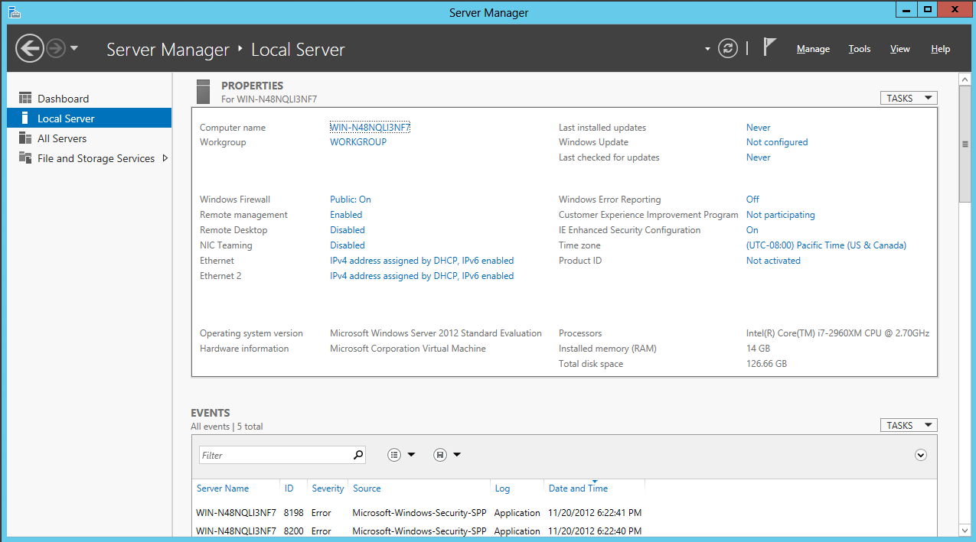

1. Change the **Computer name** of the VM to **WingtipServer**.
   1. Locate the **Computer name** property which is listed first in the **Properties** section. The current computer name was created by the Windows installation program as part of the initial setup of the operating system. Click on the value of the **Computer name** property to modify it.

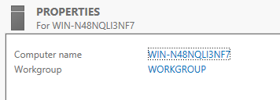

* 1. At this point you should be at the **Computer Name** tab of the **System Properties** dialog. Click on the **Change** button to update the **Computer name** property.

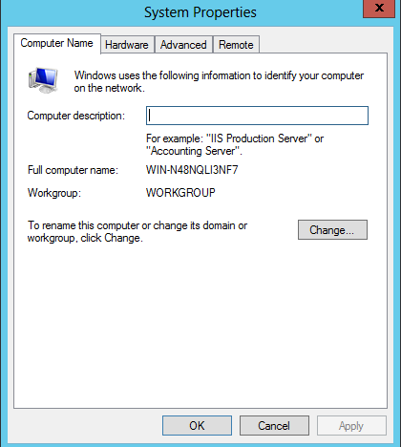

* 1. In the **Computer Name/Domain Changes** dialog, change the **Computer name** property to **WingtipServer**. Click **OK** to save your changes.

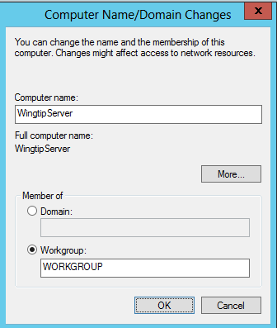

* 1. When you modify the **Computer name** property, Windows prompts you with a dialog that that tells you the machine needs to be restarted to apply the change. Choose **OK** to restart.
  2. After the VM has restarted, log in again using **[Administrator | Password1]** *(username | password)*.

1. Once you have logged back onto the VM, navigate back to the **Server Manager** and click the **Local Server** node. At this point, you should be able to see the **Properties for WingtipServer** section in the **Server Manager**.

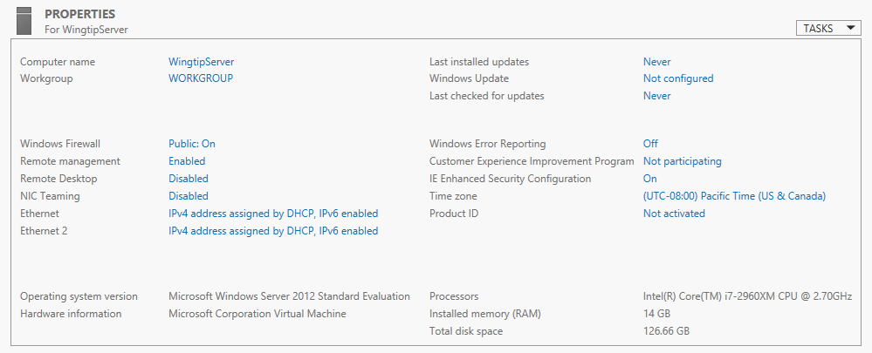

1. Disable **Enhanced Security Configuration**.
   1. In the **Properties for WingtipServer** section of the **Server Manager**, locate the **IE Enhanced Security Configuration** property in the right-hand column.
   2. You should be able to see that the **Enhanced Security Configuration** mode is configured to be on by default.
   3. Click on the value of **On** to display the **Internet Explorer Enhanced Security Configuration** dialog. This will display the **Internet Explorer Enhanced Security Configuration** dialog.
   4. In the **Internet Explorer Enhanced Security Configuration** dialog, disable **Enhanced Security Configuration** for both **Administrators** and **Users** by selecting the **Off** radio buttons as shown below and then click **OK**.

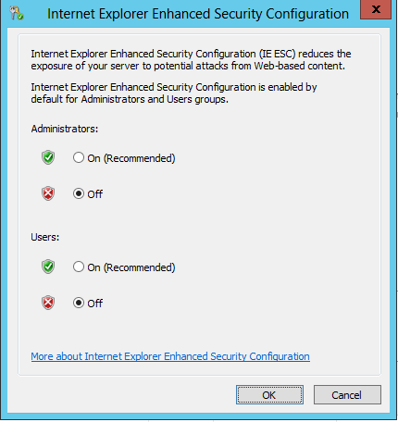

1. Disable the Windows Firewall.
   1. In the **Properties for WingtipServer** section of the **Server Manager**, locate the **Windows Firewall** property which shows an initial value of **Public: On**. Click on the value of **Public: On** to display the **Windows Firewall** dialog.
   2. In the **Windows Firewall** dialog, locate and click the **Advanced Settings** link to display the **Windows Firewall Advanced Settings** dialog.

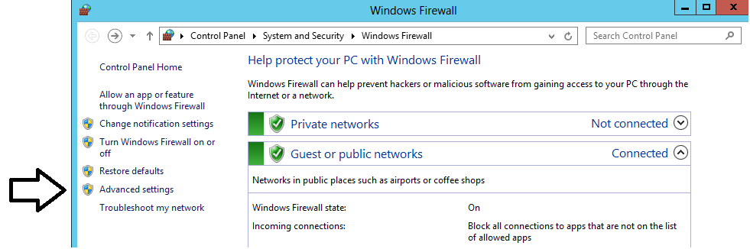

* 1. In the **Windows Firewall Advanced Settings** dialog, you should be able to see that the Windows Firewall for the **Domain Profile**, the **Private Profile** and the **Public Profile** are all enabled. Locate and click the **Windows Firewall Properties** link at the bottom of the **Overview** section to display a tabbed dialog with the title of the **Windows Firewall with Advanced Security on Local Computer**.

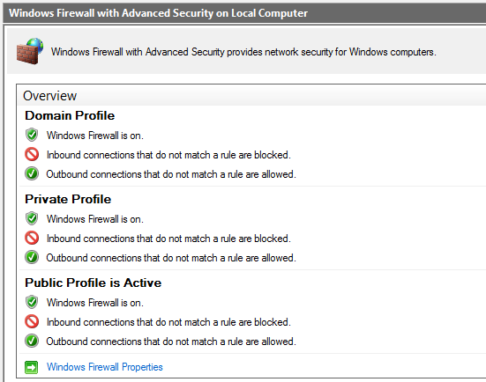

* 1. In the **Domain Profile** tab of the **Windows Firewall with Advanced Security on Local Computer** dialog, change the **Firewall state** property setting from **On** to **Off**. Click **Apply** to save your changes while leaving the tabbed dialog open.

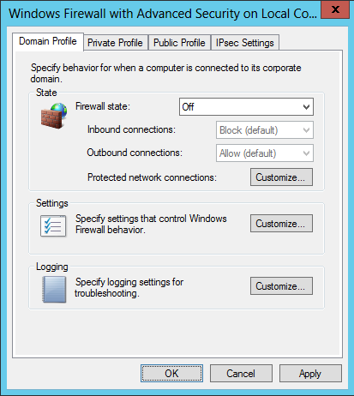

* 1. Once you have configured the **Firewall state** property to **Off** on the **Domain Profile** tab, go to the **Private Profile** tab and then the **Public Profile** tab and follow the same steps to disable the firewall for these profiles as well.
  2. Once you have turned off the firewall for all three profiles, click **OK** to dismiss the dialog. You should be able to verify in the **Overview** section of the **Windows Firewall Advanced Settings** dialog that the Windows Firewall has been turned off for the **Domain Profile**, the **Private Profile** and the **Public Profile**.

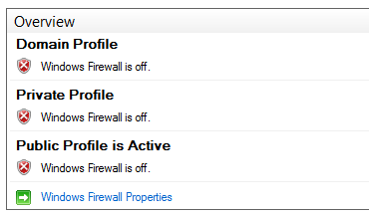

1. Enable Remote Desktop for your VM:
   1. Navigate back to the **Server Manager** and click the **Local Server** node. At this point, you should be able to see the **Properties for WingtipServer** section in the **Server Manager**.
   2. Look inside the **Properties for WingtipServer** section and locate the **Remote Desktop** property which an initial value of **Disabled**.

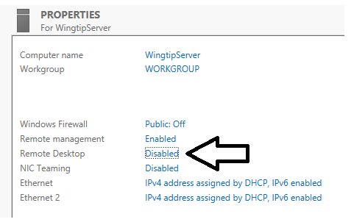

* 1. Click on the **Remote Desktop** property value of **Disabled.** This willdisplay the **Remote** tab of the **System Properties** dialog.
     1. Select the radio button option **Allow for remote connections to this computer**.
     2. Check **Allow connections only from computers running Remote Desktop with Network Level Authentication**.
     3. Click **OK** to save changes and dismiss the **System Properties** dialog.

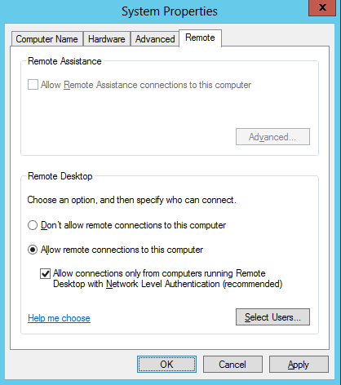

1. Configure the local **Administrators** account so the password never expires.
   1. Navigate to the **Properties for WingtipServer** section of **Server Manager** > **Local Server**.
   2. Look at the top-right corner of the **Properties for WingtipServer** section and locate the **Tasks** menu. Drop down the **Tasks** menu and select the **Computer Management** menu command to display the Windows server **Computer Management** utility.

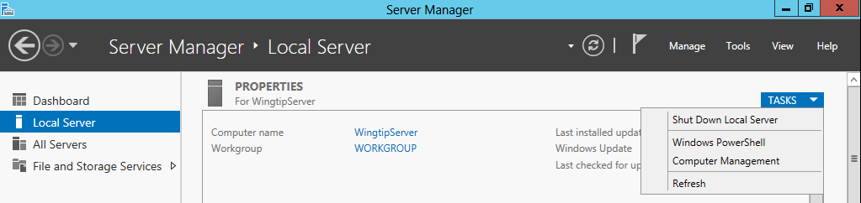

* 1. When the **Computer Management** utility appears, you can see that it provides a tree view control of nodes that represent various configurable components and services on the local machine. Within this collection of nodes, you should be able to locate the **Local Users and Groups** node.

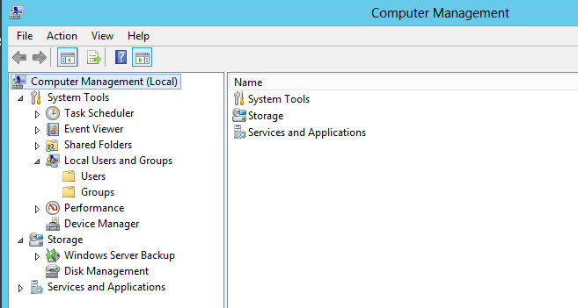

* 1. Navigate to **Local Users and Groups 🡪** **Users** and locate the local **Administrator** account.
  2. Right-click on the **Administrator** account and click **Properties**.

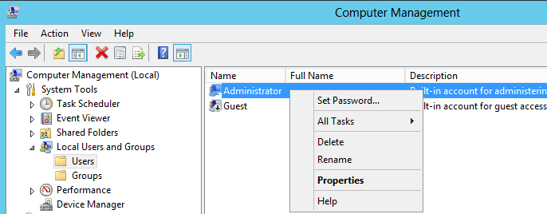

* 1. In the **Administrator Properties** dialog, select the option for **Password never expires**.

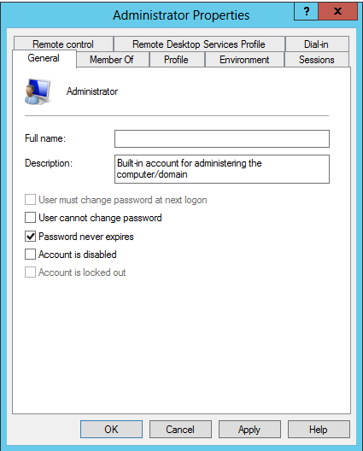

* 1. Click **OK** to save your changes and close the **Administrator Properties** dialog.
  2. Return to the **Local Server** page of the **Server Manager**.

1. Rename the two network connections so you can tell them apart.
   1. Press the **Windows** key on the keyboard to bring up the Windows Server 2012 **Start page**.
   2. Your **Start page** should appear as the one shown below.

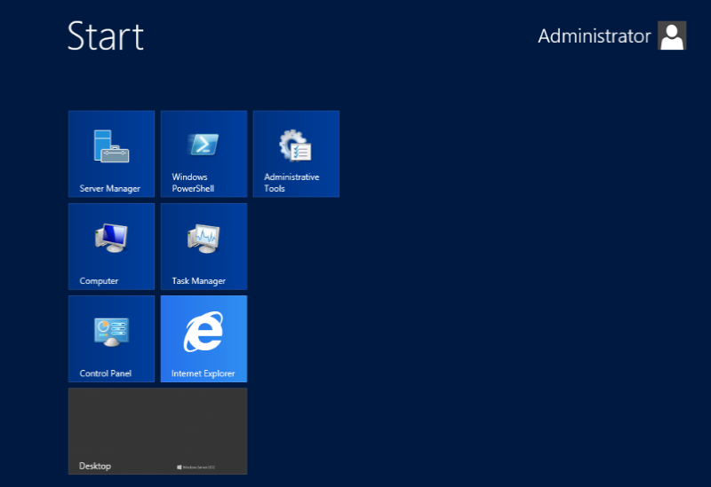

* 1. With the **Start page** showing, go to the keyboard and type in **"View Network Connections"**. Click on the **Settings** link on the right as shown in the following screenshot. You should see that Windows found the **View network connections** page. Click on **View network connections** to navigate to that page.

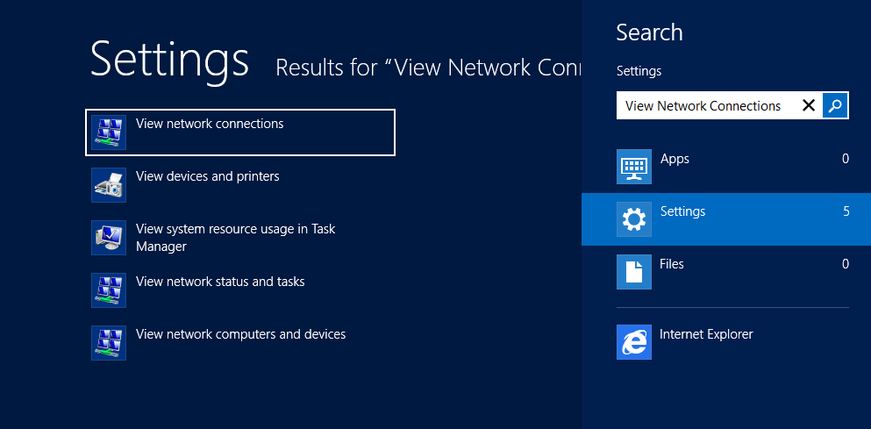

* 1. On the **View network connections** page, you should see that the VM has two network connections. You should also be able to see that one of them is connected and the other one with the big red X is disconnected.

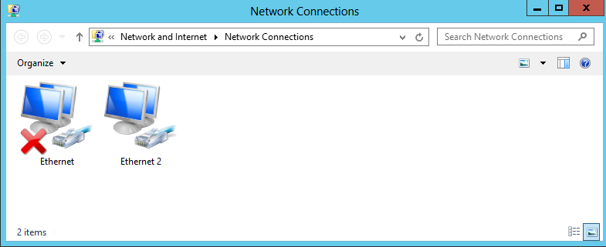

The network connection which is connected is based on network adapter for the VM which is assigned to the virtual switch named **Internal**. The other network connection which is disconnected (e.g. unplugged) has a network adapter that is not currently assigned to a virtual switch. The reason we had you leave the second network adapter unassigned earlier in the setup guide is that it makes it easier to see which network connection is which when initially configuring the VM.

* 1. Right-click the network connection which is connected and select **Rename**. Give it a name of **Internal**.
  2. Right-click the network connection which is disconnected and select **Rename**. Give it a name of **External**.

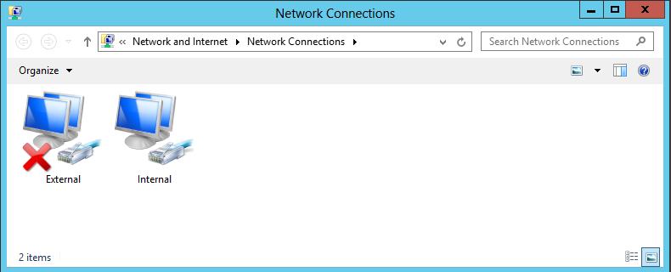

1. Configure a static IP address on **Internal** network connection.
   1. Right-click the **Internal** network connection and select **Properties**.
   2. Uncheck the item **Internet Protocol Version 6 (TCP/IPv6)**
   3. In the **Internal Properties** dialog, select the **Internet Protocol Version 4 (TCP/IPv4)** item and click **Properties**.

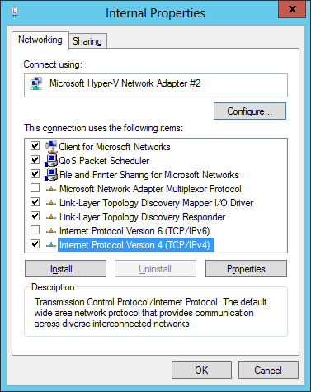

* 1. In the **Internet Protocol Version 4 Properties** dialog, select the option **Use the following IP address** and enter the following configuration settings:
     1. IP Address: 192.168.150.1
     2. Subnet mask: 255.255.255.0
  2. In the **Internet Protocol Version 4 Properties** dialog, select the option **Use the following DNS Server Addresses** and enter the following configuration setting:
     1. Preferred DNS Server: 192.168.150.1

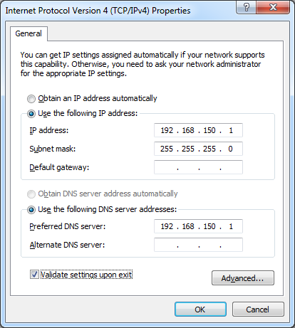

* 1. Click **OK** to accept the IP settings and **Close** the **Internet Protocol Version 4** dialog.

1. Configure the **External** network connection inside the VM to connect to the Internet:
   1. Open the **Network Connections** window if it is not still open using the same steps from the previous step.
   2. Right-click the **External** network connection and select **Properties** to display the **External Properties** dialog.
   3. Uncheck the item **Internet Protocol Version 6 (TCP/IPv6)**
   4. Select the **Internet Protocol Version 4 (TCP/IPv4)** item and click **Properties**.
   5. Enter the following information into the resulting dialog to configure the network connections IP settings:
      1. Select the radio button option **Obtain an IP Address Automatically**
      2. Select the radio button option **Use the following DNS server addresses**.
      3. Set the **Preferred DNS Server** to **127.0.0.1**.
      4. Set the **Alternate DNS Server** to **4.2.2.4**.

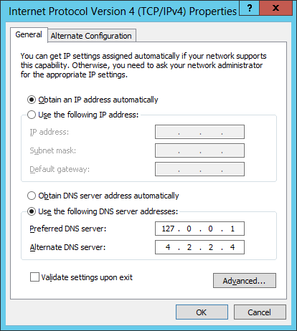

* 1. Click **OK** to accept the IP settings and **Close** the **Internet Protocol Version 4** dialog.

Setting the DNS server addresses for the **External** network connection is important. These settings will ensure that the VM always looks to its local DNS service first when attempting to resolve an Internet domain name to an IP address. The second IP address of **4.2.2.4** is a well-known address of a DNS server on the Internet. This configuration ensures that the VM will always have a secondary DNS service to look up domains on the Internet that the local DNS service cannot find.

1. Reconfigure the VM's network adapter in Hyper-V to bind it to the **External** virtual switch.
   1. Go back to the host computer and open the Hyper-V Manager.
   2. In the Hyper-V Manager window, right-click the VM named **WingtipServer** and select **Settings**.
   3. Select the second Network Adapter, the one that is not connected.
   4. For the **Virtual switch** setting, select **External** and click **OK**. This will effectively connect the **External** network connection in the **WingtipServer** VM to your local LAN and your local DHCP service.

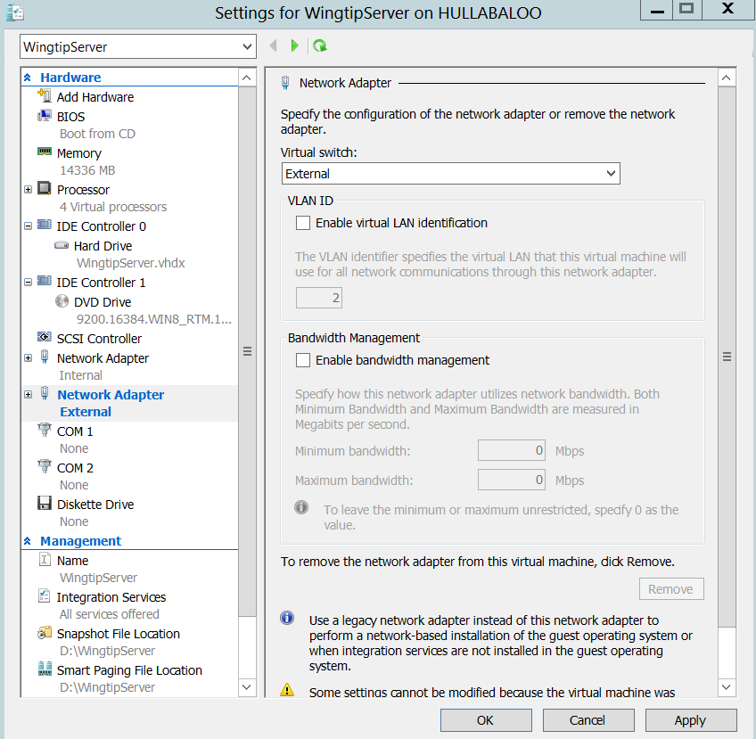

* 1. Return back into the user interface of the **WingtipServer** VM.
  2. Navigate back to the **View network connections** page. You should now see that both network connections show they are connected. In other words, the big red X should have disappeared.

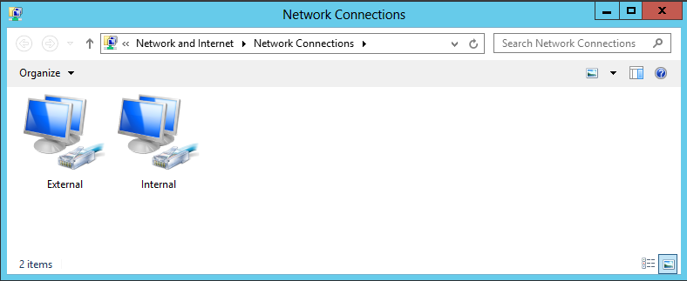

* 1. Refresh the **External** network connection
     1. Select the **External** network connection you just plugged in
     2. With the **External** network connection selected, click the **Disable this Network Device** button in the toolbar.
     3. With the **External** network connection selected, click the **Enable this Network Device** button in the toolbar
     4. When the network connection is re-enabled, Windows uses the **External** network connection to call out to the local DHCP service to acquire an IP address that will make it possible for the **WingtipServer** VM to access the Internet.
     5. Open the Internet Explorer and browse to a site on the Internet such as **http:www.bing.com**. You should be able to browse sites on the Internet without any problems.

1. Run the **ipconfig.exe** utility to verify that the VM's IP addresses have been configured properly.
   1. Press the **Windows** key + **R** key keyboard combination to bring up the Windows **Run** menu.
   2. In the **Run** dialog, type in **cmd** and click **OK** to bring up a standard Windows command prompt.

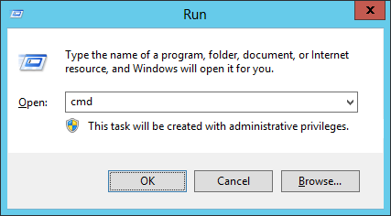

* 1. In the command prompt, run the **ipconfig** command to view the IP addresses that have been assigned to the **WingtipServer** VM. You should be able to verify that that the **Internal** network connection has the static IP address you assigned which is **192.168.150.1**. You should also be able to verify that that the **External** network connection has been assigned a dynamic IP address by your local DHCP service.

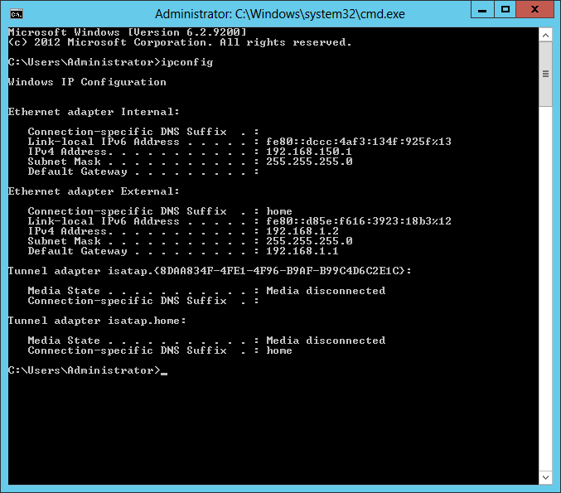

1. Enable the **Windows Server Desktop Experience** feature in the **Wingtip Server** VM.
   1. Open the **Server Manager**; If necessary, Click the **Server Manager Icon** in the lower left corner of the Windows Server 2012 screen.



* 1. On Server Manager in the right side of the dialog box click **Add roles and features** then Click **Next 🡪Next**

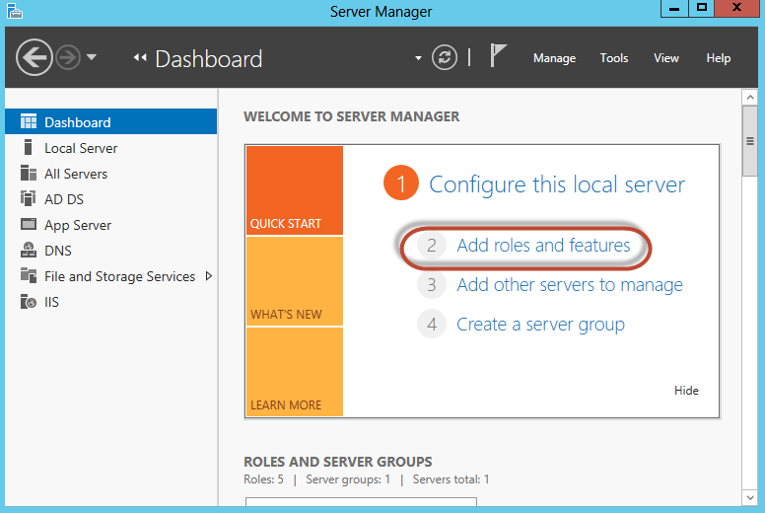

* 1. In the Add Roles and Features Wizard:
     1. Click on **Features** in the left-hand side Select features area
     2. In the Features list expand User interfaces and infrastructure (Installed)
     3. Place a check in **Desktop Experience** and then click **Add Features** to the required features dialog box that appears.

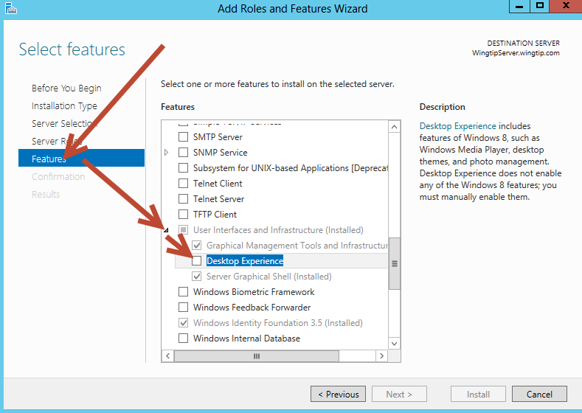

* + 1. Click **Next** then click **Install**
  1. Restart Windows server when prompted:
     1. Windows Keyboard key
     2. **Hover** the mouse in the **bottom right hand corner** of the screen to bring up the “Charm Bar” then click **Settings**.



* + 1. Click Power 🡪 Restart.

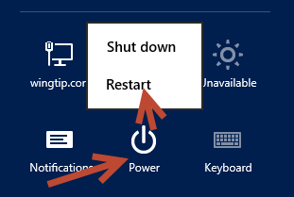

* + 1. When the Server restarts log back in using the same password (**Password1**)

1. Configure the Windows Update settings for the **WingtipServer** VM.
   1. Click on the **Windows** key on the keyboard to bring up the Windows Server 2012 **Start menu**.
   2. With the **Start menu** showing, go to the keyboard and type in **"automatic updating"**. Click on the **Settings** link on the right as shown in the following screenshot. You should see that Windows found the **Turn automatic updating on or off** page. Click on **Turn automatic updating on or off** to navigate to the **Choose your Windows Update settings** page.

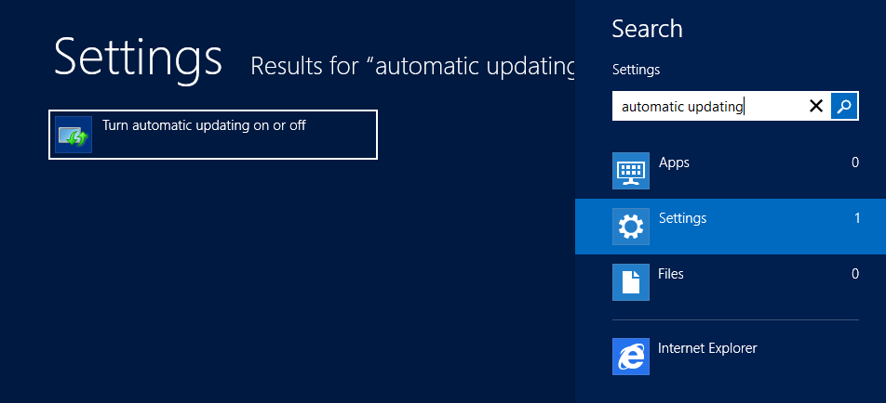

* 1. The **Choose your Windows Update settings** page shown below provides a dropdown menu that allows you to configure how the **WingtipServer** VM will deal with getting Windows Updates. Select the option for **Never check for updates (not recommended)** as shown in the screenshot below and then click **OK** to close the dialog.

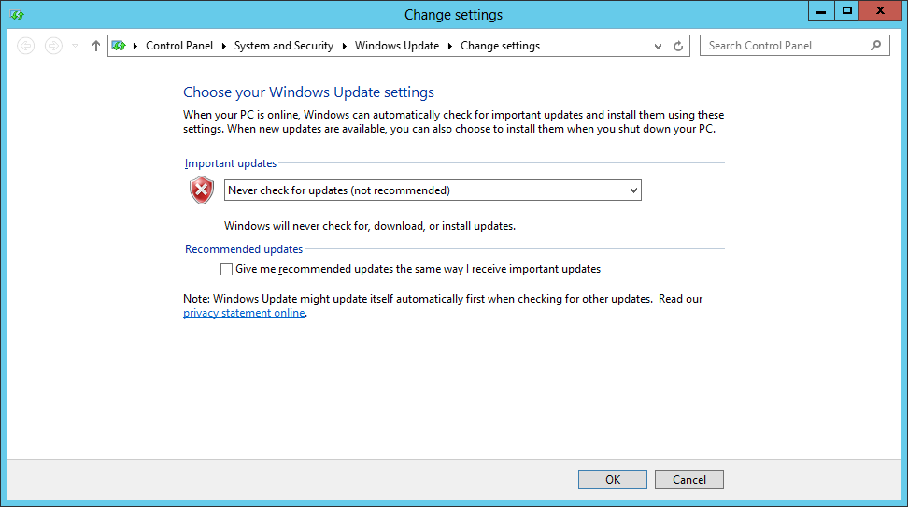

Configuring a computer with a setting of **Never check for updates** isn’t what you should use in a production environment. However, it is usually the good choice for a VM which has been created to provide a lab environment because you don't want to be taken by surprise by Windows updates that change the local computer configuration or interrupt the network connection. Instead of configuring Windows to apply updates automatically, you will now run Windows update manually a single time to apply all the important updates and recommended updates to get the **WingtipServer** VM up to date.

1. Update the **WingtipServer** VM with the latest updates using **Windows Update**
   1. Click on the **Windows** key on the keyboard to bring up the Windows Server 2012 **Start menu**.
   2. With the **Start menu** showing, go to the keyboard and type in **"install updates"**. Click on the **Settings** link on the right as shown in the following screenshot. You should see that Windows found the **Install optional updates** page. Click on **Install optional updates** to navigate to the **Windows Update** page.

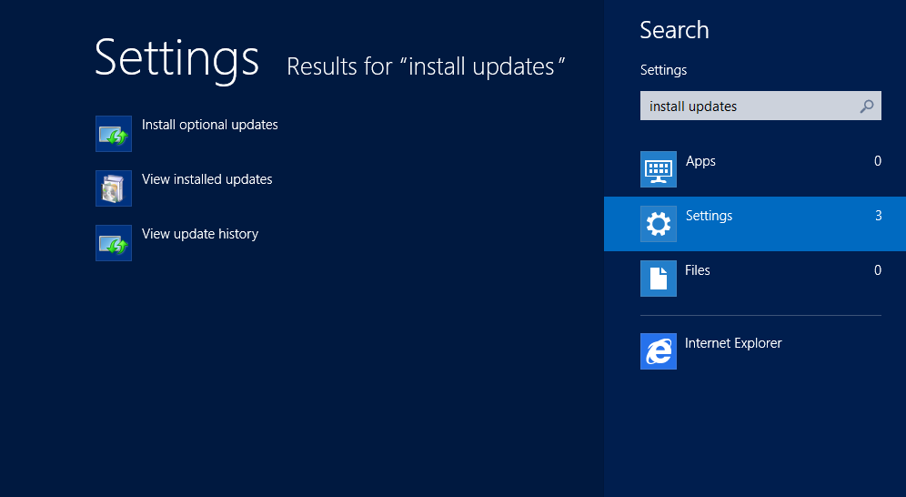

* 1. On the Windows Update page, click the **Check for** **Updates** button. When you click this button, the Windows operating system will communicate with the Windows Update service on the Internet to determine which Windows updates are available for installation.

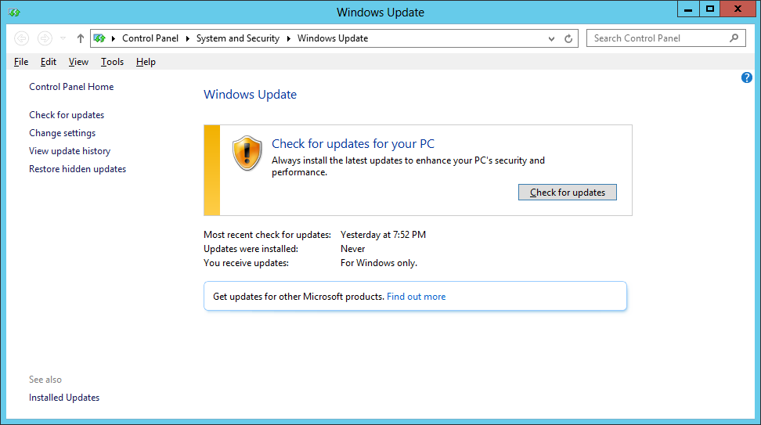

* 1. The **Windows Update** page will prompt you to install any available updates. Click the **Install updates** button to install all important and recommended updates. If you are prompted, select **I accept the license terms** for any updates that require it.

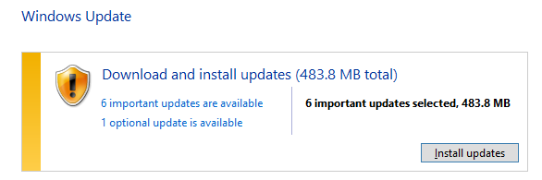

This step can take quite a bit of time so be patient.

* 1. If you are prompted to restart your PC during the Windows Update process, click **Restart now** and wait for the VM to restart. Once the VM restarts, log in as **Administrator** and navigate back to the **Windows update** page as you did earlier in this step by searching for **"install updates"** on the Windows Start page.

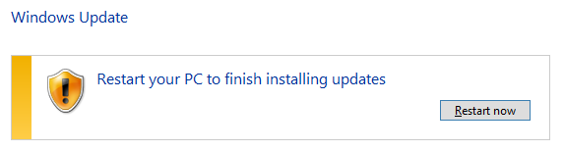

* 1. Once the first round of updates have been installed, click on **Check for updates** button again on the **Windows Update** page. Repeat the process of running Windows Update, checking for updates and installing them (rebooting if required) until the **Windows Update** page reports that **Your PC is up to date** as shown in the following screenshot.

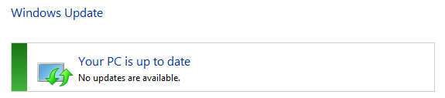

* 1. On you have applied all the important and recommended updates, close the **Windows Update** page.

1. If you have a Windows Server 2012 product key, activate the Windows operating system.
   1. If you are using the trial version of Windows Server 2012, you should skip this step and move ahead to the next step.
   2. Click on the **Windows** key on the keyboard to bring up the Windows Server 2012 **Start menu**.
   3. With the **Start menu** showing, go to the keyboard and type in **"Windows Activation"**. Click on the **Settings** link on the right as shown in the following screenshot. You should see that Windows found the **Windows Activation** page. Click on **Windows Activation** to navigate to the **Windows Activation** page.

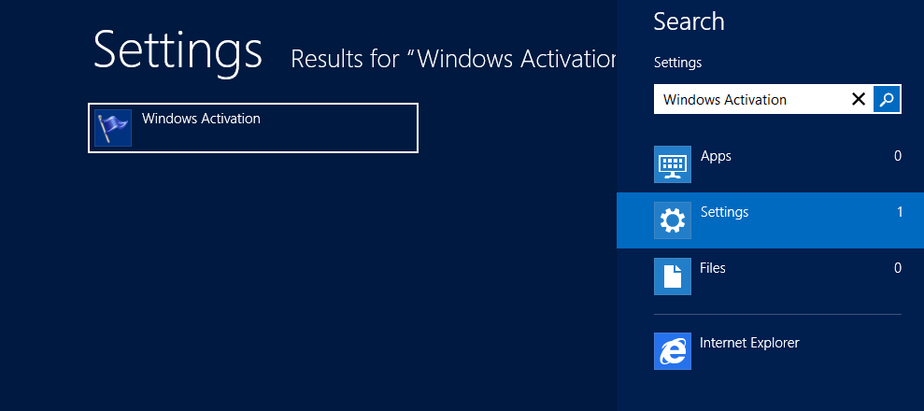

* 1. On the **Windows Activation** page, follow the step to activate your copy of Windows Server 2012.
  2. Once you have activated the Windows operating system, close the **Activate Windows** page.

At this point you have configured the **WingtipServer** VM with a fully updated version of Windows Server 2012. In the next task you will move ahead by configuring the **WingtipServer** VM to act as the Active Directory domain controller.

### Task 5: Install Active Directory Domain Services and Create a new Domain

Now you will promote the **WingtipServer** VM to a domain controller and create a new domain named **wingtip.com**

1. Navigate back to the **Dashboard** page of **Server Manager**.
   1. Press the **Windows** key to display the Windows **Start page**.
   2. Click the **Server Manager** tile to start up and navigate to the **Server Manager**.

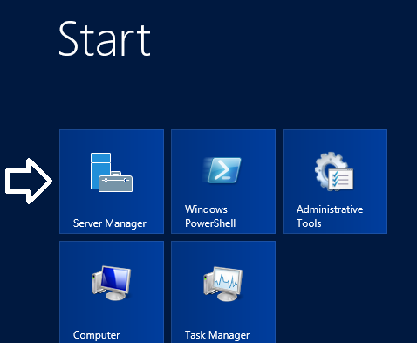

1. You should now be on the **Dashboard** page in the **Server Manager** where you can start the **Add Roles and Features Wizard**.
   1. On the right-hand side of the **Dashboard** page, locate the **Add roles and features** link.
   2. Click the **Add roles and features** link to start the **Add Roles and Features Wizard**.

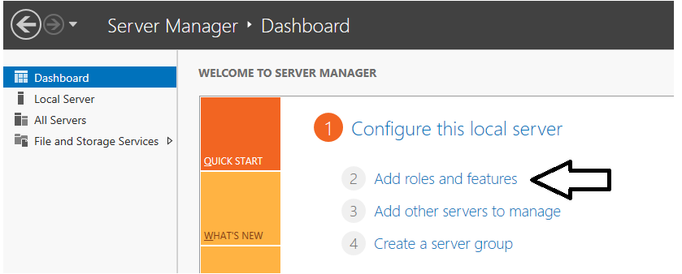

* 1. On the first page of the **Add Roles and Features Wizard**, check the box titled **Skip this page by default** and click **Next**.

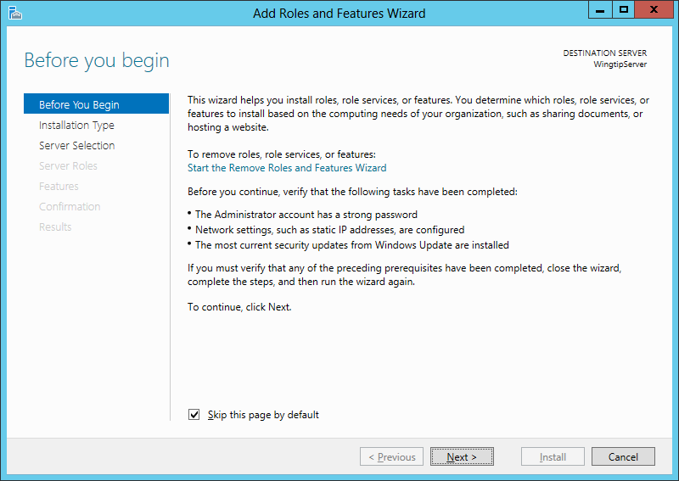

* 1. On the **Select installation type** page of the **Add Roles and Features Wizard**, do the following**:**
     1. Select the option **Role-based or feature-based installation**.
     2. Click **Next** to advance to the next page of the wizard.

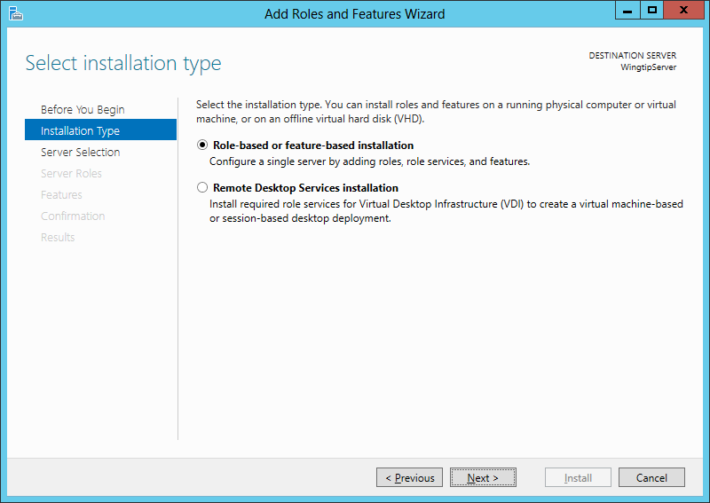

* 1. Do the following on the **Select destination server** page of the **Add Roles and Features Wizard.**
     1. Select the option **Select a server from the server pool**.
     2. Select **WingtipServer** from the **Server Pool**.
     3. Click **Next** to move to the next page.

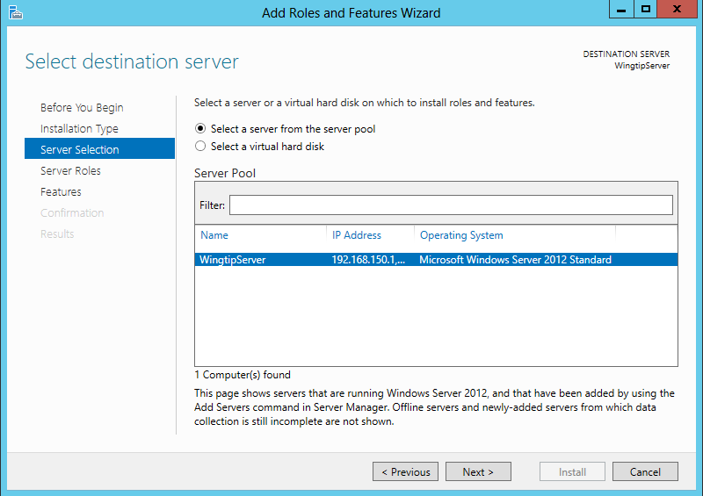

* 1. On the **Select server roles** page, select the role of **Active Directory Domain Services**. When you select this role, the wizard prompts you with the following dialog asking you to confirm you want to add the perquisite features required for this role.

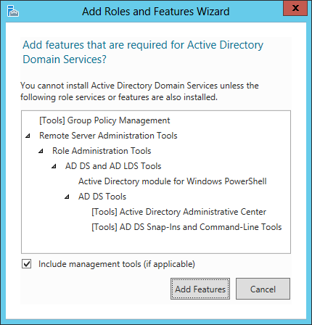

* 1. Respond to this dialog by clicking the **Add Features** button to confirm it is OK to install the perquisite features.
  2. Click **Next** on the **Select server roles** page to move on to the next page of the wizard.

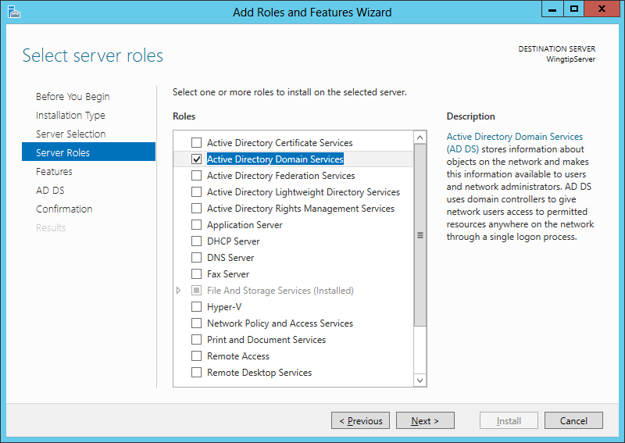

* 1. On the **Select features** page of the **Add Roles and Features Wizard**, make sure .NET Framework 3.5 is selected as shown in the following screenshot. Click **Next** advance to the next page in the wizard.

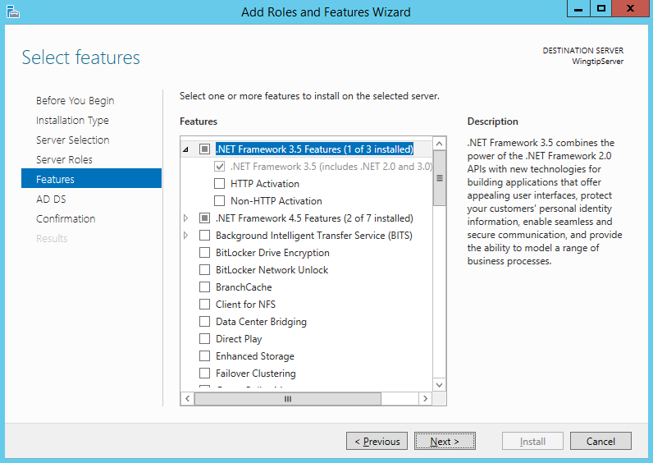

* 1. The next page provided by the wizard displays information about how Active Directory Domain Service will be installed.
     1. Click **Next t**o move to the next page of the wizard**.**
  2. The next page in the **Add Roles and Features Wizard** is the **Confirm installation selections** page. Complete these steps to start the installation of **Active Directory Domain Services**.
     1. Click the checkbox to enable the option **Restart the destination server automatically if required**.
     2. In the **Add Roles and Features Wizard** dialog box, click the **Yes** buttonto confirm you wish to allow automatic restarts.
     3. Click the **Install** button.

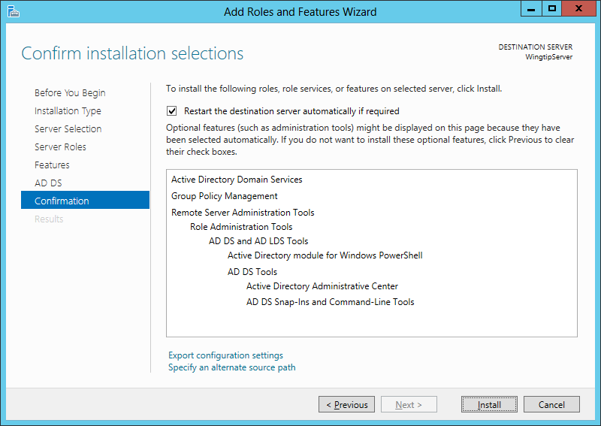

* 1. Installation will take several minutes and you will see its progress in the **Installation progress** page. After **Active Directory Domain Services** have been installed, the wizard displays a **Results** view which should indicate that the installation succeeded but additional configuration is required. Do **not** close the windows for the **Add Roles and Features Wizard** yet. You will need this window to remain open with the **Results** view showing to complete the next step.

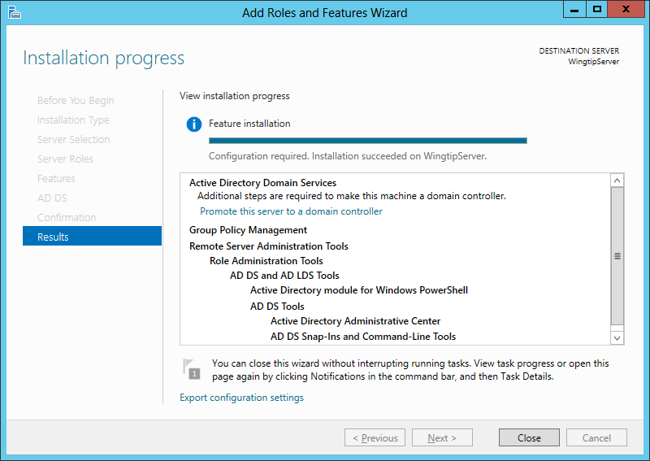

* 1. Look in the **Results** view of the dialog shown above and locate the **Promote this server to a domain controller** link.
  2. Click **Promote this server to a domain controller** to launch the **Active Directory Domain Services Configuration Wizard**.
  3. Move on to the next step to move through the details of using the **Active Directory Domain Services Configuration Wizard**.

With previous versions of Windows Server, you use a utility named **dcpromo.exe** when you need to create new Active Directory domain and to promote a server to be a domain controller. However, the **dcpromo.exe** utility is now deprecated with Windows Server 2012. The **dcrpomo.exe** utility has been replaced by the **Active Directory Domain Services Configuration Wizard** which is part of **Server Manager**.

1. Use the **Active Directory Domain Services Configuration Wizard** to create a new Active Directory domain and promote the **WingtipServer** VM to be a domain controller.  
   (Note: when clicking the **Next** button to advance between screens in this wizard it may take up to several minutes before the next screen becomes functional (due to background configuration from prior screen). Please be patient.
   1. The first page of the **wizard** is the **Deployment Configuration** page.
      1. Select the radio button option **Add a new forest**
      2. Enter a **Root domain name** of **wingtip.com**.
      3. Click **Next** to move to the next page in the wizard.

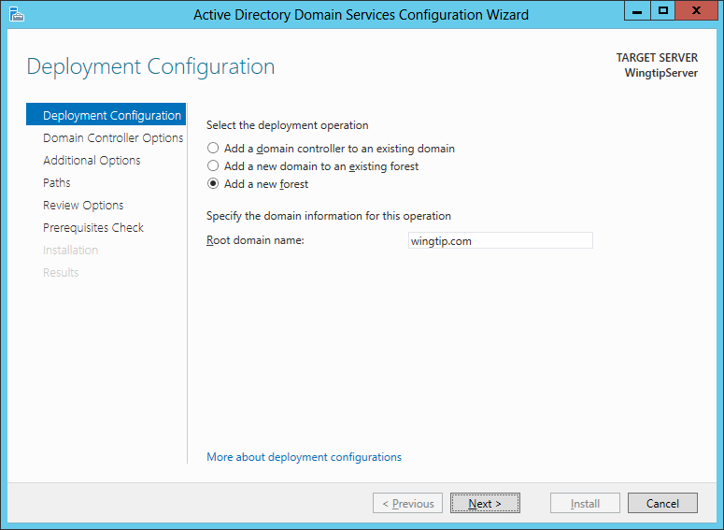

* 1. The next page is the **Domain Controller Options** page:
     1. Leave the default settings for **Forest function level** and **Domain functional level.**
     2. Leave the default settings for checkbox options for **Specify domain controller capabilities**.
     3. Locate the section with the caption **Type the Directory Services Restore Mode (DSRM) password** and type a password of **Password1** in the **Password** textbox and the **Confirm Password** textbox.
     4. Click **Next** to move to the next page.

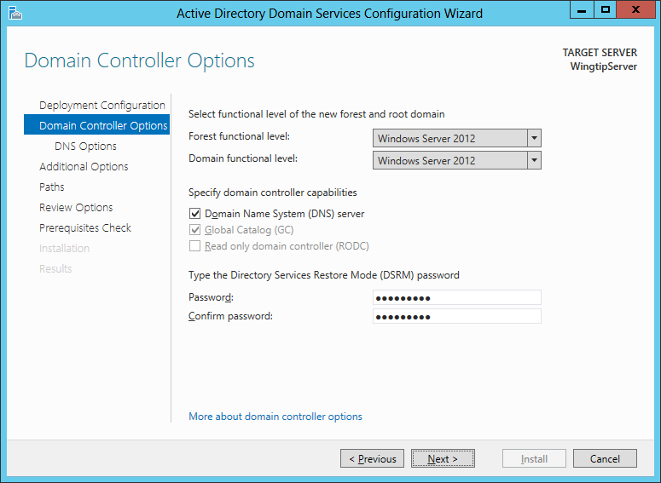

* 1. On the **DNS Options** page of the **Active Directory Domain Service Configuration Wizard** you will be prompted with a warning that Windows cannot find a delegation for this DNS server. You can ignore this warning because you will configure the **WingtipServer** VM to act as a top-level DNS server which needs no delegation. You don't need to do anything on this page other than clicking **Next** to continue to the next page in the wizard.

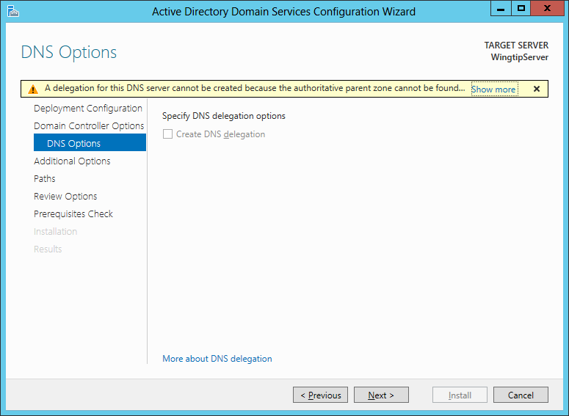

* 1. On the **Additional Options** page you are asked to verify that the NetBIOS domain name is **WINGTIP**.
     1. Accept the default value and click **Next** to continue to the next page in the wizard.

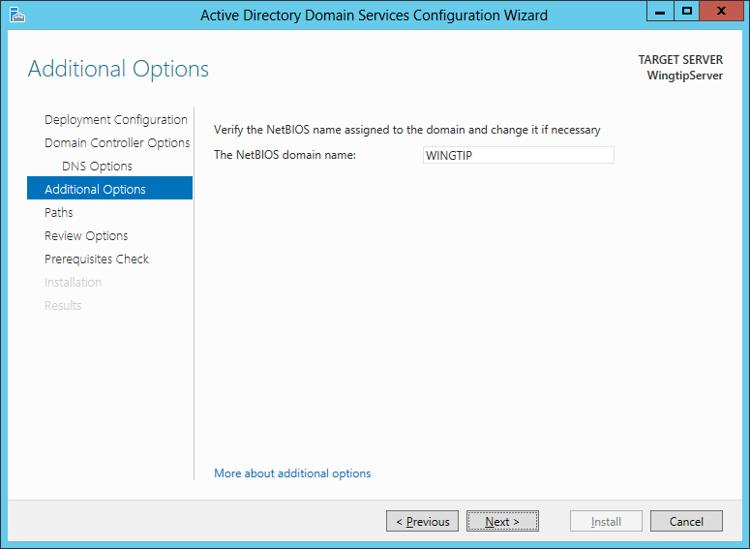

* 1. On the **Paths** page you should accept the default settings and click **Next** to continue to the next page in the wizard.

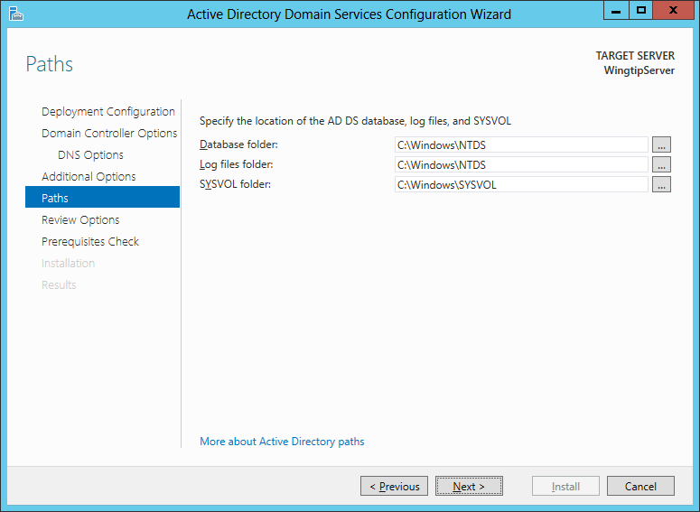

* 1. The **Review Options** page shows the wizard settings you selected. Click **Next** to continue to the next page in the wizard.

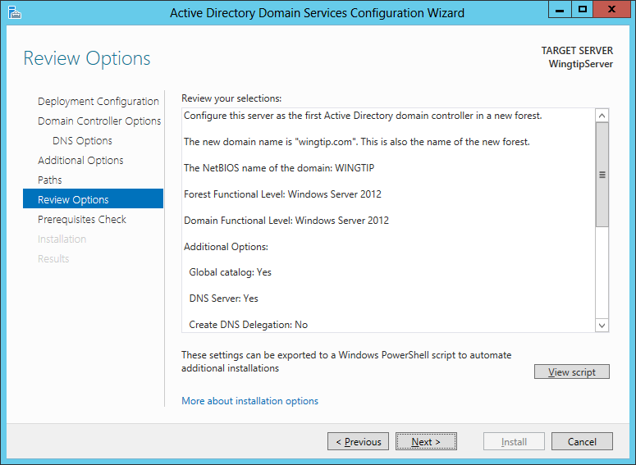

* 1. The last page of the **Active Directory Domain Service Configuration Wizard** is the **Prerequisites Check** page. This page will run a test which takes about minute. The purpose of the test is to verify that the **WingtipServer** VM meets the requirements of a domain controller computer.
  2. After the tests completes, click the **Install** button to begin the process of creating the new Active Directory domain and promoting the **WingtipServer** VM to become a new domain controller.

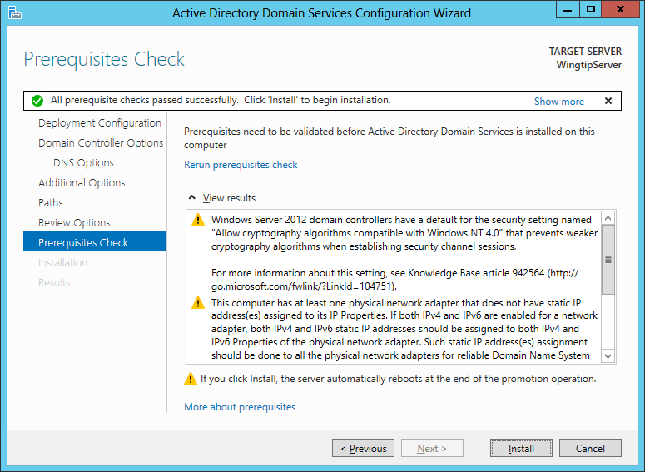

* 1. During the installation process, the **WingtipServer** VM will automatically restart. After the **WingtipServer** VM has restarted, log back in using the domain account **WINGTIP\Administrator**.

1. Launch the **Active Directory Users and Computer** administrative tool.
   1. Click on the **Windows** key to display the **Windows Start** page.
   2. Type **Active Directory** in the **Search** box.
   3. Locate and click on the **Active Directory Users and Computer** tile as shown in the following screenshot.

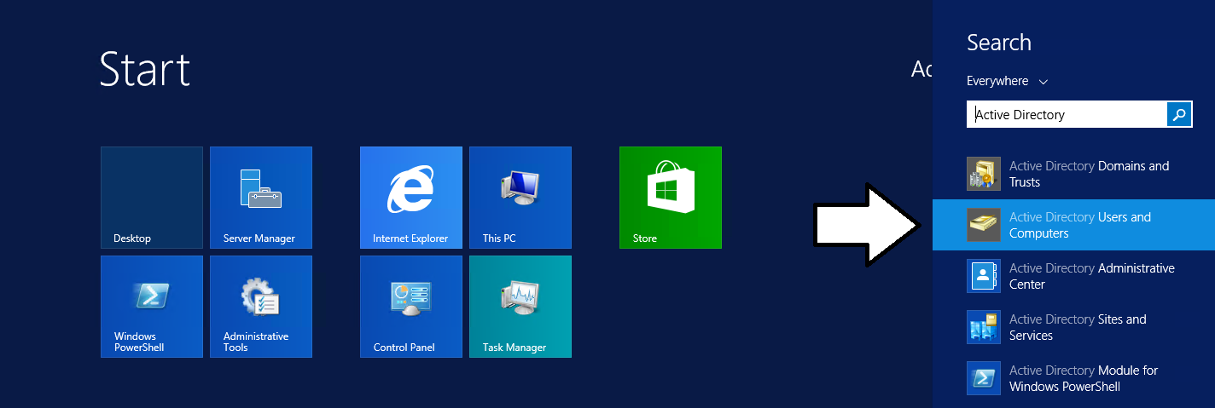

* 1. The **Active Directory Users and Computer** administrative tool should not be started.

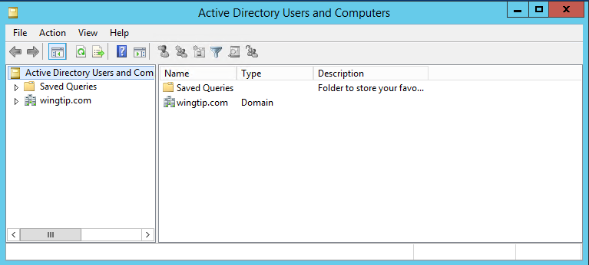

1. Use the **Active Directory Users and Computer** administrative tool to inspect the **wingtip.com** domain
   1. In the **Active Directory Users and Computer** administrative tool, you should see a node for **wingtip.com**.
   2. Expand the **wingtip.com** node and select the **Users** node inside.
   3. You should be able to see all the user and group accounts that Windows automatically adds to a new domain.

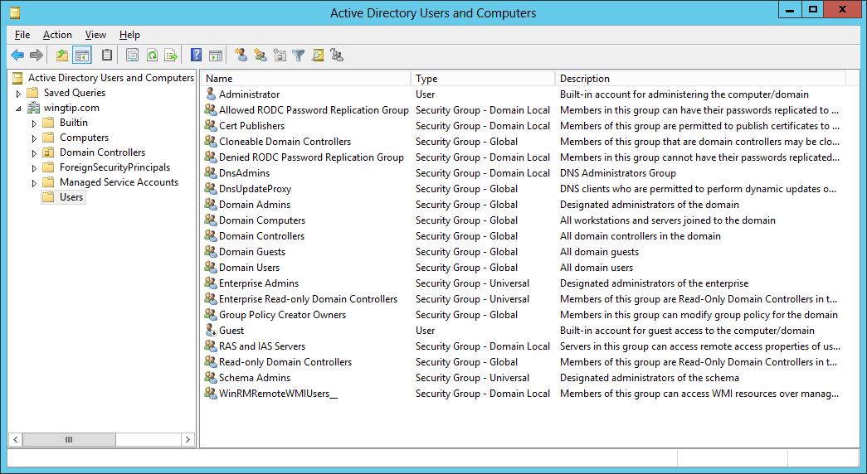

* 1. You have now verified that the **wingtip.com** domain has been properly created and that the **WingtipServer** VM has been promoted to be a domain controller.
  2. Close the **Active Directory Users and Computer** administrative tool.

### Task 6: Install SQL Server 2016 CTP 3.3

You will begin this task by acquiring the installation files and optionally a product key for SQL Server 2016. After that you will move through the basic steps of installing SQL Server 2016 and configuring it for basic usage within a SharePoint 2016 farm.

Note that this version of the setup guide is using the CTP 3.3 prerelease version of SQL Server 2016.

1. Obtain a copy of the 64-bit installation binaries for SQL Server 2016 Community Technology Preview 3.3.
   1. If you need to download the files, you can obtain them from the following link.

https://www.microsoft.com/en-us/evalcenter/evaluate-sql-server-2016

This download is several gigabytes in size so it will take some time to download. The amount of time it takes to download will depend upon the speed of your Internet connection.

1. Navigate to the Hyper-V Manager. Right-click the **WingtipServer** VM and select the **Connect…** command to display the Hyper-V console window for this VM.



1. In this step you will configure the VM to load the .ISO file with the SQL Server 2016 installation files as a DVD drive.
   1. In the Hyper-V console windows for the **WingtipServer** VM, select the **Insert Disk…** command.

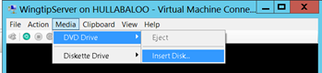

* 1. When the **Open File** dialog appears, enter the path to the .ISO file with the SQL Server 2016 installation files.
  2. Click **OK**.

1. Navigate back into the user interface of the **WingtipServer** VM.
2. Depending on your configuration, the SQL Server installation program in the DVD might or might not start automatically.
   1. If the **AutoPlay** dialog box is open, click run **setup.exe**.
   2. If the **AutoPlay** dialog box is not open, use Windows Explorer to navigate to the DVD drive and execute the **setup.exe** file in the root of the DVD drive.
   3. Wait for the SQL Server installation program to initialize and display the **SQL Server Installation Center** dialog.
3. In the **SQL Server Installation Center** dialog, complete the following steps:
   1. Click the **Installation** link on the left-hand side.
   2. Click the **New SQL Server stand-alone installation or add features to an existing installation link** on the right-hand side.

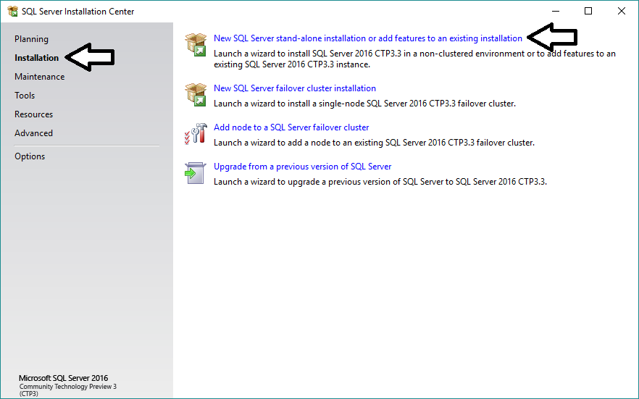

1. On the **Setup Support Rules** page, the installer will check for potential issues before installing.
2. Click **Next** on the **Product Key** page.

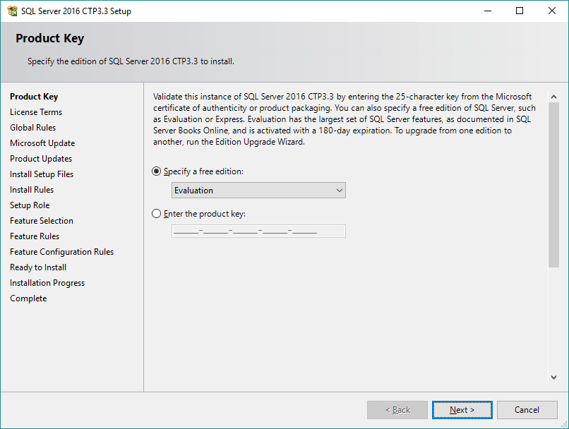

1. On the **License Terms** page, agree to the terms and select **Next**.

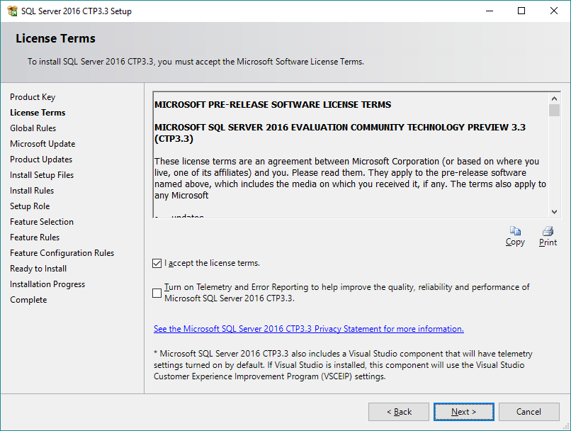

* 1. On the **Microsoft Update** page, unselect **Use Microsoft Update to check for updates** and click **Next**.

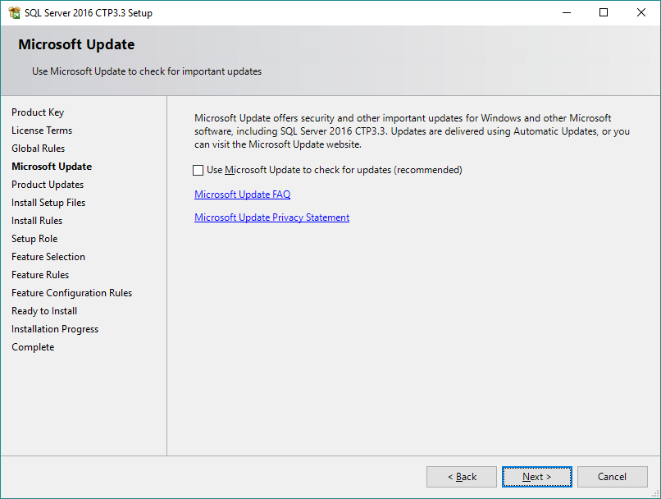

1. On the **Install Rules** page, you should see the test results for a set of setup rules. You should expect to see a single warning indicating that the current machine is a domain controller. All other rules should show success. Click **Next**.

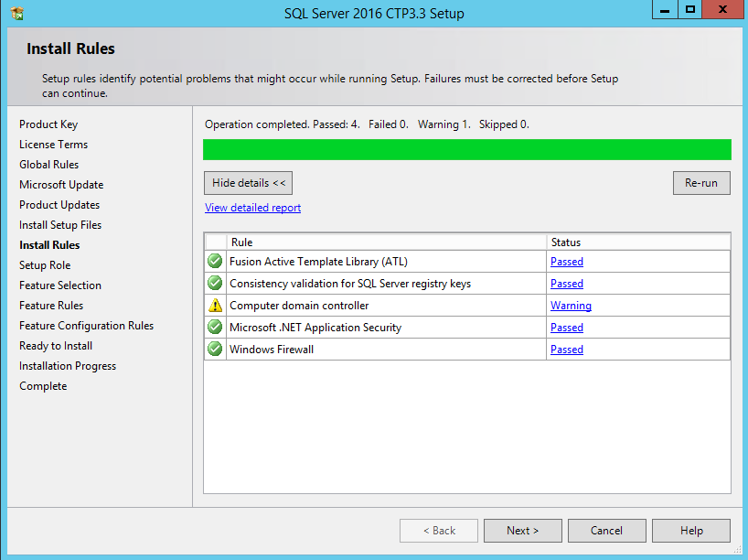

1. On the **Set Role** page, accept the default setting of **SQL Server Feature Installation** and click **Next**.

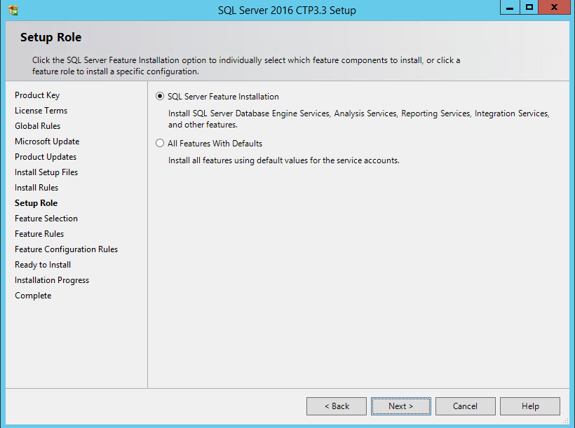

1. On the **Feature Selection** page, check the following options and click **Next**:
   1. Instances Features:
      1. Database Engine Services
      2. Analysis Services
      3. Reporting Services - Native
   2. Shared Features:
      1. SQL Server Data Tools
      2. Management Tools – Basic
      3. Management Tools – Complete

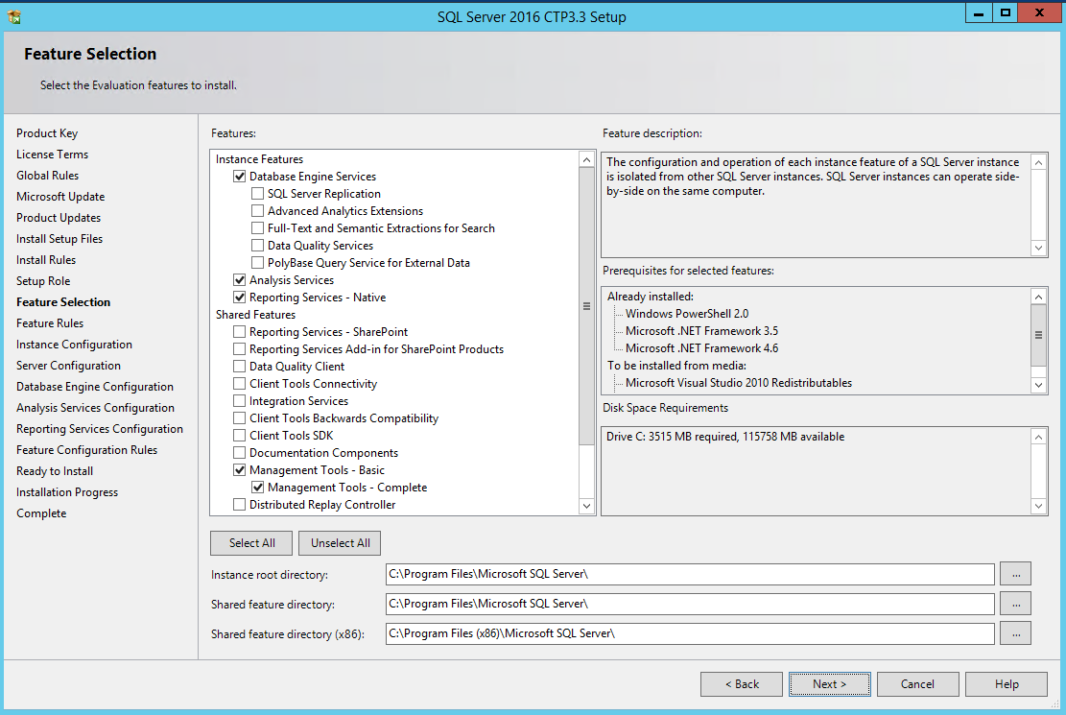

The minimal installation of SQL Server 2016 for SharePoint 2016 only requires the **Database Engine Services**. However, it is recommended that you also install the Management Tools so you have GUI tools to administer SQL Server 2016. Adding in **Analysis Services** and **Reporting Services** is only required when you want to configure and use the Business Intelligence (BI) features of SQL Server 2016 and SharePoint Server 2016.

1. On the **Installation Rules** page, click **Next**.
2. On the **Instance Configuration** page, accept all the default settings and click **Next**.

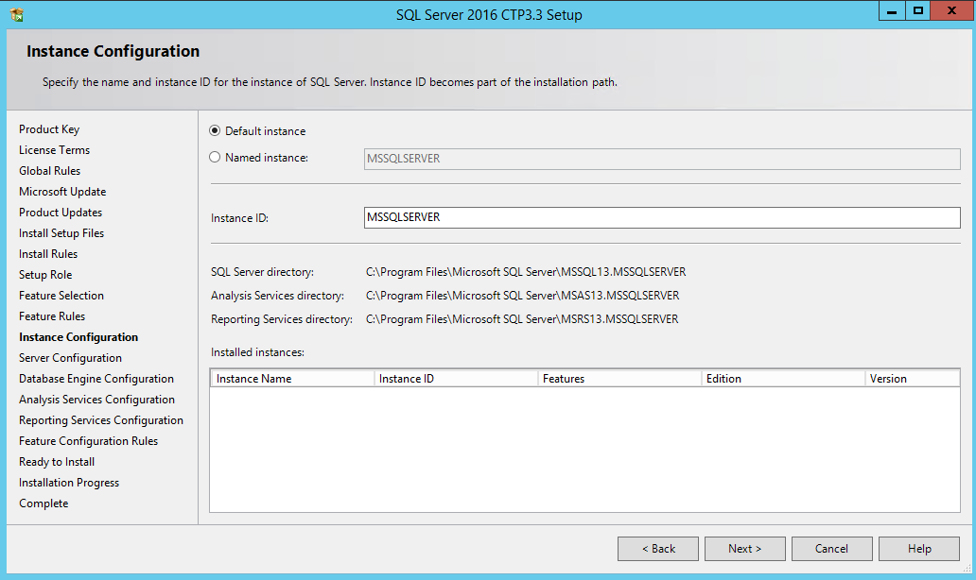

1. On the **Disk Space Requirements** page, click **Next**.
2. On the **Service Account** tab of the **Server Configuration** page, do the following:
   1. Change the **Startup Type** for the **SQL Server Agent** to **Automatic**.
   2. Change the **Account Name** for the **SQL Server Database Engine** to **NT AUTHORITY\SYSTEM**.
   3. Change the **Account Name** for the **SQL Server Analysis Services** to **NT AUTHORITY\SYSTEM**.
   4. Change the **Account Name** for the **SQL Server Reporting Services** to **NT AUTHORITY\SYSTEM**.
   5. Click **Next** to move to the next page.

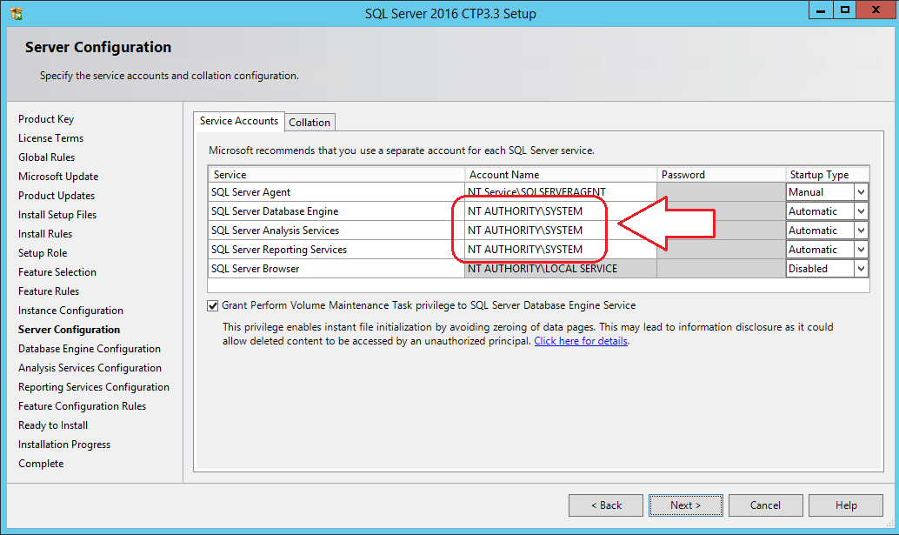

In a real-world installation of SQL Server in a production environment, you should consider using dedicated user accounts to provide the identity for the SQL Server services instead of using the SYSTEM account. This setup guide is using the SYSTEM account for the SQL Server worker processes to simplify the installation of SQL Server which is acceptable in a lab environment.

1. On the **Database Engine Configuration** page, do the following:
   1. On the **Server Configuration** tab, click the **Add Current User** button to configure the **WINGTIP\Administrator** account as a system administrator for this SQL Server instance.

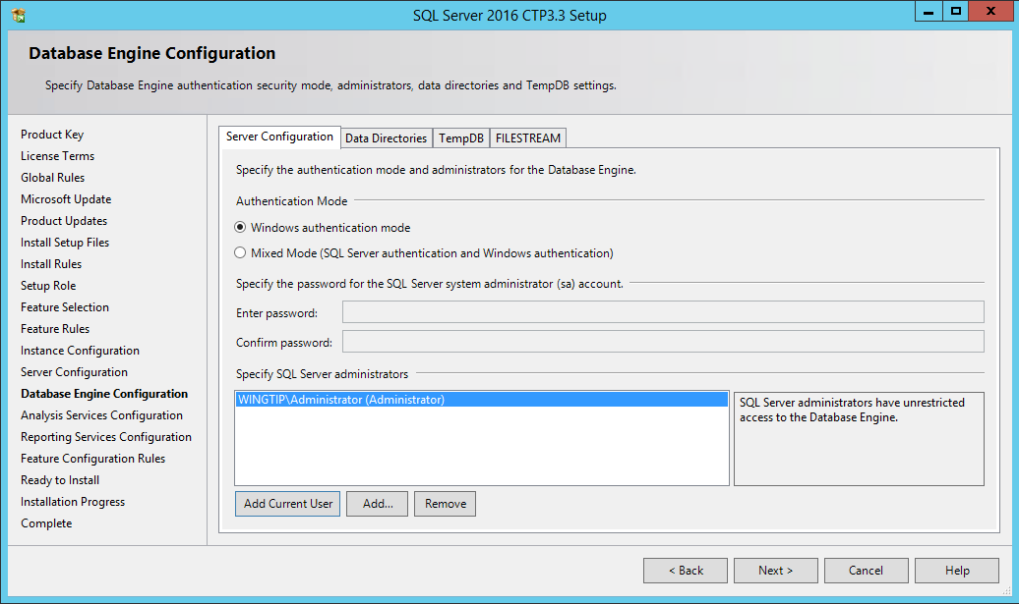

* 1. On the **FILESTREAM** tab, check **Enable FILESTREAM for Transact-SQL access** and also check **Enable FILESTREAM for file I/O access**.

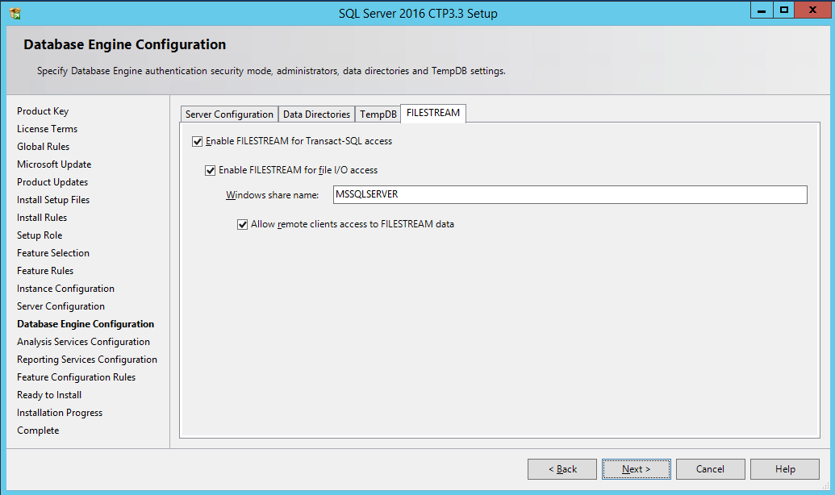

* 1. Click **Next** to move to the next page

1. On the **Server Configuration** tab of the **Analysis Services Configuration** page:
   1. Click **Add Current User** to configure the **WINGTIP\Administrator** account with administrative permissions.
   2. Click **Next** to move ahead to the next page.

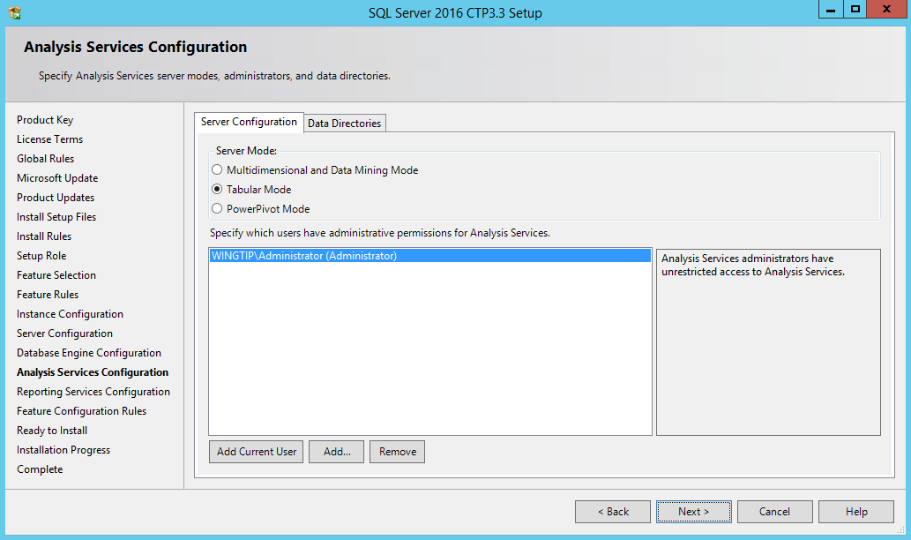

1. On the **Reporting Services Configuration** page, select the **Install Only** option in the **Reporting Service Native Mode** section and click **Next** to move ahead.

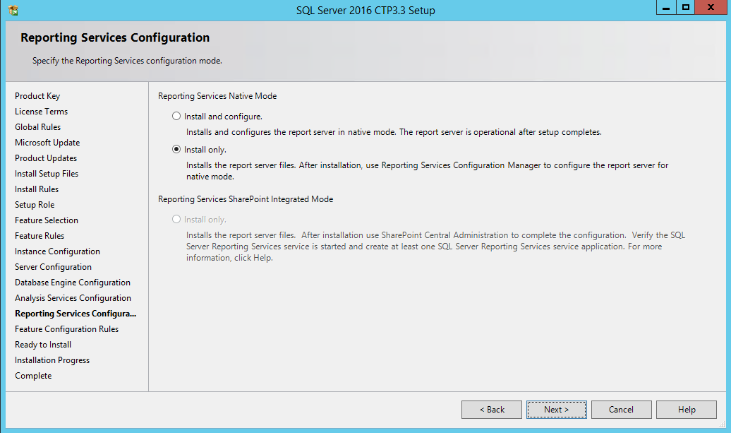

1. On the **Error Reporting** page, accept the default values and click **Next**.
2. On the **Installation Configuration Rules** page, click **Next**.
3. When you get to the **Ready to Install** page, you are finally at the point where you can begin the installation. Click the **Install** button and wait for the SQL Server installation program to complete. This process will likely take about 10-15 minutes to complete.

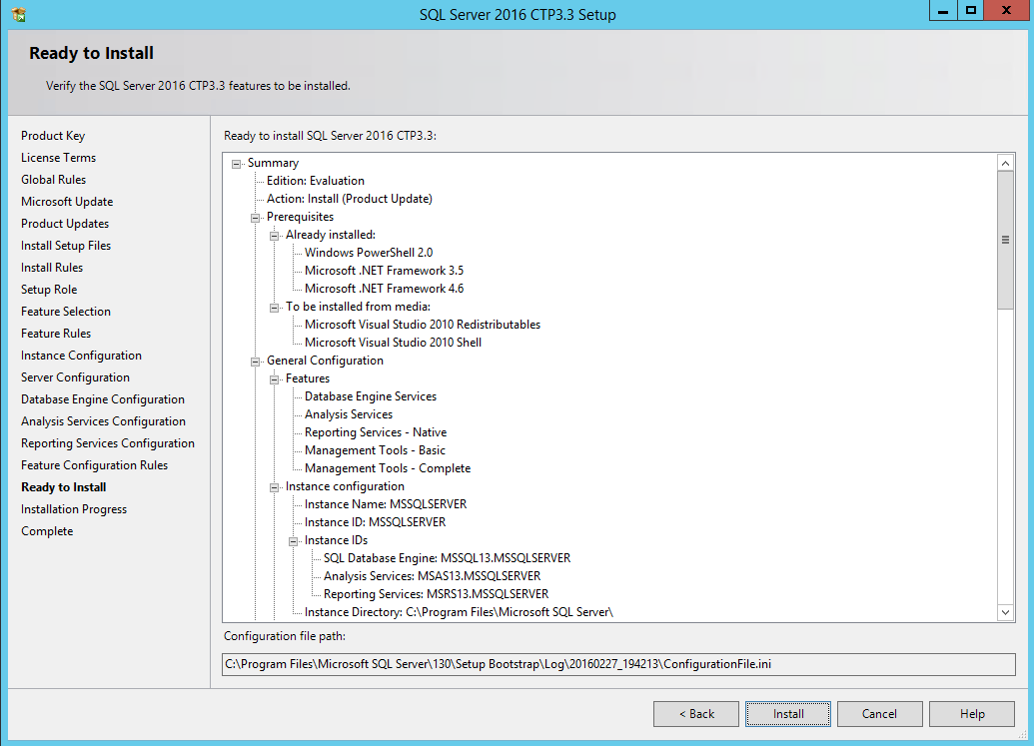

1. When the installation finishes, the **Complete** page is displayed showing the features that were successfully installed.

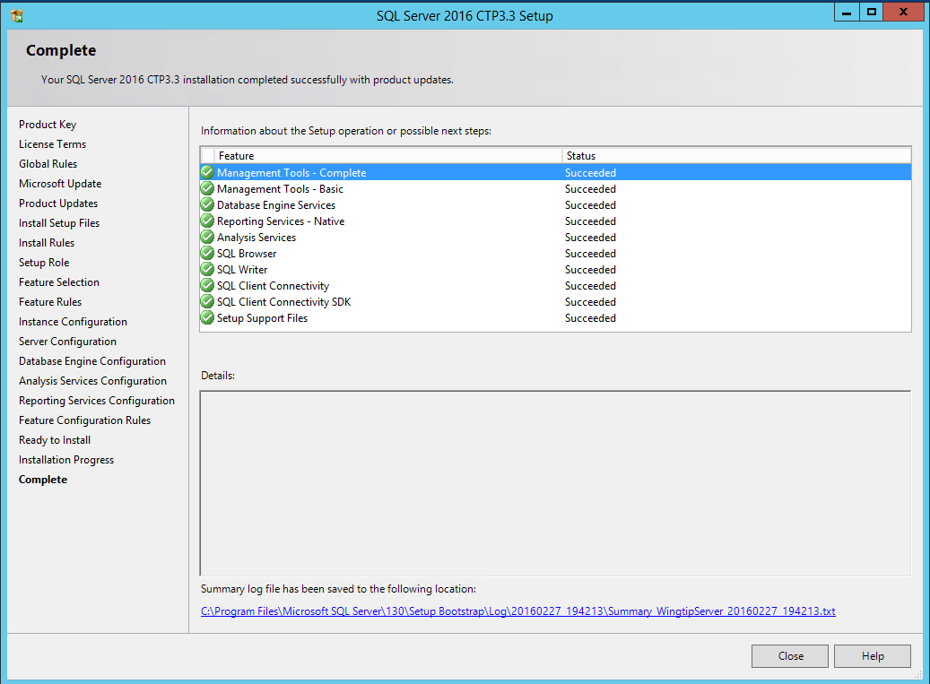

1. Click **Close** to complete the installation.

You have now successfully installed SQL Server 2016 with a default instances for the SQL Server Database Engine, SQL Server Analysis Services and SQL Server Reporting Services. Now you will run the SQL Server

1. Xx

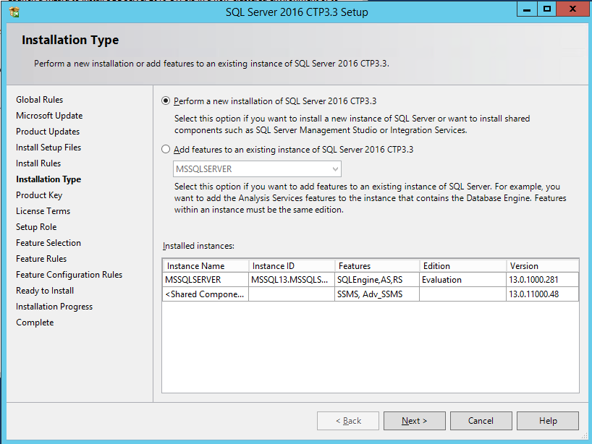

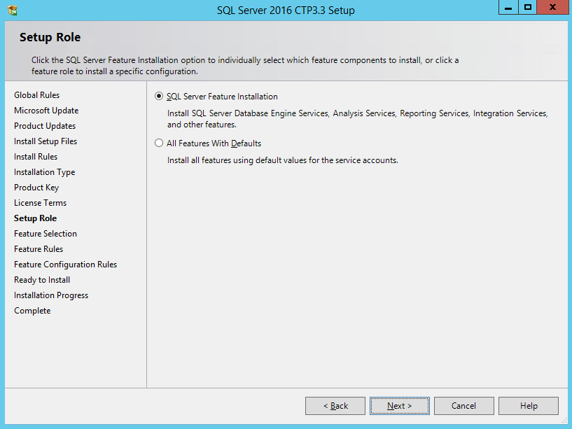

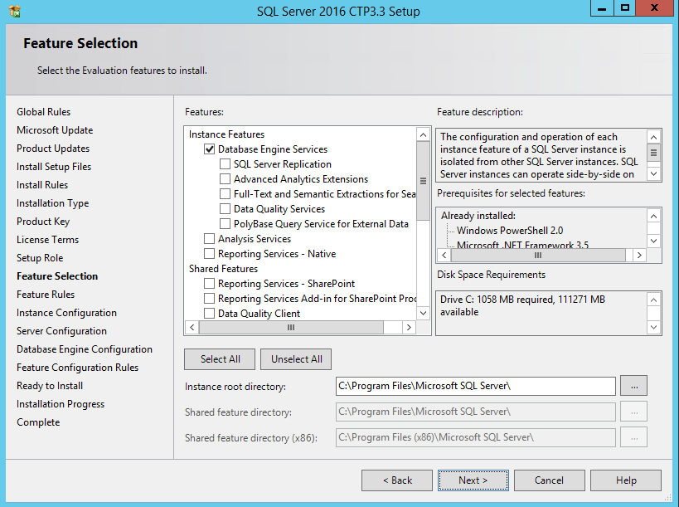

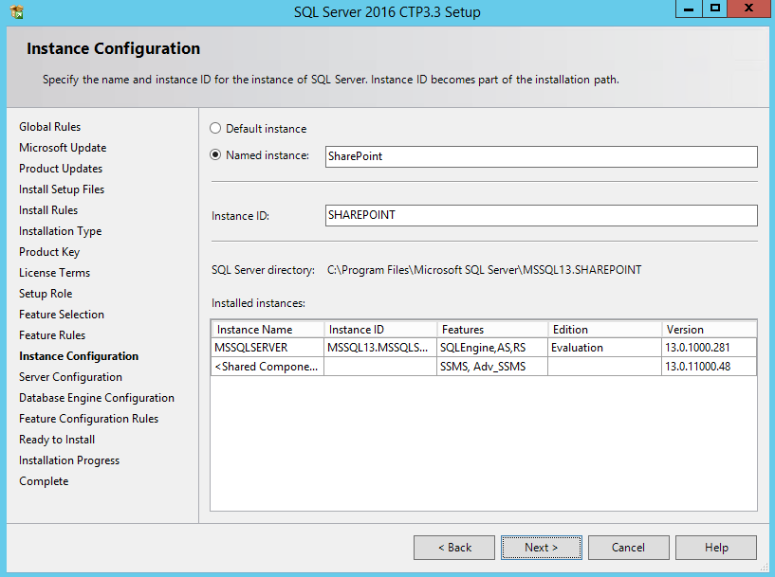

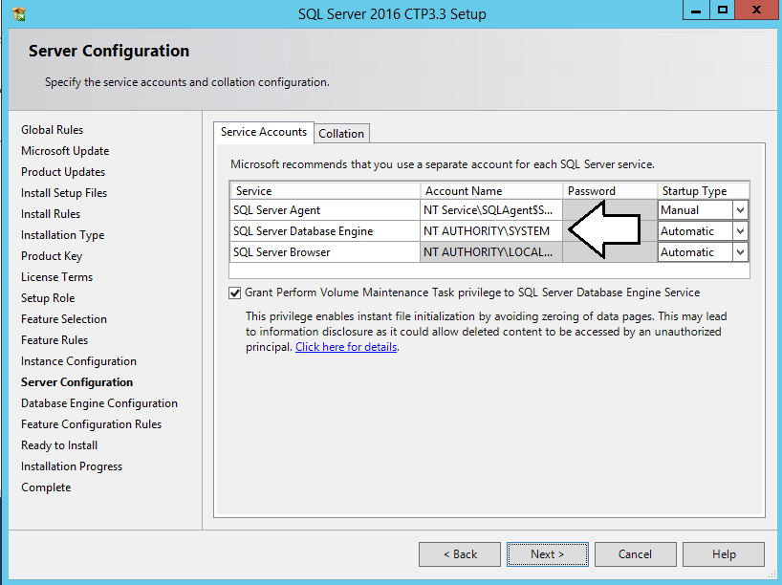

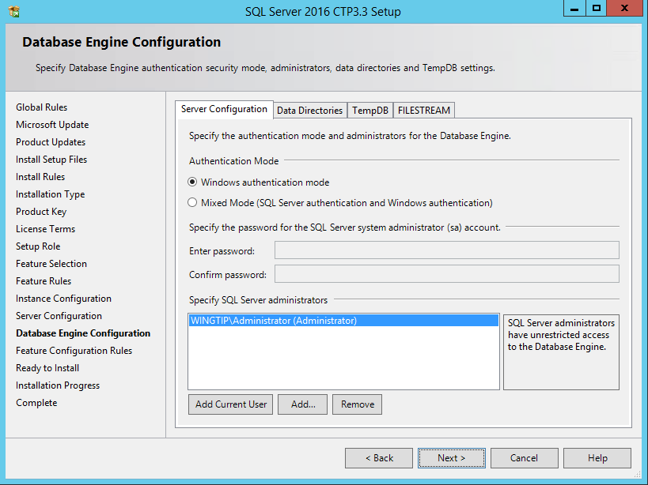

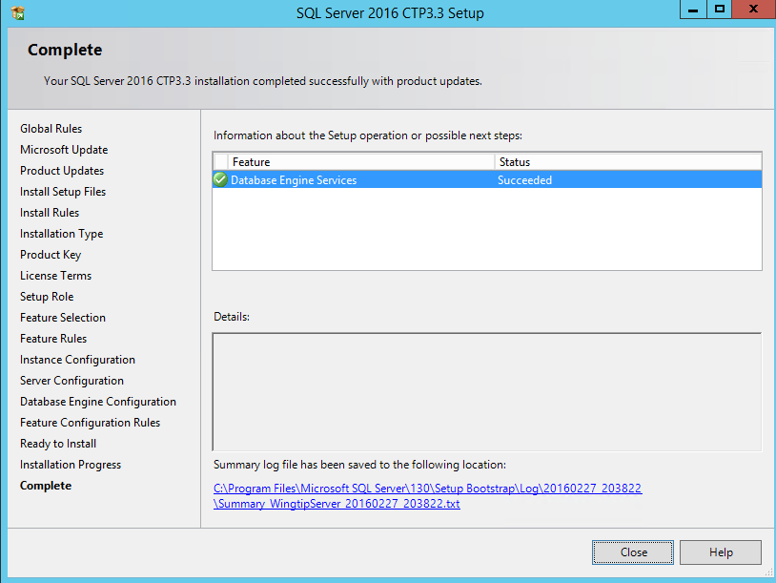

1. Configure the **Named Pipes** protocol using the **SQL Server Configuration Manager**.
   1. Press the **Windows** key to navigate to the Windows Start page.
   2. Locate and click the **SQL Server Configuration** tile to launch the **SQL Server Configuration Manager**.

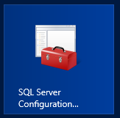

* 1. In the SQL Server Configuration Manager, expand the nodes of the tree view control on the left to the following path.
     1. **SQL Server Configuration Manager** >> **SQL Server Network Configuration** >> **Protocols for MSSQLSERVER**.  
        Note: Make certain to expand **SQL Server Network Configuration** and NOT **SQL Server Network Configuration (32bit).**
     2. On the right-had side, locate the property setting for the **Named Pipes** protocol. This protocol is initially in a disabled state.
     3. Right click on the **Named Pipes** property and select the **Enabled** command.

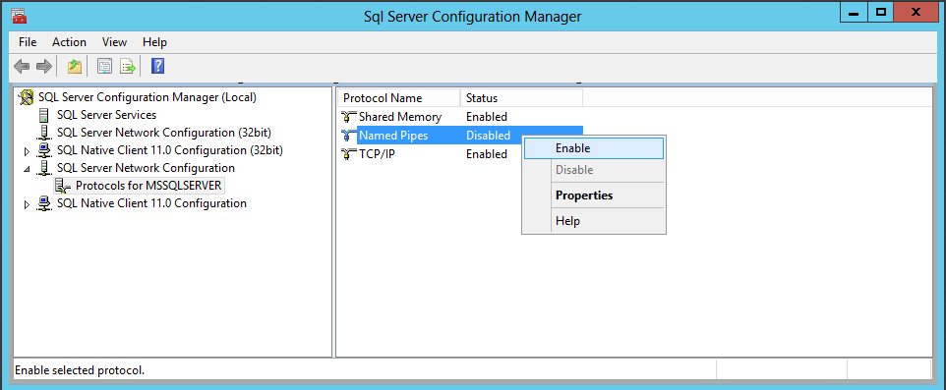

* + 1. Verify that all three protocols are in an enabled state.

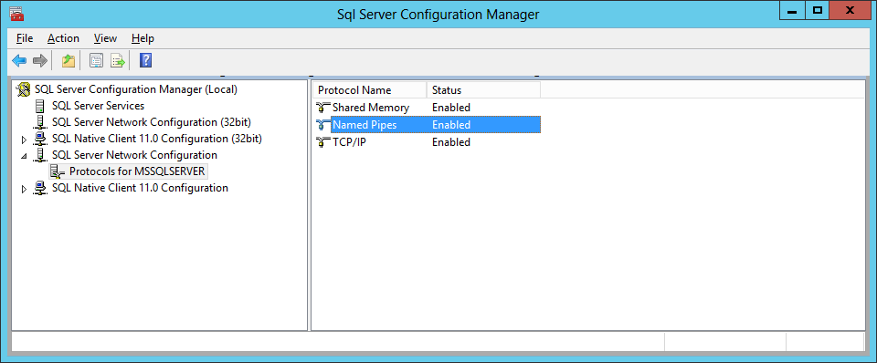

* 1. Close the **SQL Server Configuration Manager**.

1. Connect the **SQL Server Database Engine** using **SQL Server Management Studio**.
   1. Press the **Windows** key to navigate to the Windows Start page.
   2. Locate and click the **SQL Server Management Studio** tile to launch **SQL Server Management Studio**.

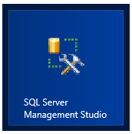

* 1. When you are prompted with the **Connect to Server** dialog, ensure it is filled out as the screenshot below. Click the **Connect** button to connect to the Database Engine where you will be able to see the existing set of databases.

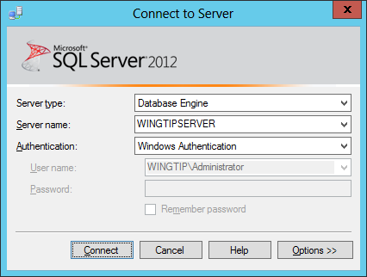

* 1. Once **SQL Server Management Studio** has connected to the **SQL Server Database Engine**, you should see the **Object Explorer** with a tree view control with **WINGTIPSERVER** as its top-level node.
     1. Expand the **Databases** node and then the **System Databases** node.
     2. You should be able to see the system database such as **master** and **tempdb**.
     3. However, there are no user-created databases yet.

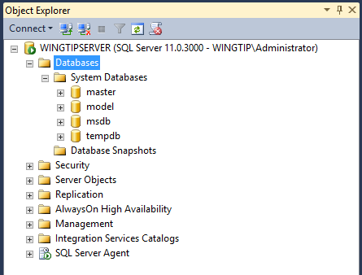

1. Connect to **SQL Server Analysis** in the **SQL Server Management Studio**.
   1. Drop down the **Connect** menu in the **Object Explorer** and select the **Analysis Services…** command.

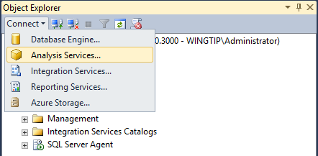

* 1. When you are prompted with the **Connect to Server** dialog, ensure it is filled out as the screenshot below. Click the **Connect** button to connect to **Analysis Services**.

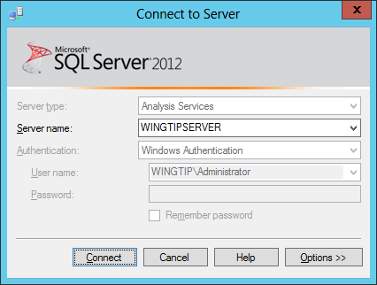

* 1. When you connect to Analysis Services, you will find there are no Analysis Services databases because this is a default installation. However, the **WingtipServer** VM is now prepared to support SQL Server Analysis Services databases if you decide to add them.

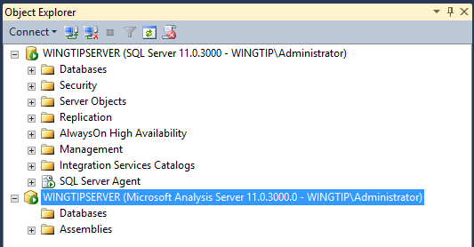

* 1. Close **SQL Server Management Studio**.

1. Next we need to Download the Adventure Works databases:
   1. Navigate to <http://msftdbprodsamples.codeplex.com/releases/view/55330>  
      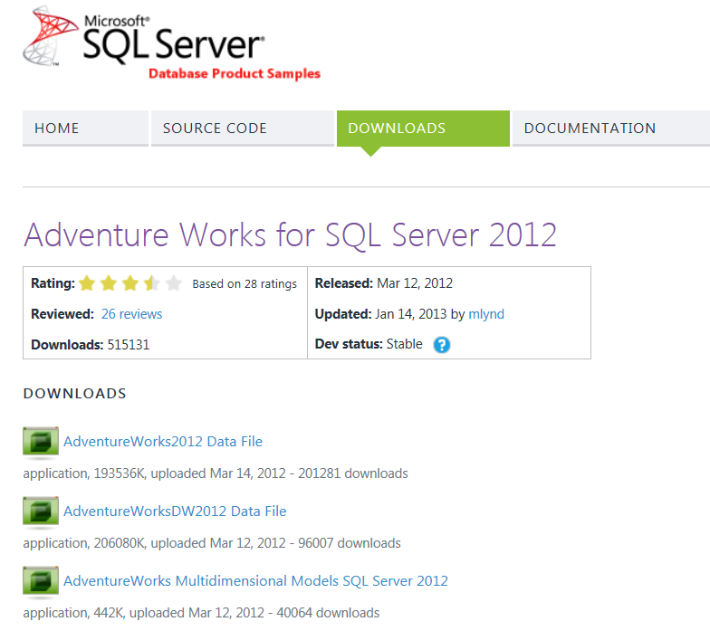
   2. Click on each of the following three files to download these into your image at C:\Install
      1. AdventureWorks2012 Data File
      2. AdventureWorksDW2012 Data File
      3. AdventureWorks Multidimensional Models SQL Server 2012
   3. Move both of the **.MDF** files to the following location

C:\Program Files\Microsoft SQL Server\MSSQL11.MSSQLSERVER\MSSQL\DATA

1. Next let’s install the Adventure Works OLTP database
   1. Press the **Windows** key and type **SQL Server** click on the **SQL Server Management Studio** tile.

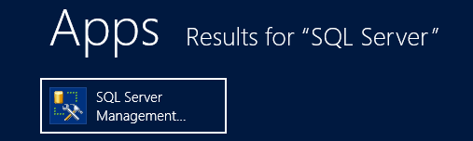

* 1. Connect to the:
     1. Server type: **Database Engine**
     2. Server Name: **WINGTIPSERVER**
     3. Authentication: **Windows Authentication**
     4. Click **Connect.**

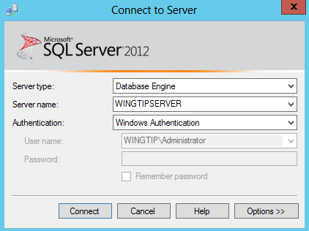

* 1. In the Ribbon click the **New Query** option:

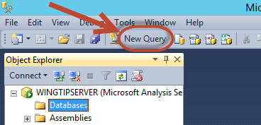

* 1. Enter the following command and then Run this to install the AdventureWorks2012_Data.MDF file  
     (Note: this command needs to be entered all on one line)

CREATE DATABASE AdventureWorks2012 ON (FILENAME =   
'C:\Program Files\Microsoft SQL Server\MSSQL11.MSSQLSERVER\MSSQL\DATA\AdventureWorks2012_Data.mdf')   
FOR ATTACH_REBUILD_LOG;

* + 1. In the Ribbon click **Execute**.
    2. You will receive a message that the Database was upgraded from **version 705 to 706** indicating success:



1. Next let’s install the Adventure Works OLAP database
   1. In the Ribbon click the **New Query** option:



* 1. Enter the following command and then Run this to install the AdventureWorksDW2012_Data.MDF file  
     (Note: this command needs to be entered all on one line)

CREATE DATABASE AdventureWorksDW2012 ON (FILENAME = 'C:\Program Files\Microsoft SQL Server\MSSQL11.MSSQLSERVER\MSSQL\DATA\AdventureWorksDW2012_Data.mdf') FOR ATTACH_REBUILD_LOG;

* + 1. In the Ribbon Click **Execute**
    2. You will receive a message that the log file was created indicating success



1. Give permissions to NT AUTHORITY\SYSTEM account for each of the new databases:
   1. In SQL Server Management Studio, expand the node for **Security**
   2. Expand the node for **Logins**
   3. Locate the account NT AUTHORITY\SYSTEM and right click the account
   4. Select **Properties**
   5. In the **Login Properties** dialog, on the left hand side, click **User Mapping**
   6. For both AdventureWorks2012 and AdventureWorksDW2012 databases, check the boxes under **Map**
   7. In each database, check the box next to **db_owner** and **public**
   8. Click **OK**
2. Now let’s create the Adventure Works Data Warehouse:
   1. In the C:\Install directory double click on the **AdventureWorks Multidimensional Models SQL Server 2012.zip** file
      1. Copy the **AdventureWorks Multidimensional Models SQL Server 2012** folder and paste it in the C:\Install folder location
   2. Press the **Windows** key and type SQL Server Data Tools
      1. Click on the SQL Server Data Tools tile
      2. In the **Choose Default Environment Settings** window select **Business Intelligence Settings** and Click **Start Visual Studio**
   3. On the **Visual Studio 2010 Shell** window select **Open Project…**

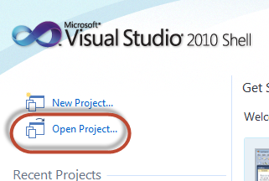

* + 1. Navigate to the **C:\InstalI\AdventureWorks Multidimensional Models SQL Server 2012\Standard** folder:
    2. Double click on the **AdventureWorksDW2012Multidimensional-SE.sln** file
       1. Click **OK** on the Security Warning dialog box
    3. Right Click on the **AdventureWorksDW2012Multidimensional-SE** solution in the Solution Explorer and select **Deploy** from the shortcut menu.

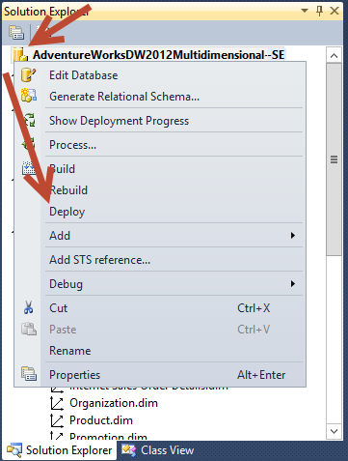

* + 1. Wait for the deployment to finish
       1. You will likely see ~18 warnings which you may ignore
    2. You should see in the bottom right hand corner a green **Deployment Completed Successfully** message when finished.
  1. Close out of all SQL Server windows as you have completed this configuration Task.

You have now successfully installed SQL Server 2012 with Service Pack 1. You are now finished installing and configuring basic software in the **WingtipServer** VM. In the next task, you will download installation files for SharePoint Server 2013 and SharePoint Designer 2013 so these installation files are available on the local hard drive of the **WingtipServer** VM for when it's time to install them later in the setup process.

### ****Task 7: Download the Installation Files Required to install SharePoint Server 2013****

In this task you will download the installation files for **SharePoint Server 2013**, **SharePoint Designer 2013,** and **Fiddler** and make them available on the local hard drive of the **WingtipServer** VM.

1. Create a new directory named **Install** on the **C:\** drive of the **WingtipServer** VM.
   1. Once created, the path to this directory should be **c:\Install**
2. Download the installation files for the trial edition of SharePoint Server 2013.
   1. Go to the SharePoint Server 2013 trial download page at **http://technet.microsoft.com/en-us/evalcenter/hh973397**.
   2. Read the instructions on the page and go through the process of registering for the trial version.
   3. Download the installation file named **SharePointServer_x64_en-us.img** to the **c:\Install** directory.
3. Extract the SharePoint Server 2013 installation files from **SharePointServer_x64_en-us.img**.
   1. Use the Windows Explorer to navigate to the **c:\Install** directory.
   2. Create a new child directory named **SharePointServer2013** at **c:\Install\SharePointServer2013**.
   3. Locate the file named **SharePointServer_x64_en-us.img** in the **c:\Install** directory.
   4. Right-click **SharePointServer_x64_en-us.img** and select the **Mount** command to access the files inside the IMG file in a new window.

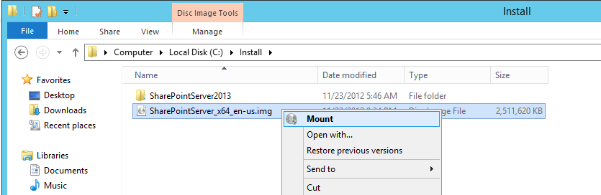

* 1. Look in the new windows and examine the files and folders inside. You should see quite a few folders and files including the main setup program named **setup.exe**.

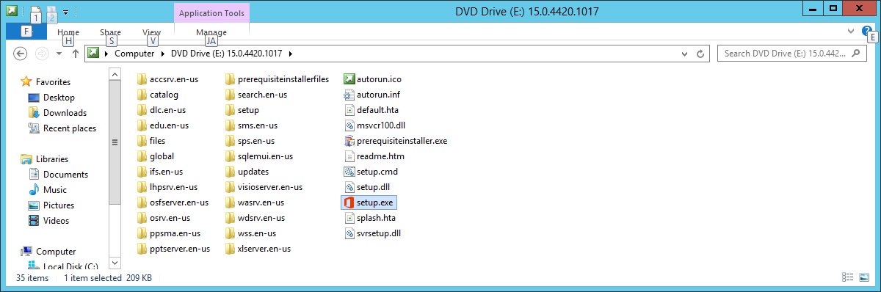

* 1. Copy all the files and folders from the IMG file to the directory at **c:\Install\SharePoint2013**. When you are done, the **C:\Install\SharePointServer2013** directory on the **WingtipServer** VM should look like the one below.

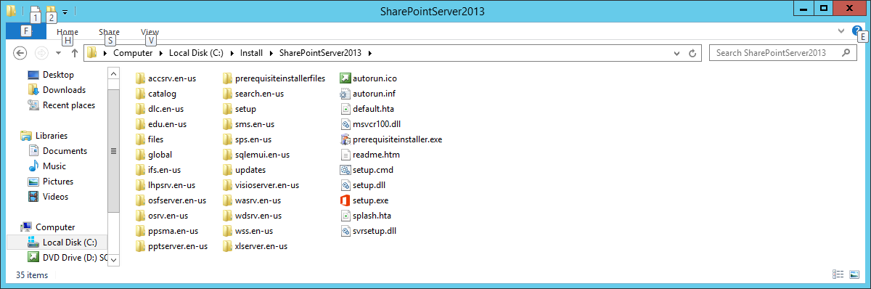

1. Download the installation files **SharePoint 2013 Service Pack 1**. Skip this step if you downloaded a version of SharePoint 2013 which already includes Service Pack 1.
   1. Go to the SharePoint 2013 Service Pack 1 download page at **http://www.microsoft.com/en-us/download/details.aspx?id=42544**.
   2. On the download page, click the **Download** button to download the **officeserversp2013-kb2880552-fullfile-x64-en-us.exe** installation file.
   3. Download the installation file to the **WingtipServer** VM at the path **c:\Install\officeserversp2013-kb2880552-fullfile-x64-en-us.exe**.
   4. Extract the installation files from **officeserversp2013-kb2880552-fullfile-x64-en-us.exe** to create a slipstream install of SharePoint 2013.
      1. Click the PowerShell icon from the taskbar to open a PowerShell console window.

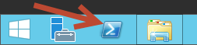

* + 1. Type the following command to extract the contents of the file into the updates folder of the SharePoint 2013 installation folder: **c:\Install\officeserversp2013-kb2880552-fullfile-x64-en-us.exe /extract**.
    2. When prompted, select the following folder to extract the files to: **c:\Install\SharePointServer2013\updates**

1. Download the installation files for **SharePoint Designer 2013**.
   1. Go to the SharePoint Designer 2013 download page at **http://www.microsoft.com/en-us/download/details.aspx?id=35491**.
   2. On the download page, locate the installation file for the 64-bit edition named **sharepointdesigner_64bit.exe**.
   3. Download the installation file to the **WingtipServer** VM at the path **c:\Install\sharepointdesigner_64bit.exe**.
2. Download the installation files for Fiddler2.
   1. Go to the Fiddler2 download page at **http://fiddler2.com/get-fiddler** and select the **Fiddler4** build.
   2. Downloadthe installation file to the **WingtipServer** VM at the path **c:\Install\** **fiddler4setup.exe**

At this point you have downloaded the installation files for SharePoint Server 2013 and SharePoint Designer 2013 and made them available on the local hard drive of the WingtipServer VM.

### **Task 8: Create Service Accounts for SharePoint Server 2013.**

In this task you will configure service accounts and user accounts for SharePoint 2013

1. Copy the setup scripts to your VM.
   1. Locate the zip archive named **VmSetupGuideScripts.zip** that was distributed along with this setup guide.
   2. Extract all files from **VmSetupGuideScripts.zip** to a new folder on the VM at the path **C:\Setup**.
   3. Use the Windows Explorer to verify the files extracted properly and that the **c:\setup** folder looks like the following screenshot.

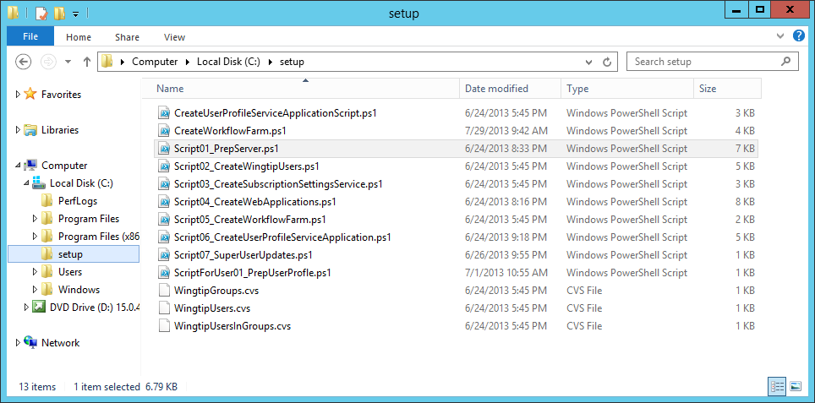

1. Enable the execution of PowerShell scripts.
   1. Launch a PowerShell console window using the **Run as Administrator** command.
   2. Type the following command into the PowerShell console window and press ENTER to execute it.

Set-ExecutionPolicy Bypass

* 1. Confirm your action by typing 'Y' and pressing ENTER.

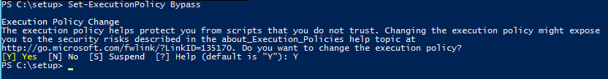

1. Return to the Windows Explorer and navigate to the folder at **C:\Setup**.
2. Right click on the **Script01_PrepServer.ps1** script and select **Run with PowerShell**.
   1. This script will:
      1. Disable the internal loopback check for accessing host header sites
      2. Create a Self-Signed Certificate for use later.
      3. Add a required DNS wildcard A record for *.wingtip.com with IP address of 127.0.0.1
      4. Create the needed SharePoint Service accounts in a new OU
   2. Press ENTER or close the console window when complete
3. **Right Click on the Script02_CreateWingtipUsers and select Run with PowerShell.**
   1. **This script will:**
      1. **Create 3 Groups**
      2. **Create 15 Users**
      3. **Set the Manager for 14 Users**
      4. **Add some users to the three groups created earlier**
   2. Press ENTER or close the console window when complete

### **Task 9: Install SharePoint Server 2016 Prerequisites.**

In this task you will configure service accounts for SharePoint 2013 and then run the SharePoint 2013 Install to prepare the Wingtip Server for SharePoint.

1. Xx

https://www.microsoft.com/en-us/download/details.aspx?id=42883

1. Sss

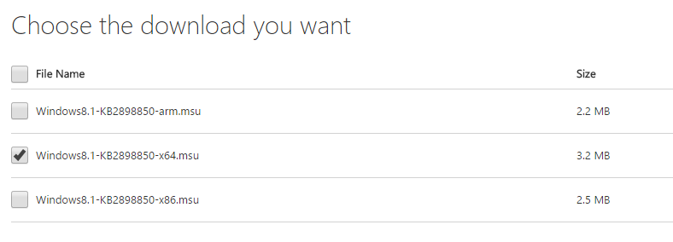

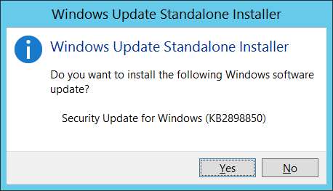

1. Navigate to the directory with the installation files at **C:\Install\SharePointServer2013**. Locate the file named **PrerequisiteInstaller.exe**. Now double-click this file to run Prerequisite Installer**.**

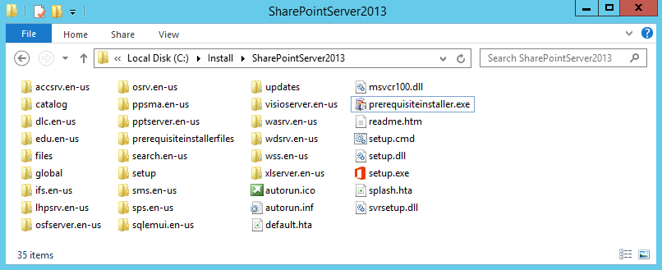

1. Click **Next** at the welcome screen.

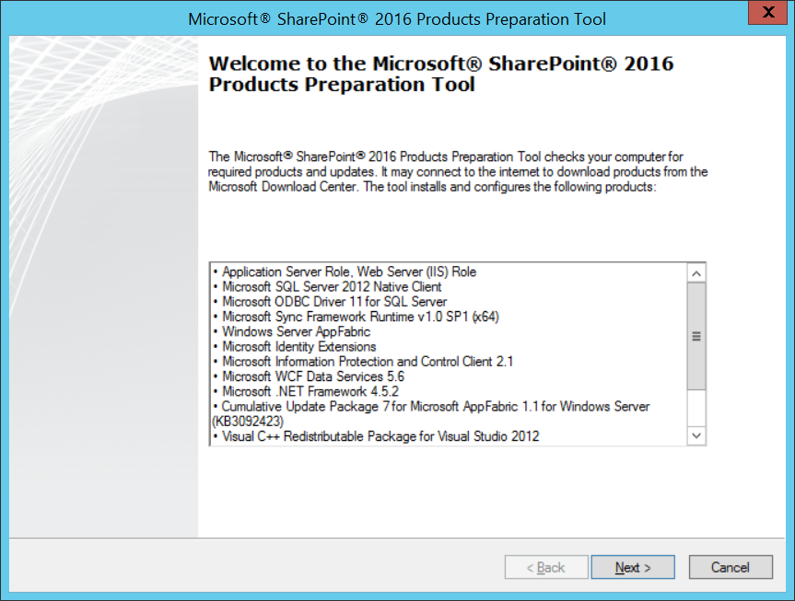

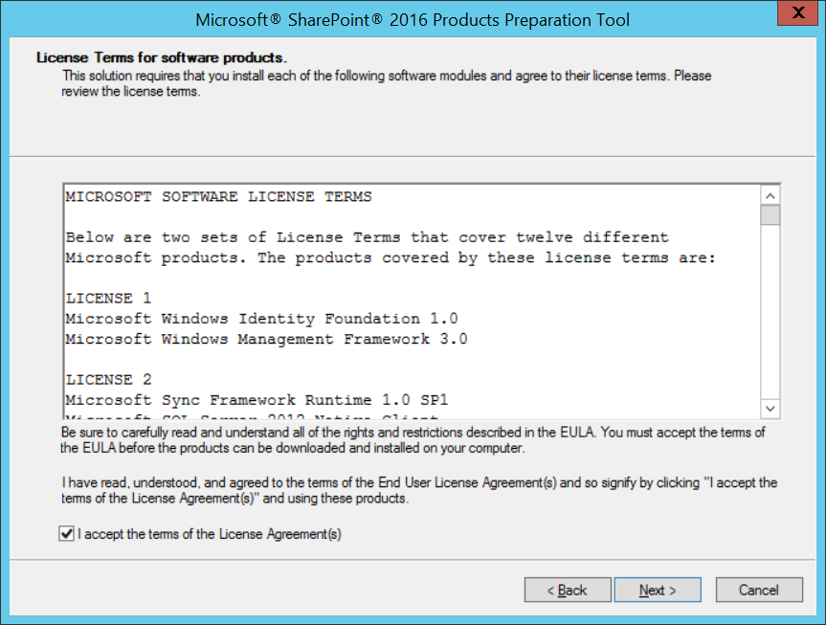

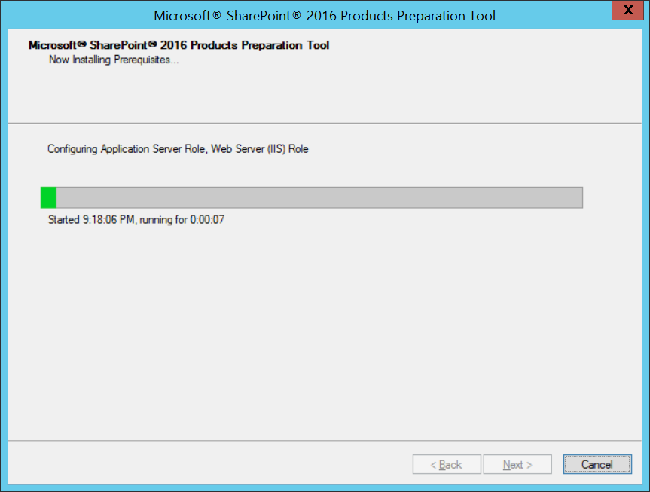

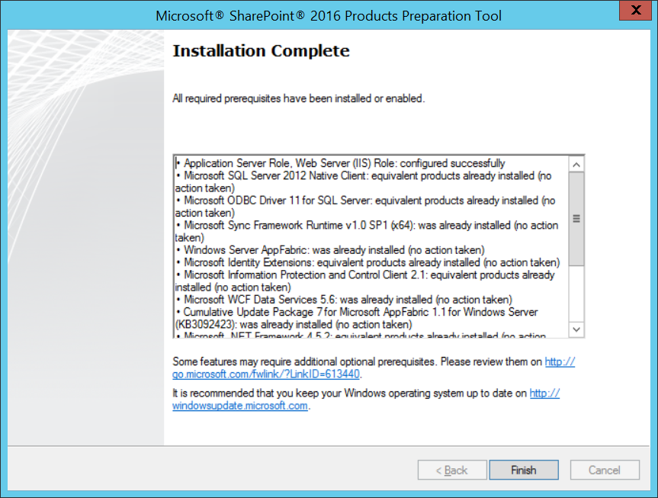

1. Click **Finish**.

At this point all prerequisites required by SharePoint Server 2013 have been installed and any necessary configuration changes have been applied to the server.

### Task 10: Install SharePoint Server 2013 base files

In this section you will install SharePoint Server 2013.

1. Ensure you are logged into the **WingtipServer** VM using the account **WINGTIP\Administrator | Password1**.
2. Navigate to the directory at **C:\Install\SharePointServer2013**. Locate the file named **setup.exe**. Now double-click this file to run the installation program for SharePoint Server 2013.

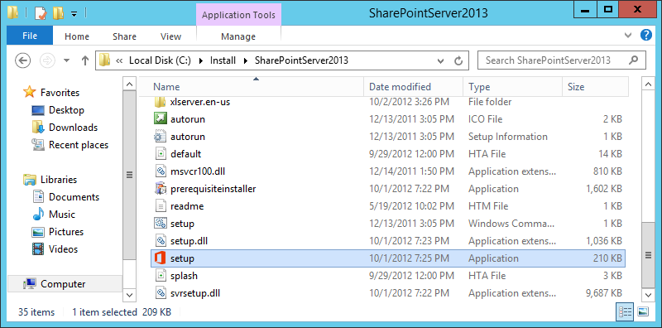

1. When prompted to **Enter your Product Key**, enter the trial key of **NQGJR-63HC8-XCRQH-MYVCH-3J3QR** tocontinue with the installation of the **Microsoft SharePoint Server 2013**. Click **Continue**.

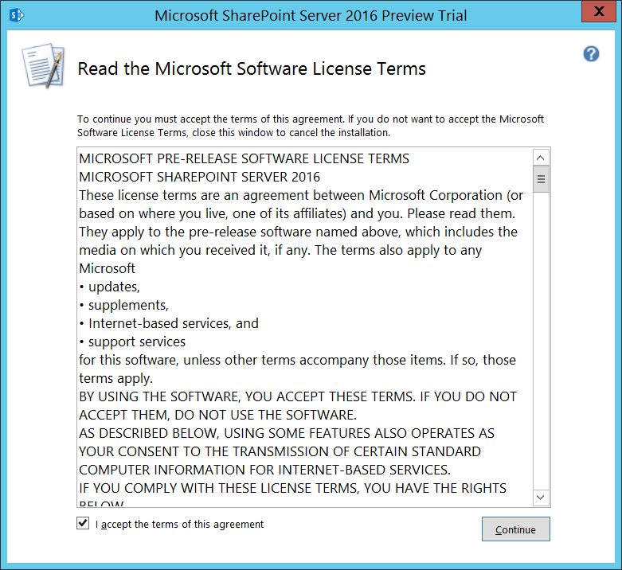

1. On the **Read the Microsoft Software License Terms** page, check the **I accept the terms of this agreement** checkbox and click **Continue**.

When you install SharePoint Server 2013 on a server computer that is not a domain controller, the SharePoint 2013 installation program displays the **Server Type** page which prompts you to select between an installation type of **Complete** or **Stand-alone**. You should always choose the **Complete** installation on any production server. Since you are installing SharePoint Server 2013 on a domain controller, the SharePoint 2013 installation program automatically selects the **Complete** installation type and does not display the Server Type page.

1. On the **Choose a file location** page, accept the default settings and click **Install Now**.

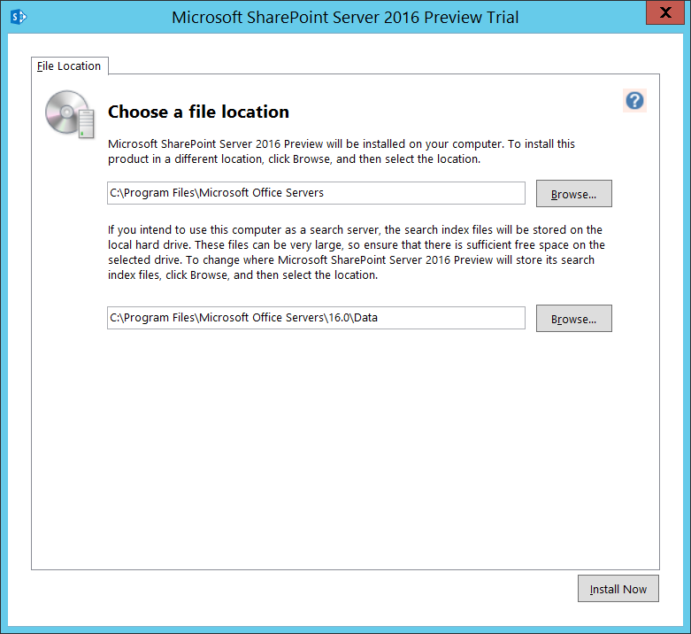

1. When the SharePoint Server 2013 installation program completes, it displays the **Run Configuration Wizard** page as shown in the following screenshot. Ensure the **Run the SharePoint Products Configuration Wizard** checkbox is **NOT** selected and click **Close**.

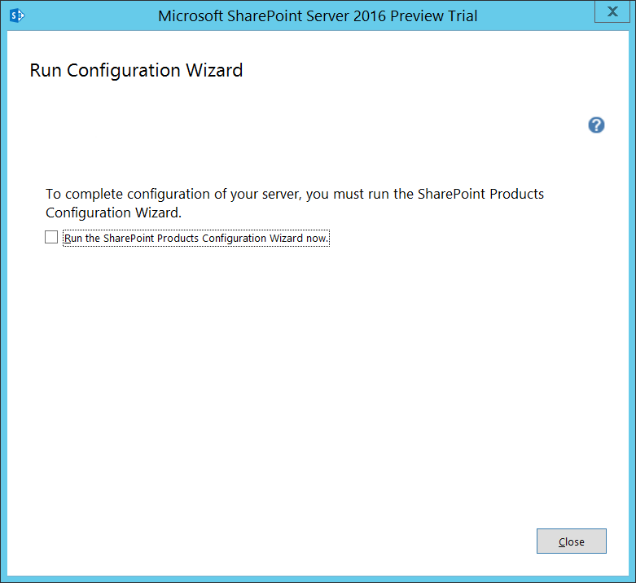

### Task 11: Add an LMHost File

127.0.0.1 WingtipServer

127.0.0.1 WingtipServer.wingtip.com

127.0.0.1 wingtip.com

127.0.0.1 my.wingtip.com

127.0.0.1 intranet.wingtip.com

127.0.0.1 dev.wingtip.com

127.0.0.1 www.wingtip.com

127.0.0.1 search.wingtip.com

127.0.0.1 research.wingtip.com

### Task 11: Install SP

In this task, you will install the SharePoint 2016 release candidate on top of the SharePoint Beta 2 installation that you prefromed in the previous step.

1. Download the bits.
   1. Go to this URL

https://www.microsoft.com/en-us/download/details.aspx?id=50737

* 1. See this.

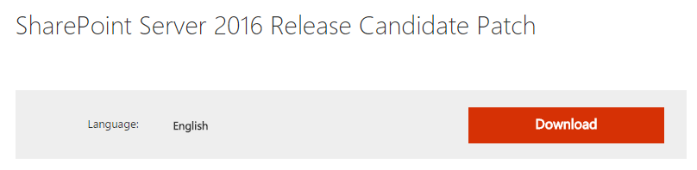

* 1. Zz

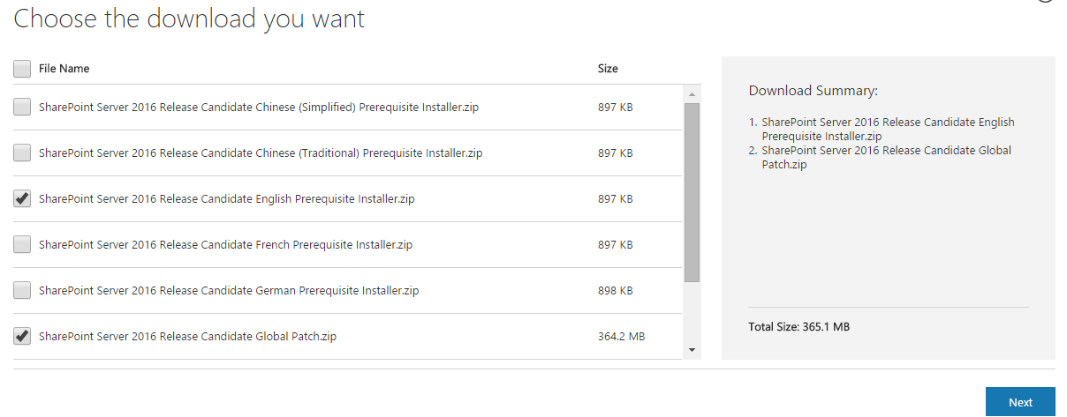

* 1. Xxx

1. Install the xxxx
   1. Extract

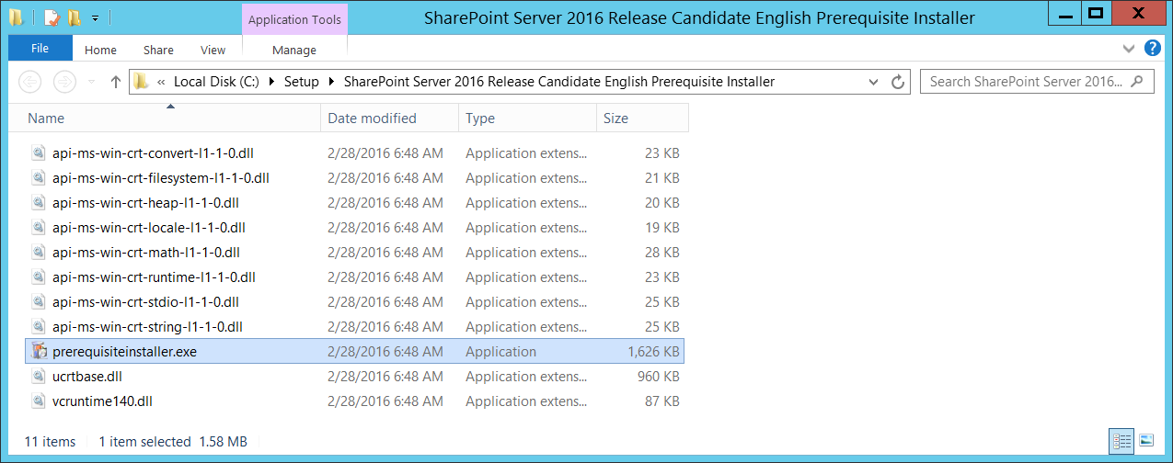

* 1. Xx

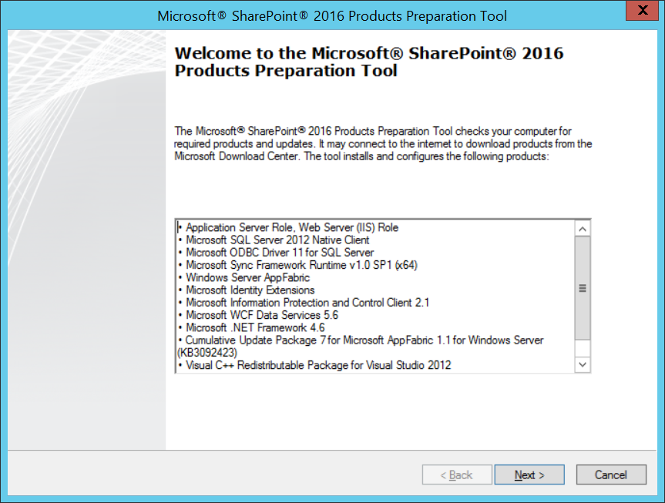

* 1. Xx

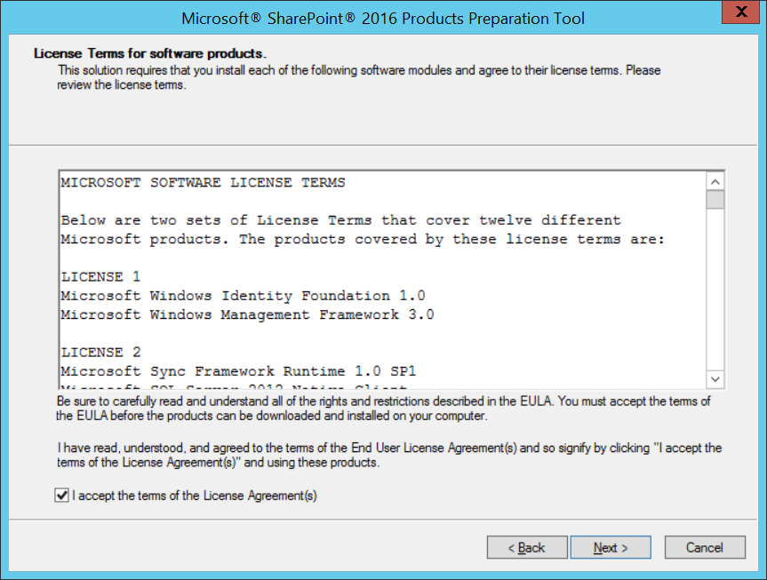

* 1. Xx

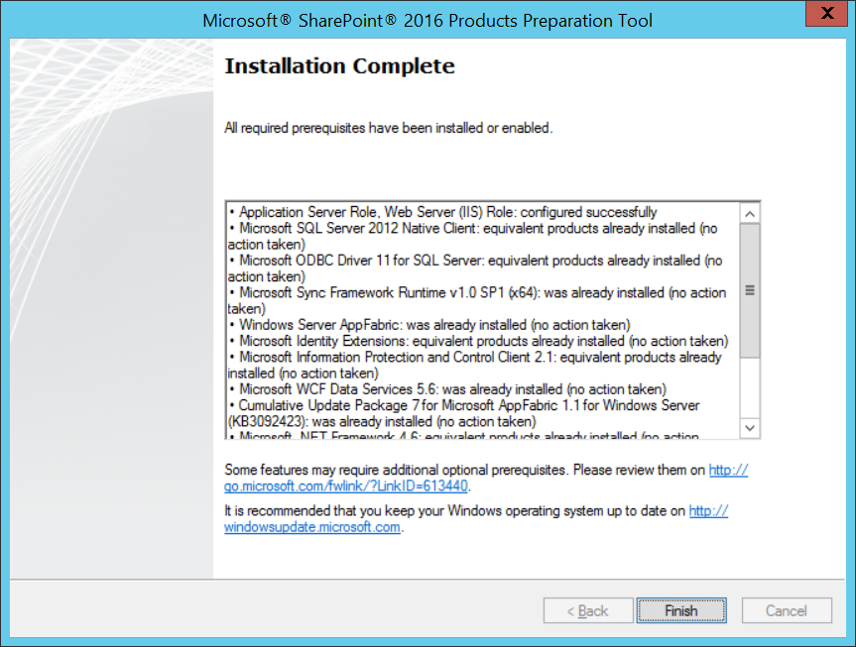

* 1. Xxx

1. Install Global Patch
   1. Extract

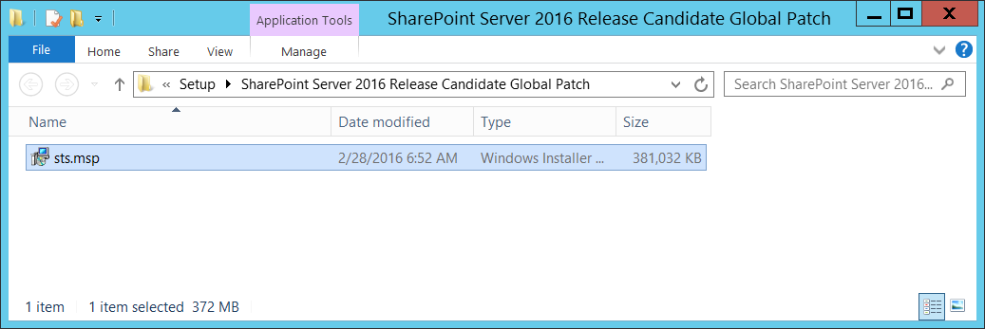

* 1. Xx

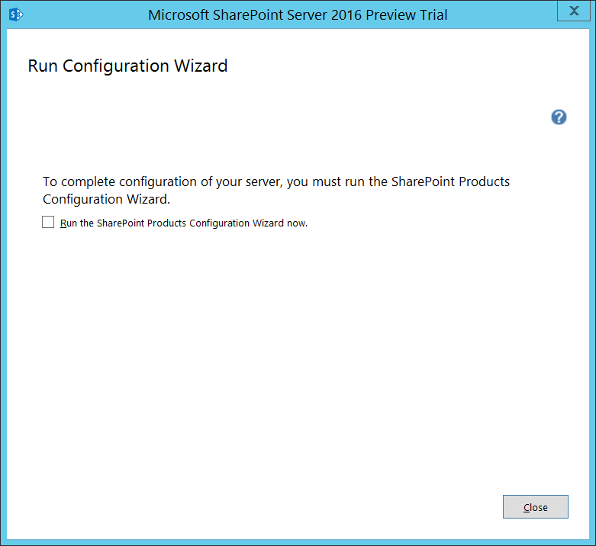

* 1. xx

### Task 11: Install Workflow Manager

In this section you will Install the Service Bus and Workflow Manager Architecture and apply the Cumulative Updates for these items (which are necessary to make the new Workflow Development model work correctly in SharePoint Server 2013 in both Development and Production environments)

1. Install **Microsoft Web Platform Installer**
   1. Ensure you are logged into the **WingtipServer** VM using the account **WINGTIP\Administrator | Password1**.
   2. Open Internet Explorer and browse to the following address:

http://www.microsoft.com/web/downloads/platform.aspx

* 1. Click **Download** and run the installer.
  2. At the end of the installer process, you should see the

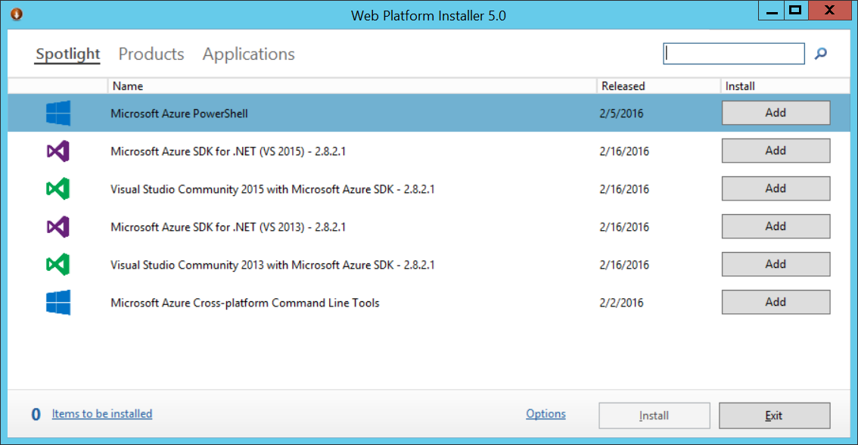

1. In the **Web Platform Installer 5.0** use the Search box at the top right to search for **Service Bus**
   1. Click **Add** for **Service Bus 1.0 Cumulative Update 1**

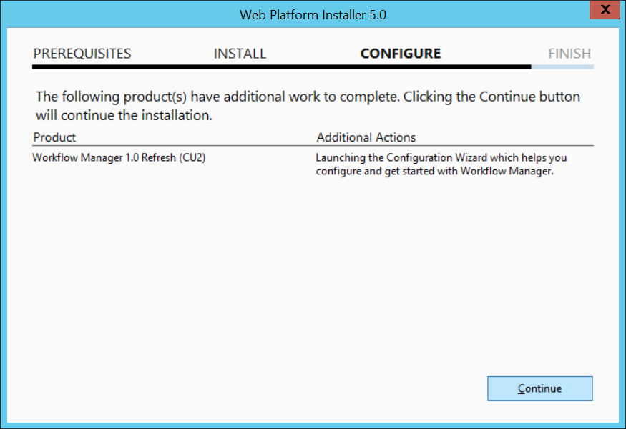

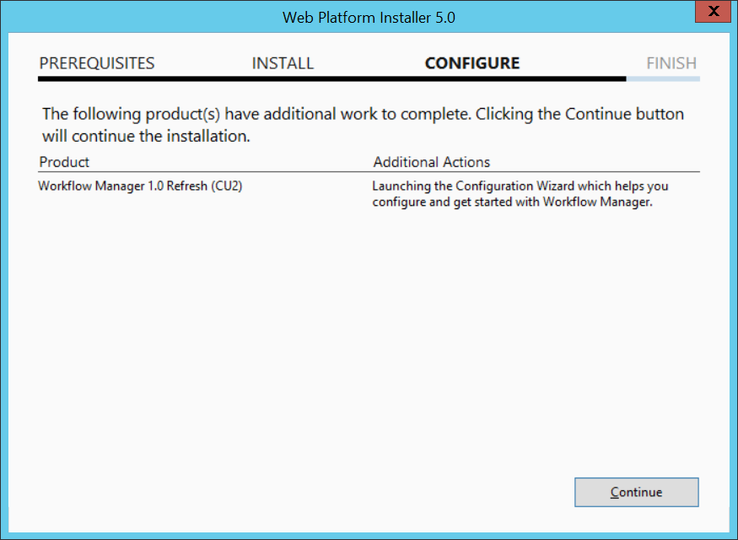

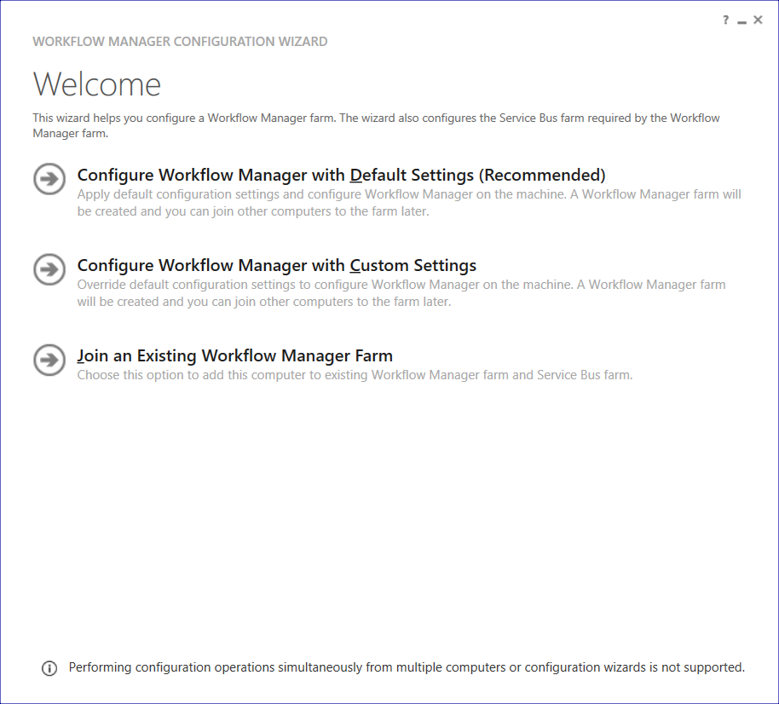

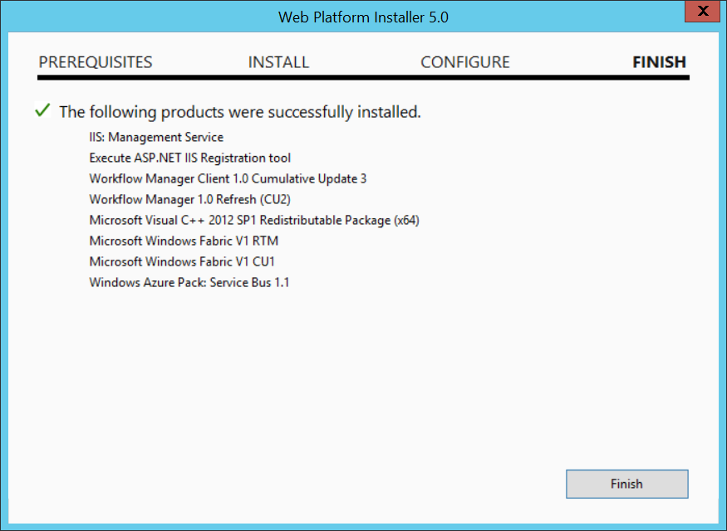

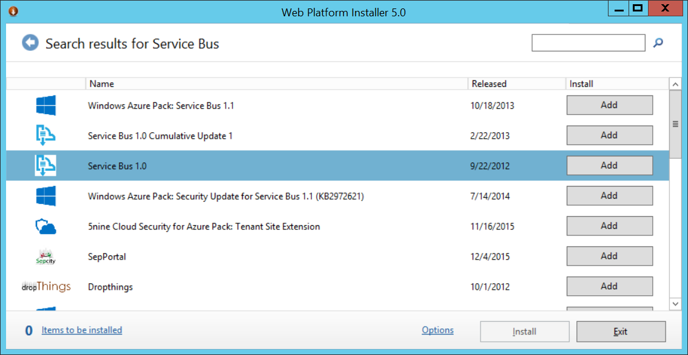

* 1. Click **Install** at the bottom of the window and then click **I Accept**
     1. If prompted to change the Microsoft Update settings, select **I don’t want to use Microsoft Update**. Click **Continue** to proceed with the installation.

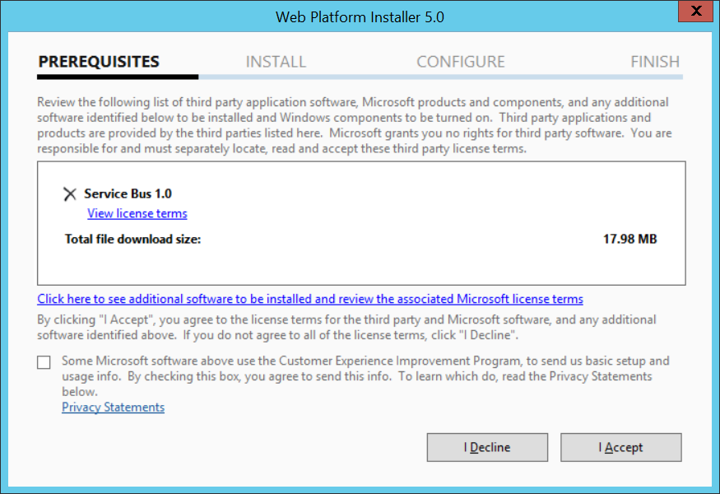

* 1. Wait for this to finish and click **Finish**

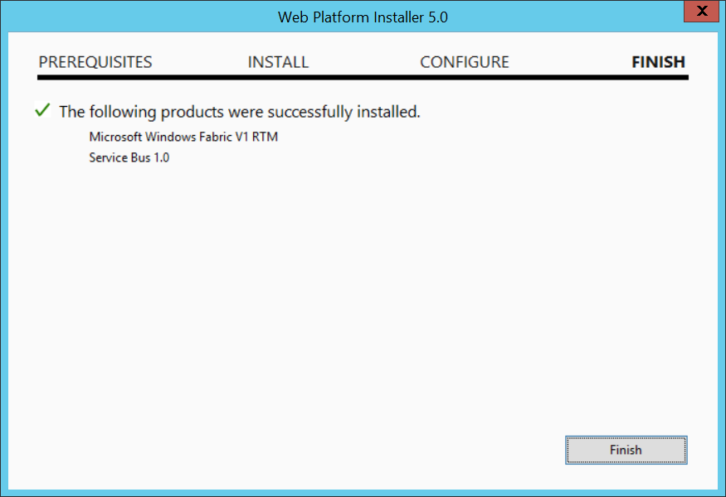

* 1. Type **Service Bus** into the **Search Box** again
  2. Click **Add** for **Service Bus 1.0 Cumulative Update 1**

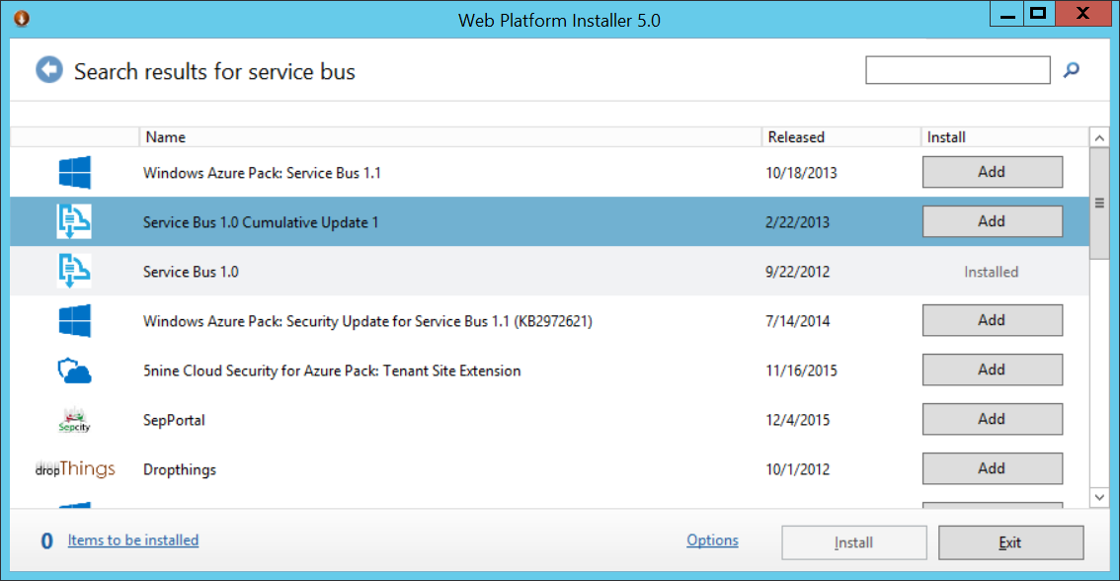

* 1. Click **Install** at the bottom of the window and then click **I Accept**
  2. Wait for this to finish and click **Finish**

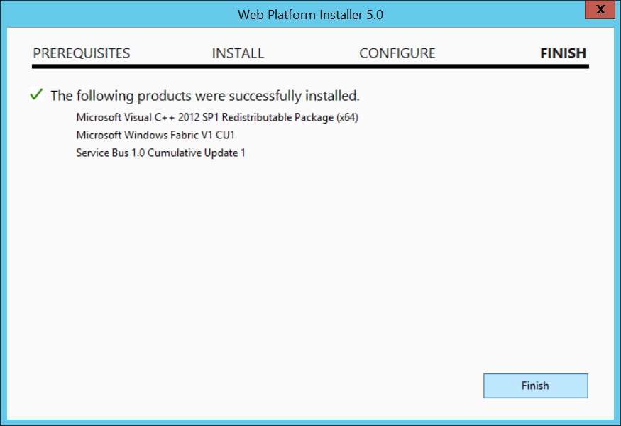

* 1. Now go back to the **Web Platform Installer 5.0** window
  2. Type **Workflow** into the **Search Box**
  3. Click **Add** for **Workflow Manager 1.0**

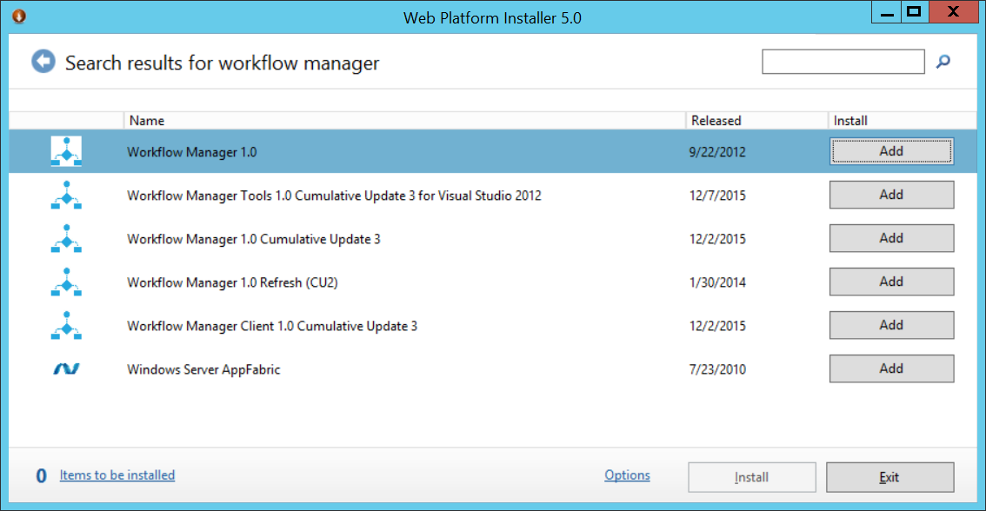

* 1. Click **Install** at the bottom of the window and then click **I Accept**
     1. If prompted to change the Microsoft Update settings, select **I don’t want to use Microsoft Update**. Click **Continue** to proceed with the installation.
  2. Wait for this to finish and click **Finish**

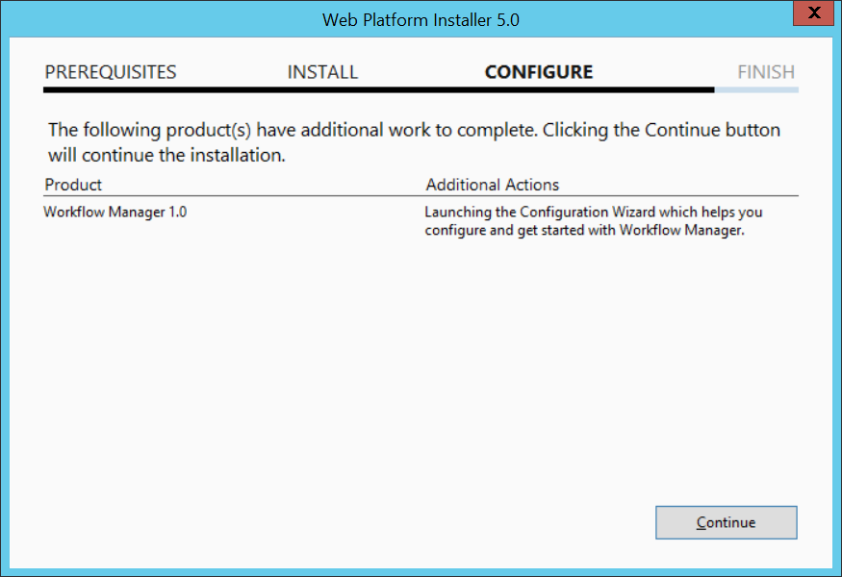



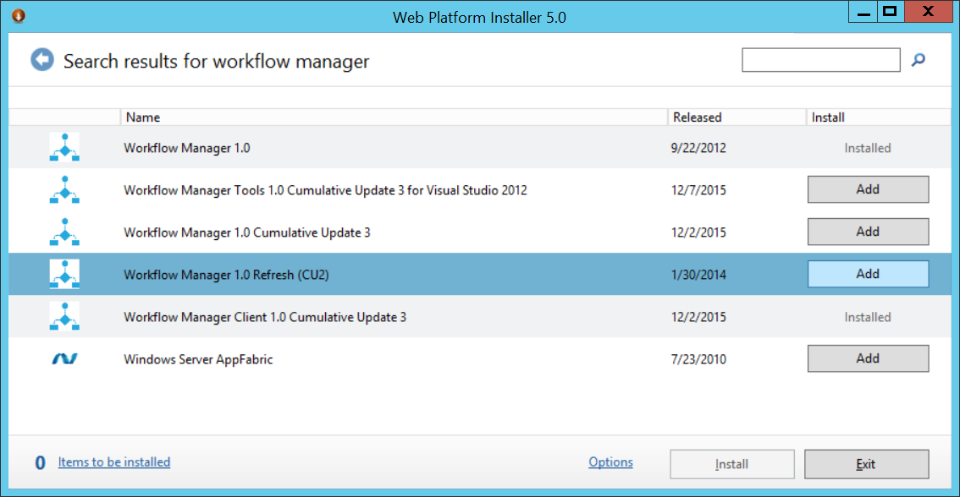

* 1. Click the **Continue** Button
  2. Click the **x** in the top right corner of this wizard to close it (as we need to install the CU1 first and will use a PowerShell Script to configure this later).
  3. Back in the **Web Platform Installer 5.0** click **Finish** (if necessary)
  4. Type **Workflow** into the **Search Box**
  5. Click **Add** for **Workflow Manager 1.0 Cumulative Update 3**
     1. **Only if this fails**, **Exit** Web Platform Installer 5.0 and re-open it and try again (i.e. go to step p)
  6. Click **Install** at the bottom of the window and then click **I Accept**
  7. Wait for this to finish and click **Finish**
  8. If necessary **Exit** the Web Platform Installer 5.0

(Note: we will configure this in SharePoint after the updates are completed)

### Task 13: Create and Configure the SharePoint Server 2013 Farm

In this section you will create and configure a new farm with SharePoint Server 2013.

1. Press the **Windows Key** to open the **Start** menu.
2. On the **Start** menu find the **SharePoint 2013 Products Configuration Wizard** tile and click on it.

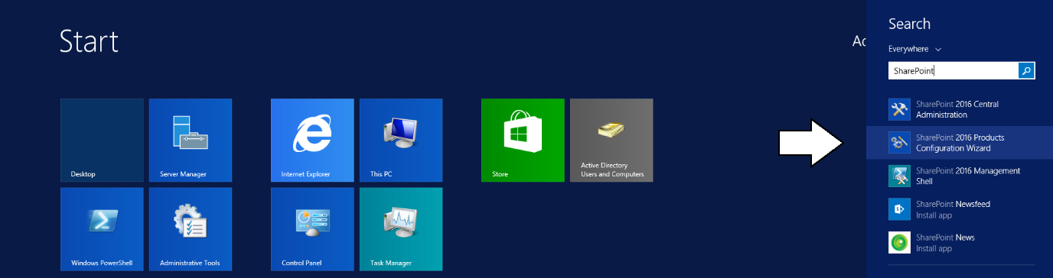

1. On the **Welcome to SharePoint Products** page, click **Next**.

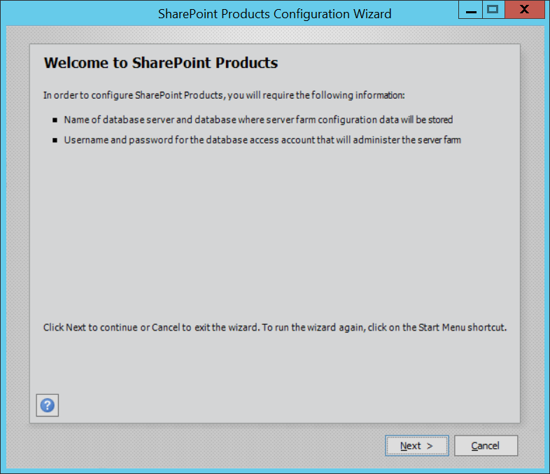

* 1. If prompted to start or reset services, click **Yes**.

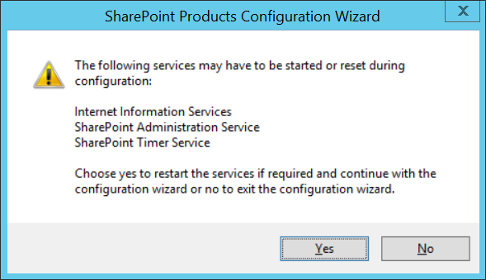

1. On the **Connect to a server farm** page, select **Create a new server farm** and click **Next**.

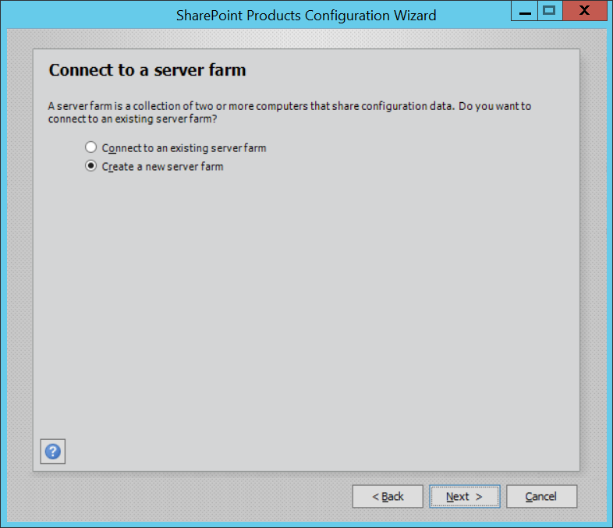

1. On the **Specify Configuration Database Settings** page, use the following to complete the page and click **Next**:
   1. Database server: **WingtipServer\SharePoint**
   2. Database name: **SharePoint_Config**
   3. Username: **WINGTIP\SP_Farm**
   4. Password: **Password1**

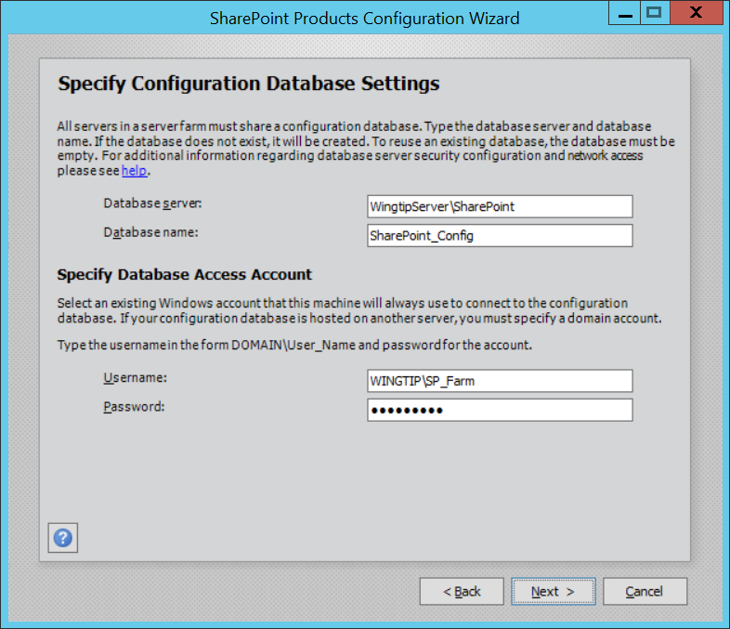

1. On the **Specify Farm Security Settings** page, enter **Password1** into both textboxes and click **Next**.

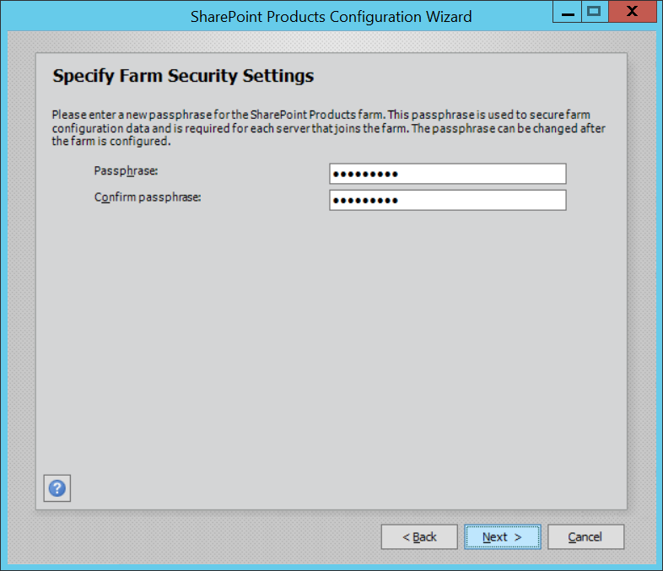

1. Xxx

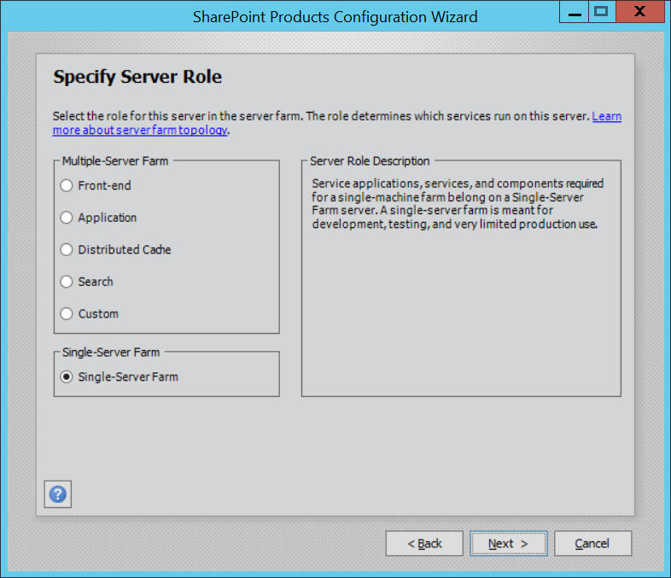

1. On the **Configure SharePoint Central Administration Web Application** page, check the **Specify port number** checkbox and enter a value of **9999**, then Click **Next**.

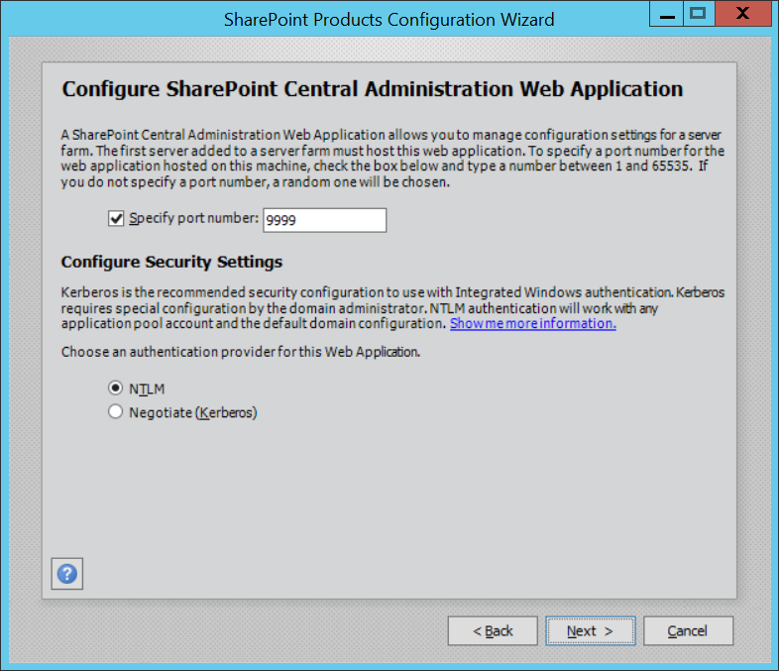

1. On the Completing the SharePoint Products Configuration Wizard page, click **Next**.

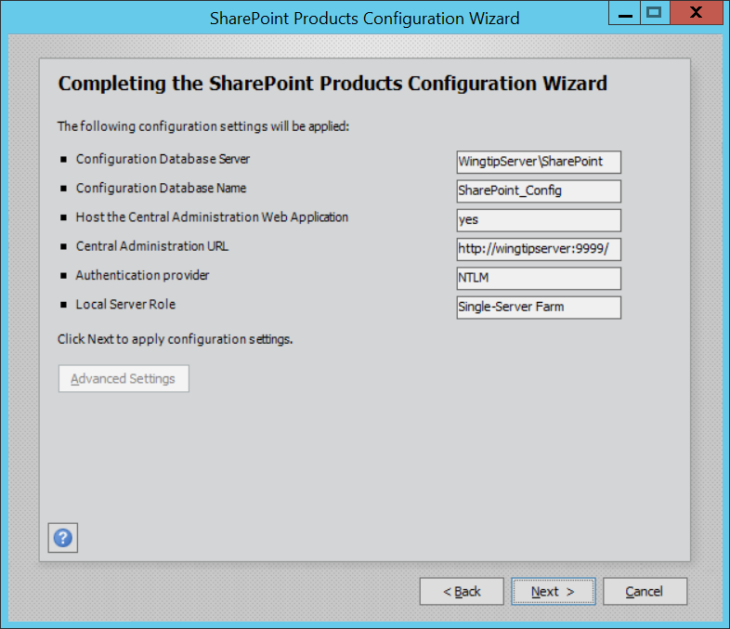

1. When the installer completes, it will display the **Confirmation Successful** page:

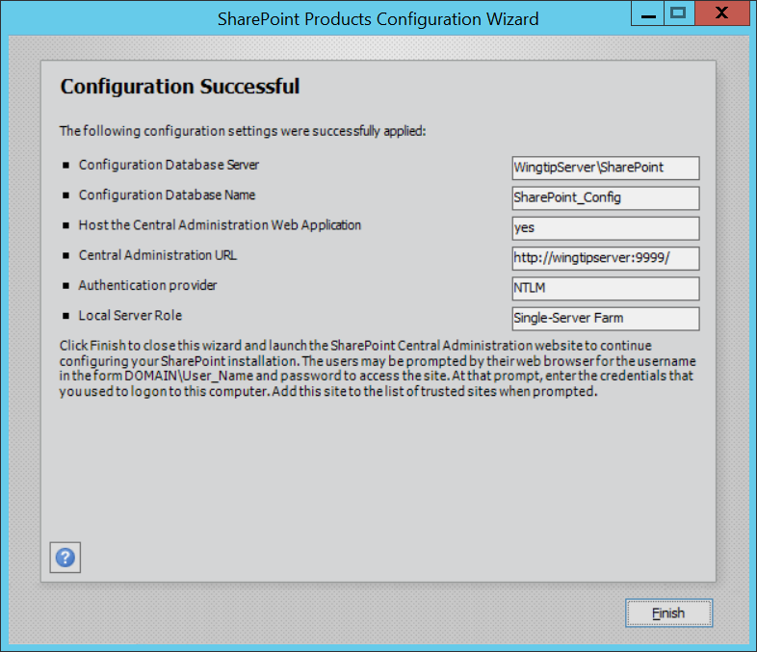

1. Click **Finish**. This will launch Internet Explorer at a page which will prompt you to continue the configuration process.
2. Click **No, I don’t wish to participate** on the Customer Experience Improvement Program screen and click **OK**
3. On the **Welcome** screen select **Yes, walk me through the configuration of my farm using this wizard.**

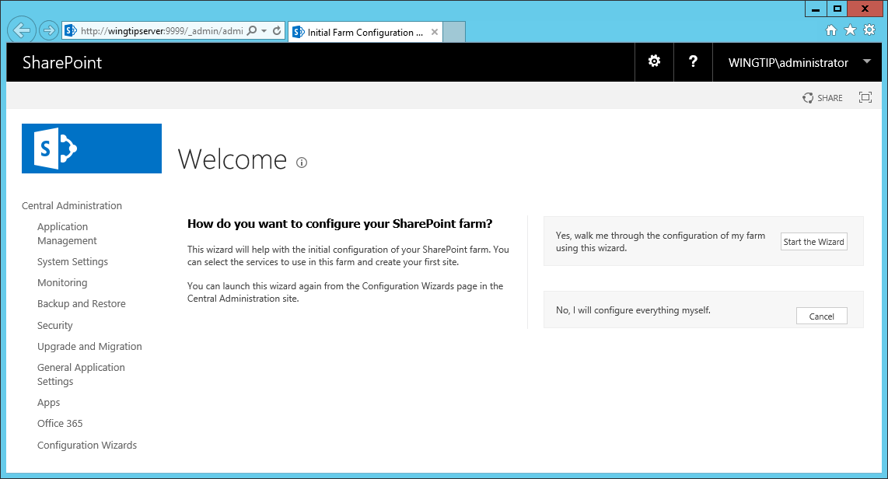

1. On the Services screen select **Create new managed account** 
   1. User name: **WINGTIP\SP_Services**
   2. Password: **Password1**

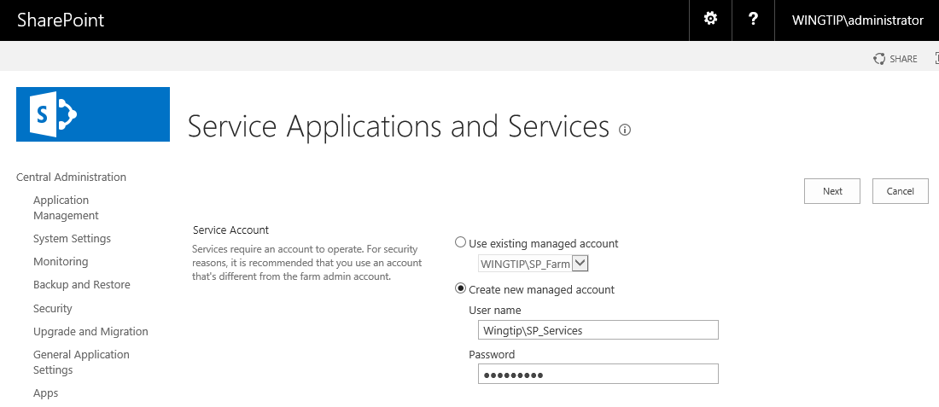

* 1. On the **Services** screen select the services as shown in the graphic below and click **Next**:

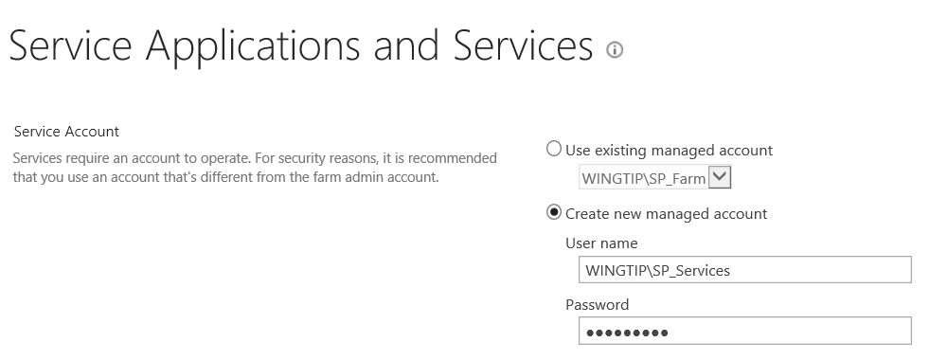

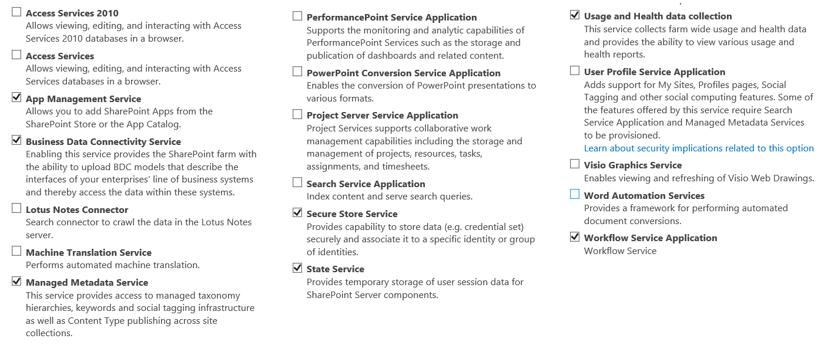

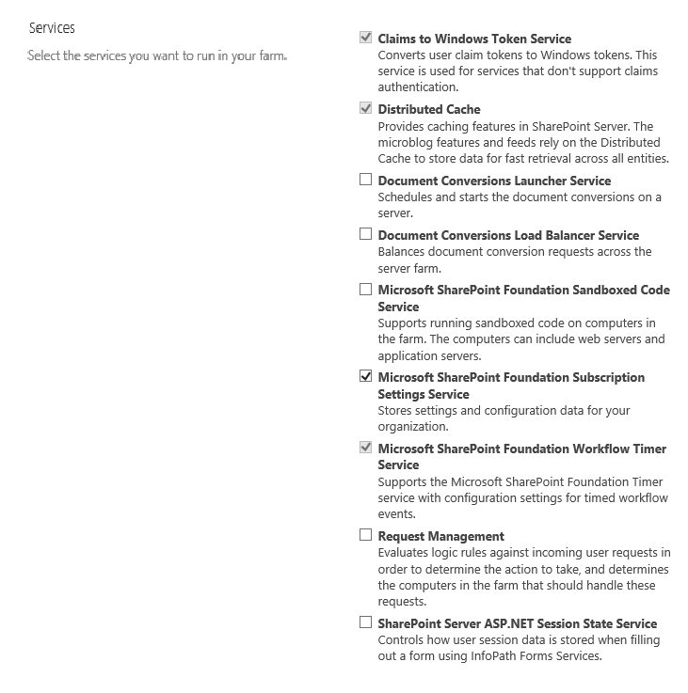

1. Wait for this to finish and then on the **Create Site Collection screen** set:

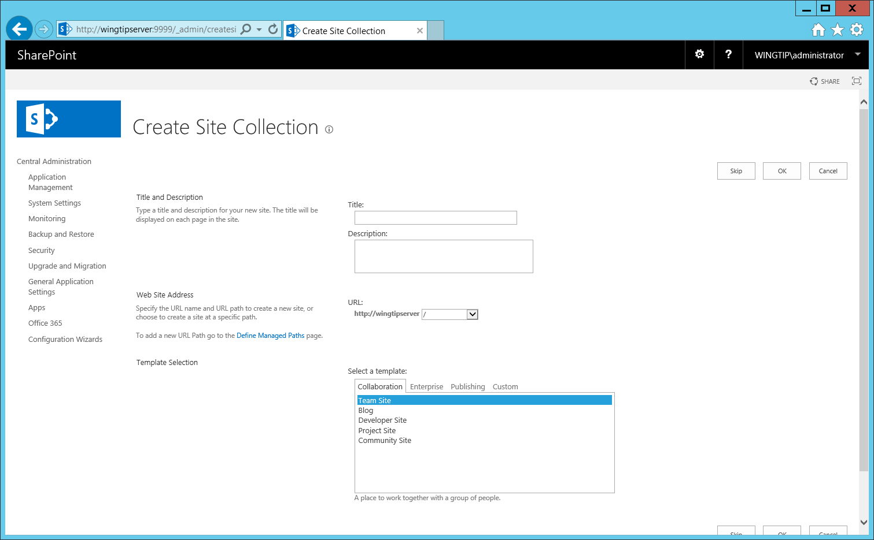

* 1. Click **Skip**

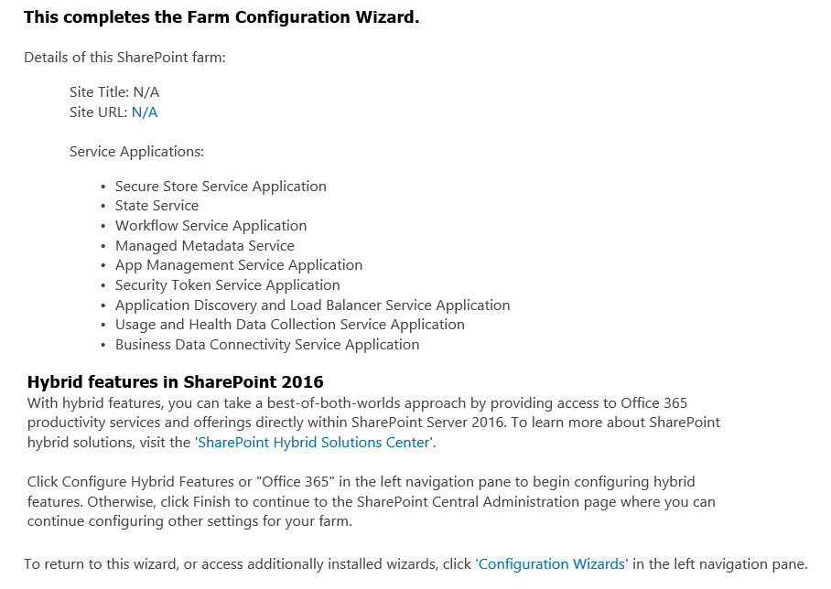

Next we need to run a couple of PowerShell Scripts to create the Subscription Settings Service, Web Applications, 2013 Workflow Service, and User Profile Service.

1. In the Windows Explorer, navigate to the folder a **C:\Setup\**.
2. Right Click on the **Script03_CreateSubscriptionSettingsService.ps1** script and select **Run with PowerShell**
   1. This script will do just what it says (Create the Subscription Settings Service)
   2. Wait for this to finish
   3. Press ENTER or close the console window when complete

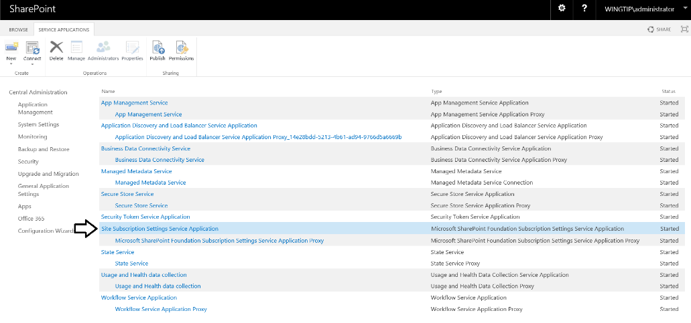

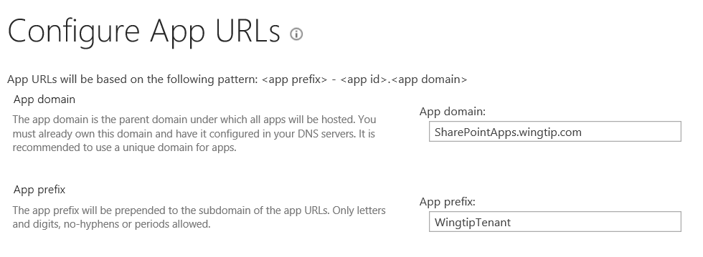

1. Right Click on the **Script04_CreateWebApplications.ps1** script and select **Run with PowerShell**
   1. This script will:
      1. Remove the existing Default SharePoint Web Application at port 80
      2. Create a new Web Application Pool
      3. Create 2 new Web Applications (WingtipServer and MySites Host)
      4. Configure the MySites Host Service Application
   2. Wait for script to finish (this will take several minutes).
   3. Press ENTER or close the console window when complete

When this script is finished you should see that an Internet Explorer window has appeared. Check to see that both the **http://WingtipServer** site load successfully.

1. Right Click on the **Script05_CreateWorkflowFarm.ps1** and select **Run with Powershell**
   1. Wait for a couple of seconds until you are prompted by User Account Control and click **Yes**
   2. A second PowerShell window will open and a subsequent script will be autorun using a different User Account needed to correctly configure this using PowerShell. Note that this will take a couple of minutes. Be patient.
   3. When the script runs, it will configure the Service Bus and Workflow Management Services as well as integrate these services with SharePoint 2013 to add support for SharePoint 2013 workflows.

Keep in mind that the script that ran earlier which created the Wingtip Service accounts created an account named **WINGTIP\SP_Farm** which serves as the farm account. The script also added the **WINGTIP\SP_Farm** account to the local Administrators group which is required to successfully run the next script. Keep in mind that once you have finished the initial configuration of the User Profile Service and The User Profile Synchronization Service, you will then remove the **SP_Farm** account from the local Administrators group.

1. Right Click on the **Script06_ CreateUserProfileServiceApplication.ps1**and select **Run with PowerShell**
   1. Wait for a couple of seconds until you are prompted by User Account Control and click **Yes**
   2. A second PowerShell window will open and a subsequent script will be autorun using a different User Account needed to correctly configure this using PowerShell. This will take a couple of minutes so be patient.
      1. When this script runs it will configure the User Profile Service Application and the User Profile Synchronization Service Application
2. Now we need to complete the configuration of the User Profile Service
   1. Press the **Windows** Key and type **SharePoint Central.**
   2. Select the **SharePoint 2013 Central Administration** tile.
   3. Go to the **User Profile Service Application** management page:
      1. **Application Management** → **Manage Service Applications** → **User Profile Service Application**
3. Next, establish a connection to the wingtip.com domain in Active Directory:
   1. Under Synchronization, select **Configure Synchronization Settings**.
   2. Under Synchronization Options, ensure that the selected option is **Use SharePoint Profile Synchronization**.
   3. Click **OK**
   4. Under **Synchronization**, select **Configure Synchronization Connections**.
   5. On the **Synchronization Connections** page, select **Create New Connection**.
   6. Enter the following values on this form:
      1. Connection Name: **Wingtip Users**
      2. Type: **Active Directory**
      3. **Connection Settings**:
         1. Fully Qualified Domain Name: **wingtip.com**
         2. Specify a domain controller: **selected**
         3. Domain controller name: **WingtipServer**
         4. Authentication Provider Type: **Windows Authentication**
         5. Account Name: **WINGTIP\SP_UPS**
         6. Password (and Confirm Password): **Password1**

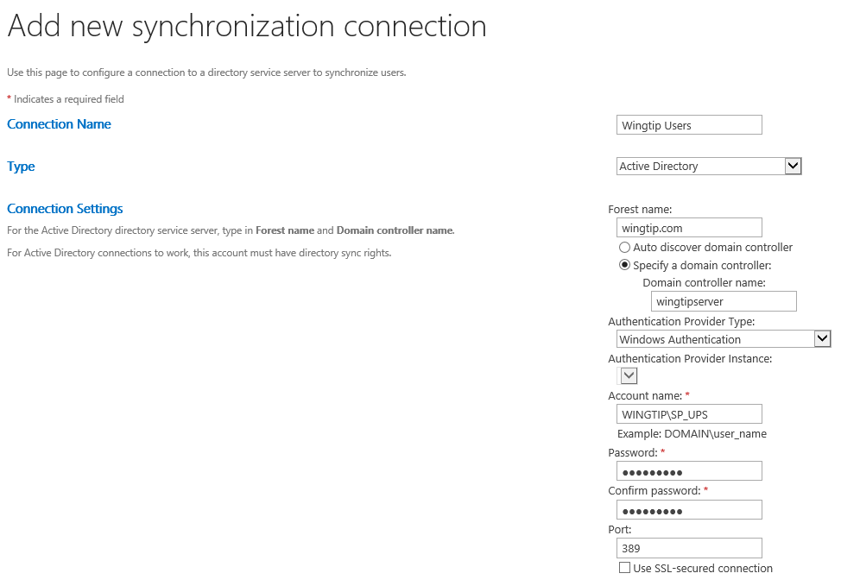

* + 1. **Containers**:
       1. Click **Populate Containers**.
       2. After it loads, expand the **WINGTIP** node and select the Organizational Unit named **Wingtip Users**.  
          (Note: place a check in the **Wingtip Users** checkbox as shown below)

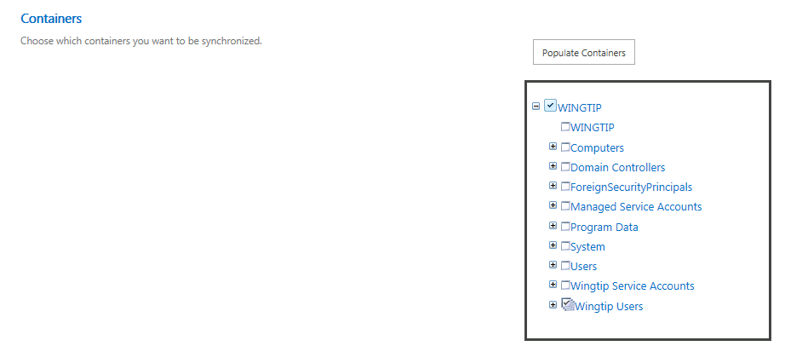

* 1. Click **OK** to save the connection. You should see the connection has been successfully created.

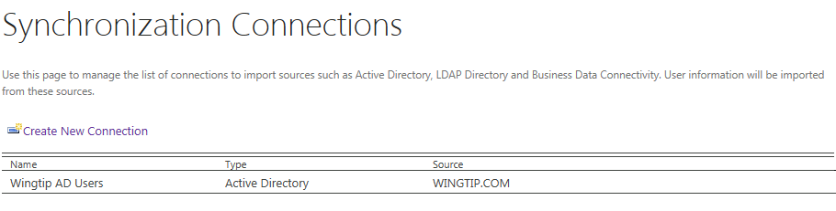

1. Go back to the **User Profile Service Application** management page: **Application Management** → **Manage Service Applications** → **User Profile Service Application**.
2. Finally, start a synchronization import:
   1. Under **Synchronization**, select **Start Profile Synchronization**.
   2. Select **Start Full Synchronization** and click **OK**
   3. Wait for this to finish
   4. You will be taken back to the **User Profile Service Application** management page. Notice in the top-right corner there is a status block that reports how many profiles are in the UPA database. **Refresh** the page to see it increase to a handful of profiles as the import process runs.   
      (Note: you should have 15 User Profiles when finished)
   5. At this point you have successfully configured the **User Profile Service Application** to import profiles from the local AD.

You are now at a point where you can remove the **SP_Farm** account from the **Administrators** group. Granting local **Administrators** group permission to the **SP_Farm** account is only needed in steps that you have already completed.

1. Remove the **WINGTIP\SP_Farm** account from the local Administrators group.
   1. Display the Windows Start page.
   2. Click the tile Active Directory Users and Computers.
   3. Locate the **WINGTIP\Administrators** account.

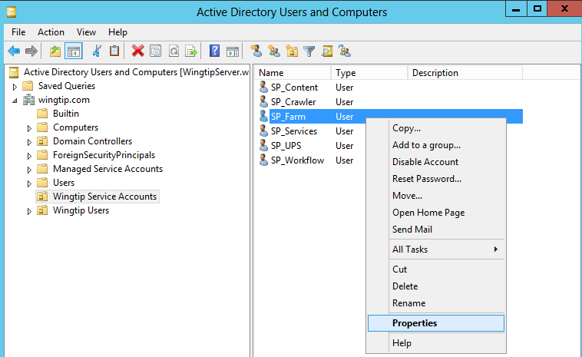

* 1. Select the **Member Of** tab on the **SP_Farm Properties** dialog. Select the **Administrators** group and click the **Remove** button to remove the **SP_Farm** account from the local **Administrators** group.

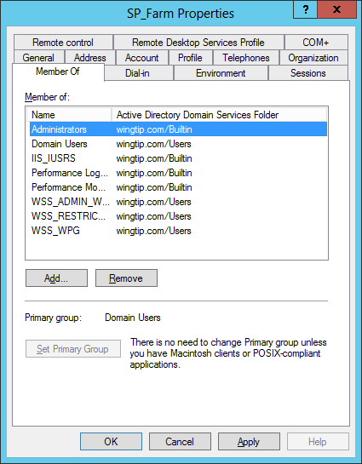

* 1. Once you have removed the **Administrators** group, click the **OK** button to close the **SP_Farm Properties** dialog.
  2. Now reboot the student VM.
  3. Once the student VM has restarted, log in again as **WINGTIP\Administrator**.

1. Next we need to configure the Search Service in SharePoint 2013
   1. Press the **Windows** key and type “SharePoint” and select the **SharePoint 2013 Central Administration** tile
   2. In Central Administration select **Manage** **Service Applications** under the **Application Management** section
   3. On the Service Applications screen, select the drop down under **New** in the ribbon and select the **Search** **Service Application** option.

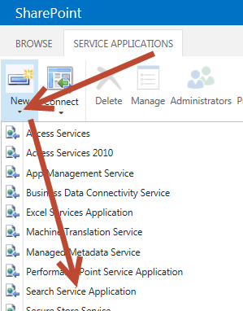

* 1. On the Create New Search Service Application screen set the following items:
     1. Service Application Name: **Search Service Application**
     2. Search Service Account: **WINGTIP\SP_Services**
     3. Application Pool for Search Admin Service: **Use existing application pool**
        1. Name**: SharePoint Web Services Default**
     4. Application Pool for Search Query and Site Settings Web Service
        1. Name: **SharePoint Web Services Default**
     5. Click **OK** at bottom of window and wait for this to finish.
     6. When you see the Manage Search Topology screen with the success message, click **OK** to continue
  2. Back on the Manage Service Applications screen scroll down to find the **SharePoint Server Search Service Application** and **click** on this to go to the **SharePoint Server Search Service Application** configuration screen
  3. Next we need to configure the identity of the Search Service Application Crawl Account
  4. In Central Administration Navigate to the main Search Administration page of the Search Service Application.
     1. **Central Administration → Manage service applications → Search Service Application** link

If you see an error on the search administration page stating that the search service is not able to connect to the machine that hosts the administration component you can try to reboot the server and try returning to the page.

* 1. Inspect the properties in the **System Status** section and locate the property named **Default content access account**.
     1. Currently, the **Default content access account** property should have a value of **WINGTIP\SP_Services**.
     2. Click on the link which shows the property value of **WINGTIP\SP_Services** to configure it to use a different account. A dialog will appear that allows you to add a new account and password. Add the **WINGTIP\SP_Crawler** account and a password / confirm password of **Password1** and then click **OK** to save your changes.

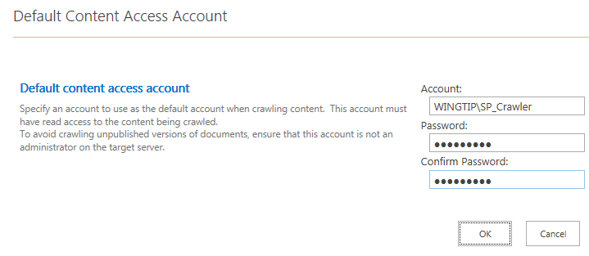

* 1. Return to the main Search Administration page of the Search Service Application.

When you configure a new identity for the crawler account by updating the **Default content access account** property, SharePoint will automatically add a user policy to each existing web application to provide the account will Full-Read access. Therefore, you do not need to worry about configuring permissions for the crawler account to access SharePoint sites. However, SharePoint will not automatically configure permissions for the crawler account to properly access the User Profile Service Application. You will configure the permissions that are required in the following step.  
(Note: you would also need to provide access to any external content you wished to crawl)

1. Provide the **WINGTIP\SP_Crawler** account with access to the User Profile Service Application.
   1. Navigate to the Manage service applications page and select the User Profile Service Application
      1. **Central Administration → Manage service applications →** just select **User Profile Service Application** (but do not click the link (i.e. click anywhere on this line but the link itself to highlight/select this application))
   2. With the **User Profile Application Service** selected, click the **Administrators** button in the Ribbon.
   3. In the textbox in the Administrators for User Profile Service Application dialog, enter the account **WINGTIP\SP_Crawler** and then click **Add**.
   4. Configure the **WINGTIP\SP_Crawler** account with the **Retrieve People Data for Search Crawlers** permission.

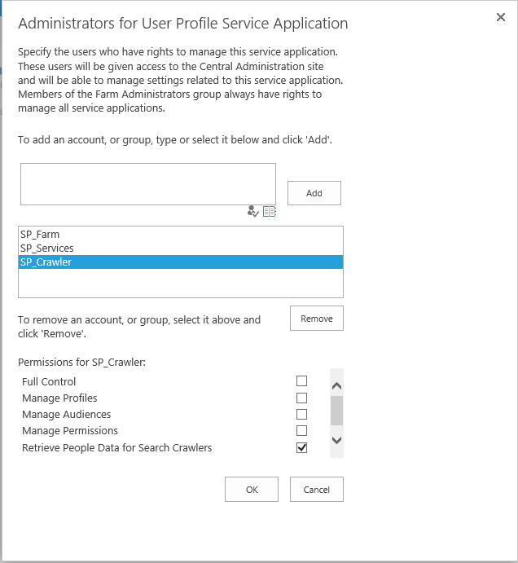

* + 1. Click **OK** to save your configuration changes.
    2. Return to the main Search Administration page of the Search Service Application
       1. Click on the **Search Service Application** link in the **Manage service applications** screen (i.e. the screen you are currently on).
  1. On the main Search Administration page of the Search Service Application, locate and click the **Content Sources** link in the **Crawling** section of the Quick launch. This will redirect you to the **Manage Content Source** page where you should be able to see that there is a single content source named **Local SharePoint Sites**.

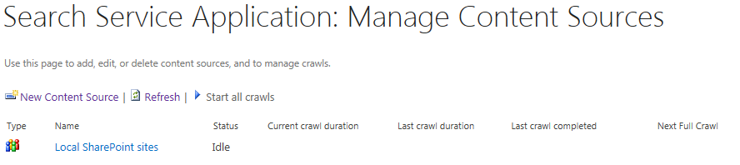

* 1. Use the drop down menu on **Local SharePoint sites content source** to start a full crawl of the content.

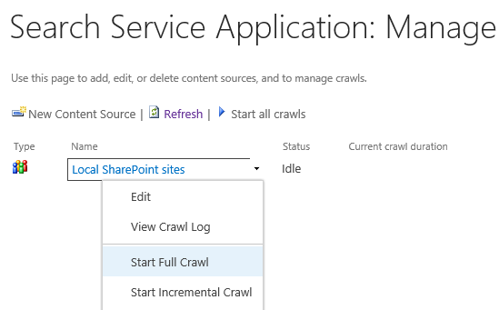

The full crawl process will likely take about 5 minutes or so to complete. However, you don't have to wait for it to complete. You can move ahead to the next step and continue with the setup.

1. Next we need to configure a Search Center on our Main Intranet site:
   1. In Central Administration Select **Manage Web Applications** under the Application Management section
   2. Select **Wingtip Intranet** and then in the Ribbon select **Managed Paths** and then set:
      1. Path: **Search**
      2. Type: **Explicit inclusion**
      3. Click **Add Path** and then click **OK**
   3. Select **Application Management**  then **Create site collections** and set:
      1. Web Application: http://intranet.wingtip.com/
      2. Title: **Search Center**
      3. URL: **http://intranet.wingtip.com/search**
      4. Template Selection
         1. Experience version: **2013**
         2. Select a template: **Enterprise** tab then **Enterprise Search Center**

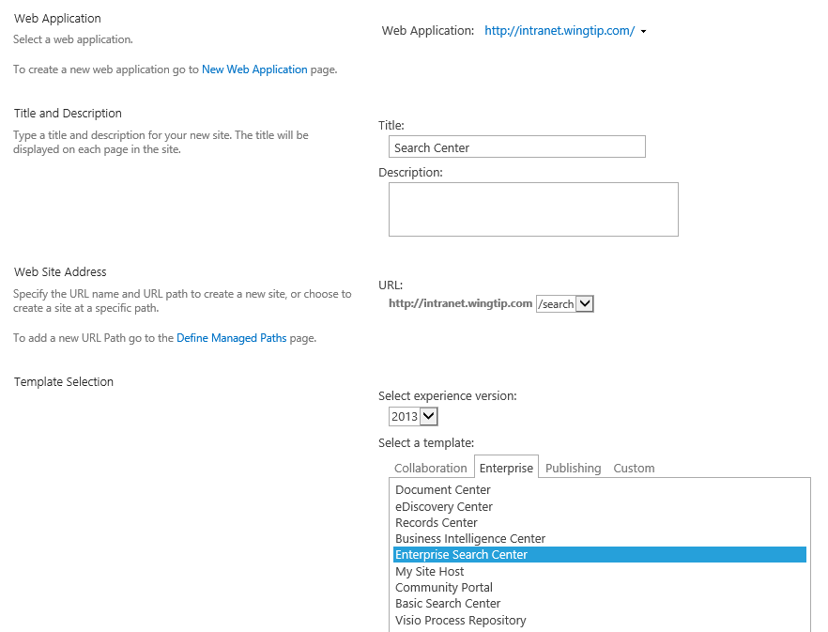

* + 1. Primary Site Collection Administrator: **Administrator**
    2. Click **OK** at bottom of window
  1. When the site has been created click the link http://intranet.wingitp.com/search to open the new search center.
  2. Test the search center:
     1. Type **Administrator** in the search box and press **Enter**
        1. You should receive at least one hit (**Wingtip Team Site)**
     2. Type **John** in the search box, select **People** for the category of the search
        1. You should see **John Holliday** in the results list.

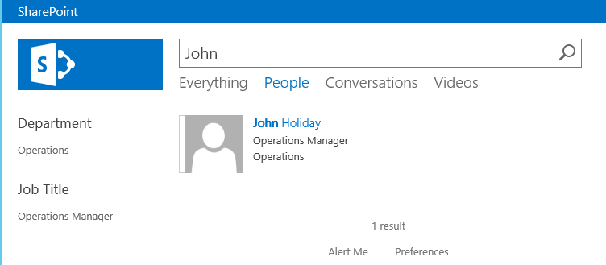

* 1. Congratulations! Search appears to be working correctly… but wait there’s more…
     1. We should set this as the Global Search Center URL in the Search Service Application
        1. Go back to the **Search Service Application** management page: **Application Management** → **Manage Service Applications** → **Search Service Application**.
        2. Under **System Status** click on **Set a Search Center URL**
           1. Set this to: http://intranet.wingtip.com/search/Pages/results.aspx
           2. Click **OK**

Search Configuration is now completed…

1. Finally, we need to finish the SQL Server Reporting Services (SSRS) integration into SharePoint 2013 configuration
   1. Press the window key and type “SharePoint Management” and **Right Click** on the **SharePoint 2013 Management Shell** tile
   2. Now select **Run as Administrator** from the bottom of the screen  
      (Note: these commands will only work if you run this shell as an administrator)
   3. In the Management shell type each of the following commands followed by the **Enter** key.

Install-SPRSService

Install-SPRSServiceProxy

get-spserviceinstance -all |   
 where {$_.TypeName -like "SQL Server Reporting*"} |   
 Start-SPServiceInstance

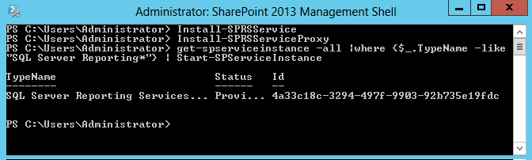

* 1. **Close** the SharePoint 2013 Management Shell window
  2. Press the **Windows** key and type “SharePoint Central” and select the **SharePoint 2013 Central Administration** tile
  3. In Central Administration select **Manage** **Service Applications** under the **Application Management** section
  4. On the Service Applications screen, select the drop down under **New** in the ribbon and select the **SQL Server Reporting Services Service Application** option.

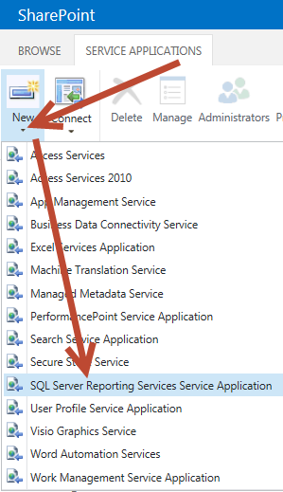

* 1. On the Create SQL Server Reporting Services Service Application screen set the following items:
     1. Name: **SharePoint** **SQL Server Reporting Services**
     2. Application Pool: **Use existing application pool**
     3. Name**: SharePoint Web Services Default**
     4. Database Name: **SharePoint_SSRS_Data**
     5. Web Application Association (Place a **check** next to):
        1. **Wingtip HNSC Web Application**
        2. **Wingtip Intranet**
     6. Click **OK**
     7. Wait for this to finish and on the final screen (i.e. with the success message) click **OK.**

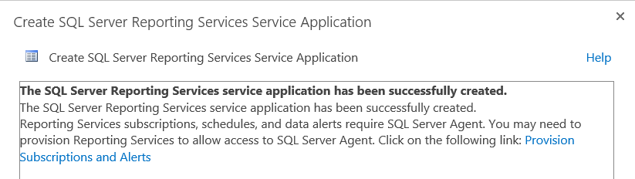

* 1. Back on the Manage Service Applications screen scroll down to see the **SQL Server Reporting Services** Service. It should show up as **Started** as shown below:

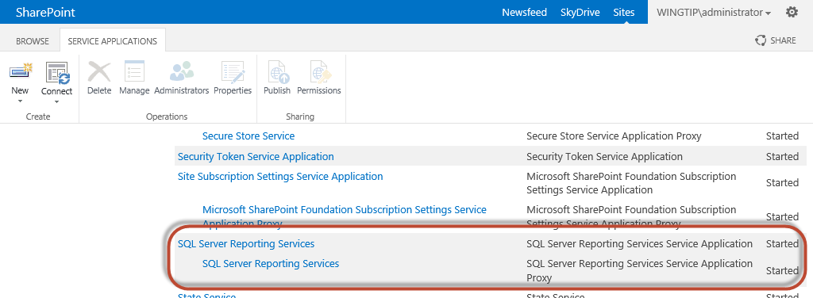

1. Close the Internet Explorer window which was launched at the end of the SharePoint Server 2013 installation program. Close any other Internet Explorer windows that are open on the **WingtipServer** VM.

At this point you have successfully configured the base install of SharePoint Server 2013

### Task 14: Install Fiddler, SharePoint Designer 2013, and test Workflow Services in SharePoint 2013

In this section you will finish the Install SharePoint Designer 2013 and test the Workflow Service Manager integration into SharePoint 2013 by using SharePoint Designer to create a new 2013 style Workflow

1. Navigate to C:\Install
2. Double click on the **fiddler4setup.exe** file to install Fiddler
   1. Click **I Agree** to the License Agreement
   2. Click **Install**
   3. Click **Close**
   4. Internet explorer should appear with a **First Run** Screen for **Fiddler**
   5. Close **Internet Explorer**
3. Double click on the **sharepointdesigner_64bit.exe** file to install SharePoint Designer 2013
   1. **Accept** the License Terms and click **Continue**
   2. Click **Install Now**
   3. When finished installing click **OK**.
4. Apply the February 2013 Update for Microsoft SharePoint Designer 2013 (KB2767858) 64-Bit Edition.
   1. Download the update from here: **http://www.microsoft.com/en-us/download/details.aspx?id=36744**
   2. Once the update has downloaded, apply it by double-clicking on the update installation file which is named **spd2013-kb2767858-fullfile-x64-glb.exe**.
   3. Wait until the update has been applied and then close all windows.
5. Open SharePoint Designer 2013:
   1. Press the **Windows** key and type **SharePoint Designer**
   2. Select the **SharePoint Designer 2013** tile
   3. Select **Use recommended settings** and click **Accept**
   4. **Close** the Office Welcome pop-up window
   5. Click **Open Site** and set the site name to **http://wingtipserver/** and click **Open**
6. On the Ribbon click on **Site Workflow** and note the Platform Type in the **Create Site Workflow** dialog box.  
   You should now see **SharePoint 2013 Workflow** as a choice. As long as you see **SharePoint 2013 Workflow** as a choice, you know that you have successfully configured support for SharePoint 2013 workflows in the local farm.

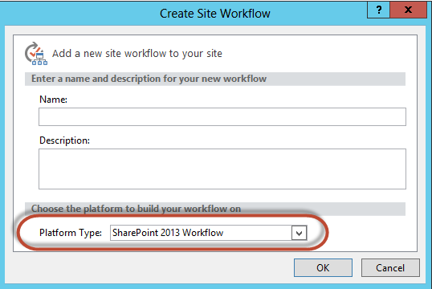

1. Click **Cancel** and then **Close** SharePoint Designer 2013

You have now successfully installed Fiddler, SharePoint Designer 2013, and demonstrated that the new 2013 style SharePoint Workflows have been installed correctly into your environment.

### Task 15: Install, Update, and Configure Visual Studio 2013

In this section you will Install Visual Studio 2013, Update, and configure it for use with SharePoint 2013.

1. Create a new directory named **VSInstall** in the **C:\Install** directory of the **WingtipServer** VM.
   1. Once created, the path to this directory should be **c:\Install\VSInstall**

Note that minimally you will need Visual Studio Professional 2013 if you wish to use an MSDN licensed copy for this setup.

1. Download the installation files for the trial edition of Visual Studio 2013.
   1. Go to the Visual Studio Ultimate 2013 trial download page at **http://www.visualstudio.com/en-us/downloads/download-visual-studio-vs**.
   2. Click the Visual Studio Ultimate 2013 category.
   3. Click the **Download Now** link to download to the VM.
   4. If prompted, login using your Microsoft Account.
   5. Click the **Ultimate 2013** tile to begin the download.
2. Download the installation file named **vs_ultimate_download.exe** to the **c:\Install\VSInstall** directory.
3. Double-click on the **vs_ultimate_download.exe** program to download the application.
   1. Specify **c:\Install\VSInstall** as the download location and click **Download** to begin the download.

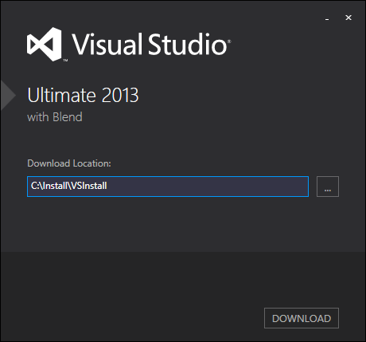

* 1. Click **Close** when complete.

1. Double-click the **vs_ultimate.exe** program to begin the installation.
   1. **Agree** to the license terms and conditions and click **Next.**

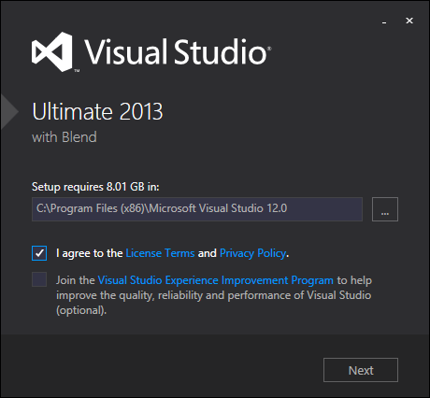

* 1. Make sure that everything except the Windows Phone 8.0 SDK and the Tools for Maintaining Store apps for Windows 8 is selected and click **INSTALL**(Note: you must have Microsoft Office Developer Tools, Silverlight Development Kit, and Microsoft Web Developer Tools selected).

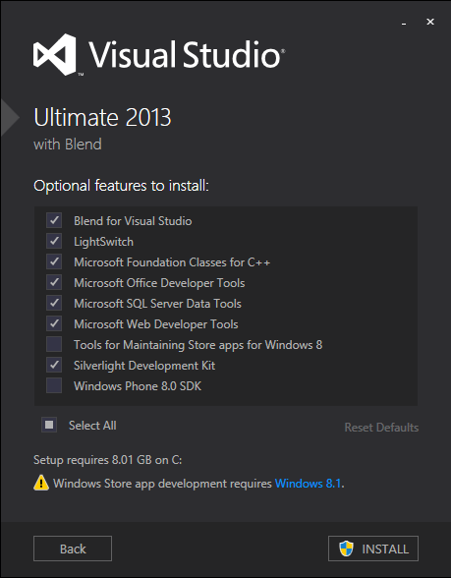

* 1. Wait for the install to finish (this will take approximately 20 minutes to finish… relax, grab a muffin and another cup of coffee; decaf this time (don’t want to overdo it…)).
  2. When finished go ahead and run Visual Studio 2013 by clicking the **LAUNCH** button
  3. When asked to sign in click **Not now, maybe later**
  4. Click **Start Visual Studio** to accept the default environment settings

1. Next we need to update Visual Studio 2013
   1. In Visual Studio 2013 on the **TOOLS** menu select **Extensions and Updates…**

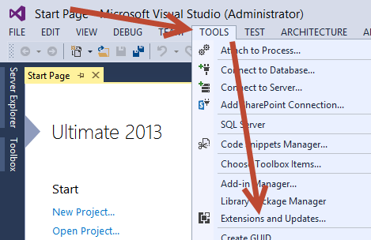

* 1. On the Extensions and Updates window select **Updates** then **Product Updates** Then **Visual Studio 2013 Update [X]** where [X] represents the currently available update for Visual Studio 2013 and click **Update**.

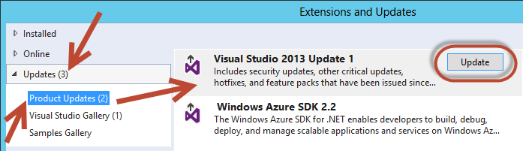

* 1. Then click **Run.**

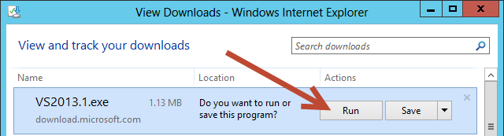

* 1. **Close** Visual Studio 2013 when prompted by the update and then click **Retry** on the Update install screen
  2. **Agree** to the License terms and conditions and click **INSTALL**
  3. When finished run Visual Studio 2013 again by clicking the **LAUNCH** button.

1. Next we will check for the ability to create SharePoint 2013 projects using Visual Studio
   1. Using the **File** Menu select **New Project**
   2. Expand **Visual C#**
   3. Expand **Office/SharePoint**
   4. Notice the three categories of projects you can now create for SharePoint 2013.

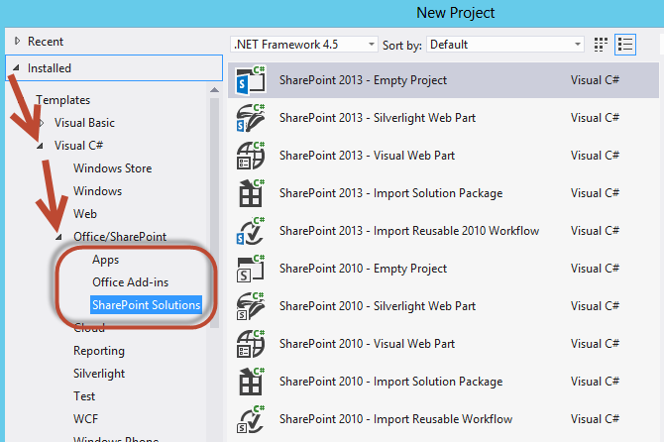

### Task 16: Install Office 2013 Professional and Visio 2013

In the final step you will install Microsoft Office 2013 Professional. Note that if you are using a trial version of Microsoft Office 2013 Professional, you may wish to wait until closer to your actual class date to install these as you only have a 30 day trial period with these.

1. Obtain a copy of the 64-bit installation binaries for Office 2013 Professional
   1. Choose between using your own licensed copy of Office 2013 Professional or using the free trial version.
   2. If you plan to use a licensed copy, you must acquire the install image (*.iso) for Office 2013 Professional as well as a product key.
   3. If you plan to use a free trial copy of Office 2013 Professional, follow these steps:
      1. Navigate to the Office 2013 Professional trial download site: **http://msdn.microsoft.com/en-US/evalcenter/jj720319.aspx** or you can use an MSDN version of this if you have an MSDN subscription
      2. Download the install files to a location on your host computer (these will typically be in .iso or .img format.
      3. Once this has been downloaded you may either 1) burn this to a blank dvd or 2) attempt to attach to this file. We will attempt to attach the VM to this file using Hyper-V Manager

This download is over a gigabyte in size so it will take some time to download. The amount of time it takes to download will depend upon the speed of your Internet connection.

1. Navigate to the Hyper-V Manager. Right-click the **WingtipServer** VM and select the **Connect…** command to display the Hyper-V console window for this VM.



1. In this step you will configure the VM to load the .ISO file with the Office 2013 Professional installation files as a DVD drive.
   1. In the Hyper-V console windows for the **WingtipServer** VM, select the **Insert Disk…** command.



* 1. When the **Open File** dialog appears, enter the path to the .ISO/.IMG file with the Office 2013 Professional installation files. Click **OK**.

1. Navigate back into the user interface of the **WingtipServer** VM.
2. Depending on your configuration, the Office 2013 Professional installation program in the DVD might or might not start automatically.
   1. If the **AutoPlay** dialog box is open, click run **setup.exe**.
   2. If the **AutoPlay** dialog box is not open, use Windows Explorer to navigate to the DVD drive and execute the **setup.exe** file in the root of the DVD drive.
   3. Wait for the Microsoft Office Professional 2013 installation program to initialize and display the **License Terms** dialog.
3. In the **Microsoft Office Professional 2013 Installation** dialog, complete the following steps:
   1. **Accept** the terms of the license agreement and click **Continue**
   2. Click **Install Now** to install the application
   3. Wait for this to finish and click **Close** when done.
   4. Start Word
      1. Press the **Windows** key and type Word.
      2. Select the **Word 2013** tile
      3. When Word starts you will see an **Activate Office** window
      4. Click **Enter a product key instead**
      5. Enter your product key and click **Install**
   5. Your Office 2013 Professional installation is now ready to use.
4. The final thing we need to do is download and install Visio 2013.
5. Obtain a copy of the 64 bit installation binaries/executable for Visio Professional 2013
   1. Choose between using your own licensed copy of Visio Professional 2013 or use the free trial version.
   2. If you plan to use a licensed copy, acquire the install image (*.iso or .exe) for Visio Professional 2013 and the product key.
   3. If you plan to use a free trial copy of Visio Professional 2013, follow these steps:
   4. Navigate to the Visio Professional 2013 trial download site: **http://technet.microsoft.com/en-US/evalcenter/hh973399?WT%2Eintid1=ODC%5FENUS%5FFX103791368%5FXT104000916**

or you can use an MSDN version of this if you have an MSDN subscription

* + 1. Download the install files to a location on your host computer (these will typically be in .iso, .img, or .exe format.

1. Once this has been downloaded, if you have an iso/img file, you may either 1) burn this to a blank dvd or 2) attempt to attach to this file. We will attempt to attach the VM to this file using Hyper-V Manager  
   (Note: if you have an .exe file skip ahead to step 18.
   * 1. Navigate to the Hyper-V Manager. Right-click the **WingtipServer** VM and select the **Connect…** command to display the Hyper-V console window for this VM.



* + 1. In this step you will configure the VM to load the .ISO file with the Visio Professional 2013 installation files as a DVD drive.
       1. In the Hyper-V console windows for the **WingtipServer** VM, select the **Insert Disk…** command.



Skip ahead to **step f**.

* + - 1. When the **Open File** dialog appears, enter the path to the .ISO/.IMG file with the Visio Professional 2013 installation files. Click **OK**.
  1. Navigate back into the user interface of the **WingtipServer** VM.
  2. Depending on your configuration, the Visio Professional 2013 installation program in the DVD might or might not start automatically.
     1. If the **AutoPlay** dialog box is open, click run **setup.exe**.
     2. If the **AutoPlay** dialog box is not open, use Windows Explorer to navigate to the DVD drive and execute the **setup.exe** file in the root of the DVD drive.
     3. Wait for the Microsoft Visio Professional 2013 installation program to initialize and display the **License Terms** dialog
     4. Skip to step 19.

1. One this has been downloaded, if you have an .exe file you will **copy** this file into your image at the c:\Install location.
   1. **Double Click** on the .exe file to begin the Install.
      1. Wait for the Microsoft Visio Professional 2013 installation program to initialize and display the **License Terms** dialog
2. Now let’s install and activate Visio Professional 2013
   1. **Accept** the terms of the license agreement and click **Continue**
   2. Click **Install Now**
   3. Click the **Close** button
   4. Press the **Windows** key and type **Visio**
   5. Select the Visio Professional tile
   6. When Visio starts you will see an **Activate Office** window
   7. Click **Enter a product key instead**
   8. Enter your product key and click **Install**
   9. Your Visio Professional 2013 installation is now ready to use
3. Close all windows and prepare to shut down your Virtual Machine…

You have now completed building the VM that can be used as the starting point to complete the lab exercises for the SharePoint 2013 Developer courses offered by Critical Path Training. You may now shut down the VM in preparation for the course start.   
To shut down the VM press **Windows Key + I** and then on the Settings window select the **Power** button.  
(Note: it is always a good idea to take a backup of this VM Image just in case you would like to try something again after you begin the course)